Code | Unit 10-Acid/Base  Content Expectation | Textbook Reference
C5.7 | Acids and Bases Acids and bases are important classes of chemicals that are recognized by easily observed properties in the laboratory. Acids and bases will neutralize each other. Acid formulas usually begin with hydrogen, and base formulas are a metal with a hydroxide ion. As the pH decreases, a solution becomes more acidic. A difference of one pH unit is a factor of 10 in hydrogen ion concentration.
C5.7A | Recognize formulas for common inorganic acids, carboxylic acids, and bases formed from families I and II.
C5.7B | Predict products of an acid-based neutralization.
C5.7C | Describe tests that can be used to distinguish an acid from a base.
C5.7D | Classify various solutions as acidic or basic, given their pH.
C5.7E | Explain why lakes with limestone or calcium carbonate experience less adverse effects from acid rain than lakes with granite beds.
C5.7x | Bronsted-Lowry Chemical reactions are classified according to the fundamental molecular or submolecular changes that occur. Reactions that involve proton transfer are known as acid/base reactions.
C5.7f | Write balanced chemical equations for reactions between acids and bases and perform calculations with balanced equations.
C5.7g | Calculate the pH from the hydronium ion or hydroxide ion concentration.
C5.7h | Explain why sulfur oxides and nitrogen oxides contribute to acid rain.

Vocabulary
Acid rain  Acid/base reaction  Acidic  Alkaline  Basic  Bronsted-Lowry  Carboxyl group | Hydrogen ion  Hydronium ion  Hydroxide  Ion  Kw,  Neutral  Neutralize  pH

BIG IDEAS:

Acids and bases play a central role in much of the chemistry that affects daily life. In order to function properly the human body needs acids and bases. The environment is impacted by chemical reactions on Earth. Acids, bases and pH are systems developed by man to help describe natural phenomenon. Changes in matter involving natural systems can be measured by pH levels. On the pH scale, which ranges from 0 to 14, neutral solutions have a ph of 7. The farther away from 7 one moves in either direction the more toxic or caustic a solution becomes.

- batcon.org. 2007. Bracken Cave Bat Emergence. Video. http://www.youtube.com/watch?v=baFUdA6_yIM

- youtube.com. 2007. The Bats of Bracken Cave. Video. http://www.youtube.com/watch?v=nkWq0SjB3to&feature=related

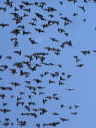 Bracken Cave, near San Antonio Texas is home to 20 to 40 million bats. Visitors to this cave wear goggles and respirators to protect them from the dangerous levels of ammonia (a base, a byproduct of the bats’ urine) in the cave.

Practice Skill: Anticipation Guide for Preconceived Notions about the Chemistry of Acids & Bases

Directions: Put a check under “Likely” if you believe that the statement has any chemical truth. Put a check under “Unlikely” if you believe that it has no chemical truth. Be ready to explain your choices.

Likely Unlikely

______ ______ Most acids have a hydrogen atom written in front of the formula.

______ ______ A Lewis base can donate a pair of electrons.

______ ______ pH is a number used to measure the concentration of hydrogen ions.

______ ______ pH levels range from -14 to 14.

______ ______ A pH meter can be used to measure the level of pH in a solution.

______ ______ pH can also be tested by using pH test paper.

______ ______ If a solution has a pH of 2 then it is considered a base.

______ ______ When you neutralize an acid one of the products is water.

______ ______ When oxides react with atmospheric water they produce acid rain.

______ ______ -log [.01] = 2.

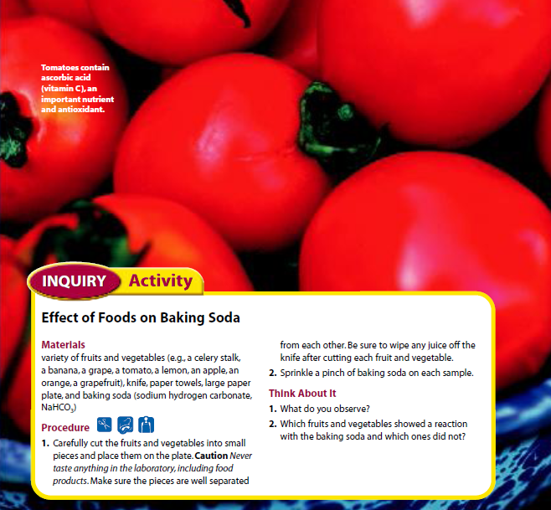

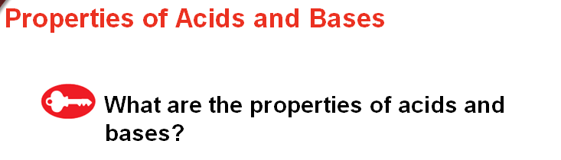

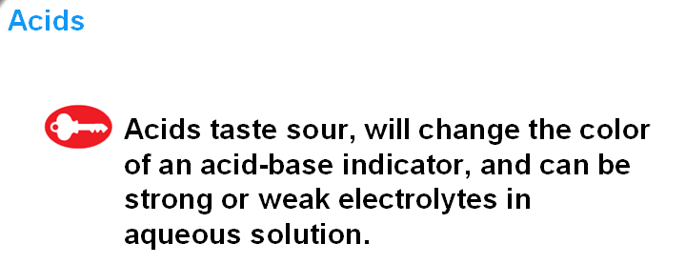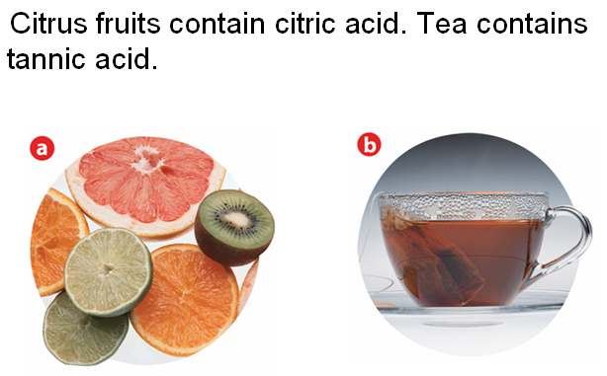

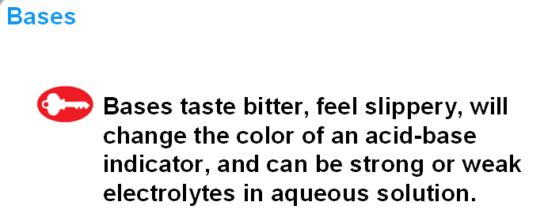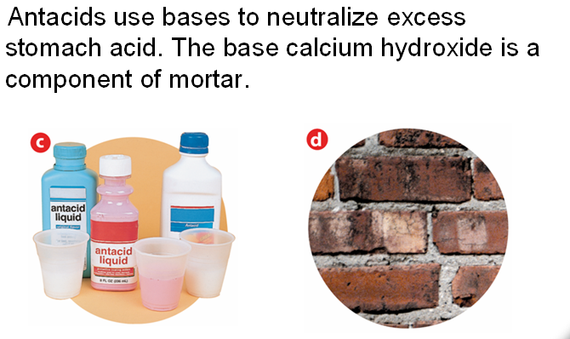

_____________________________________________________________________________________________
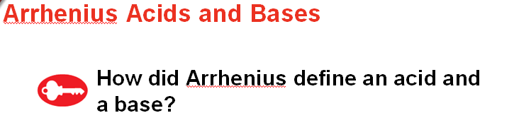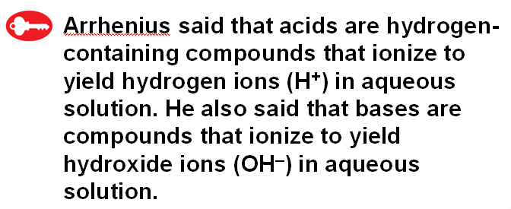

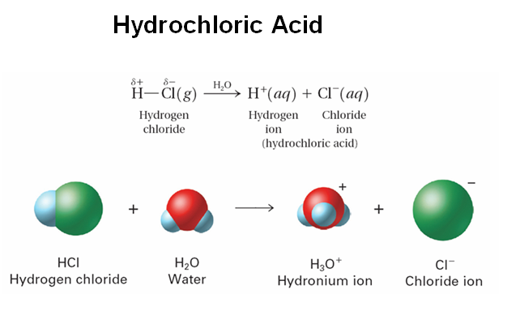
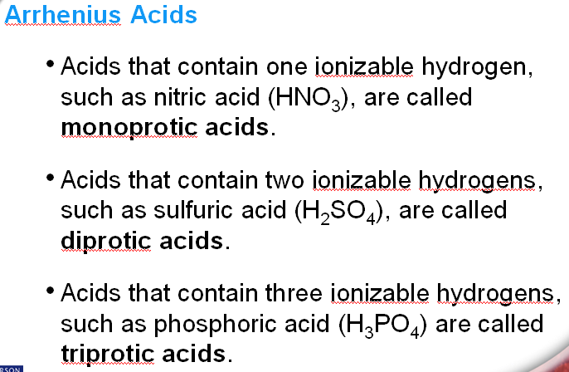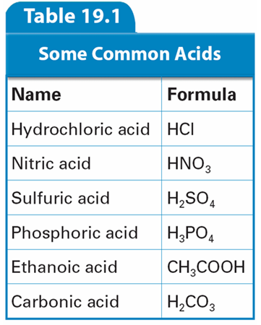

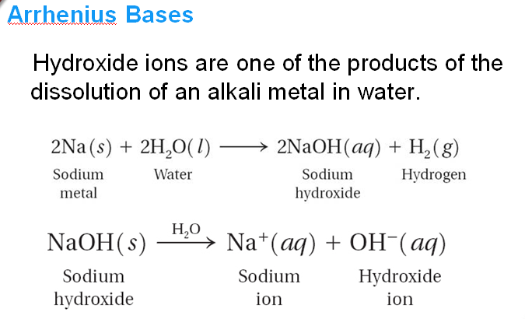

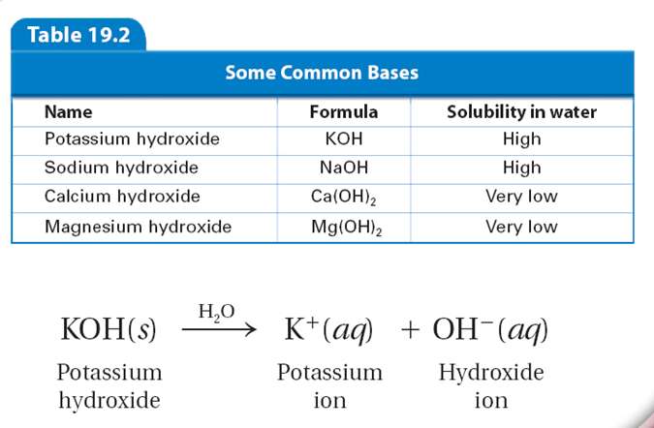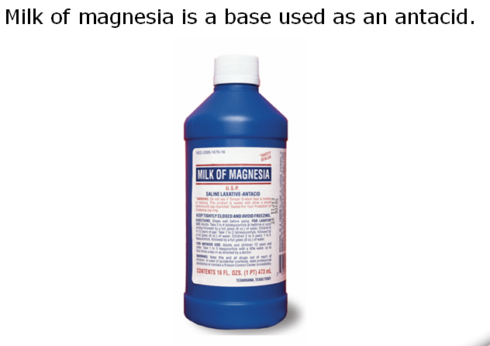
Arrhenius Acid/Base: https://youtu.be/y47upr76y20

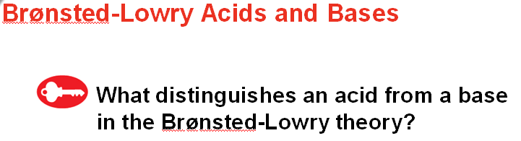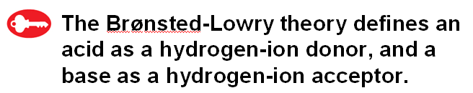

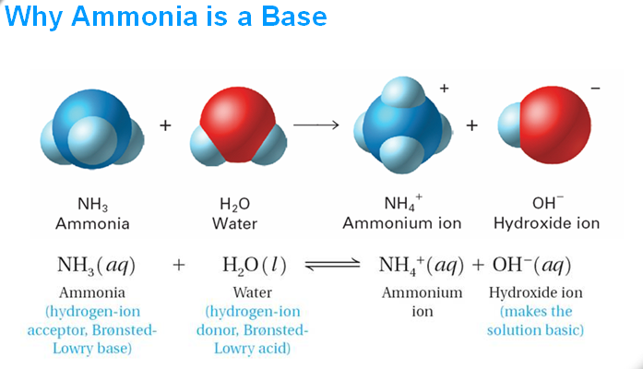

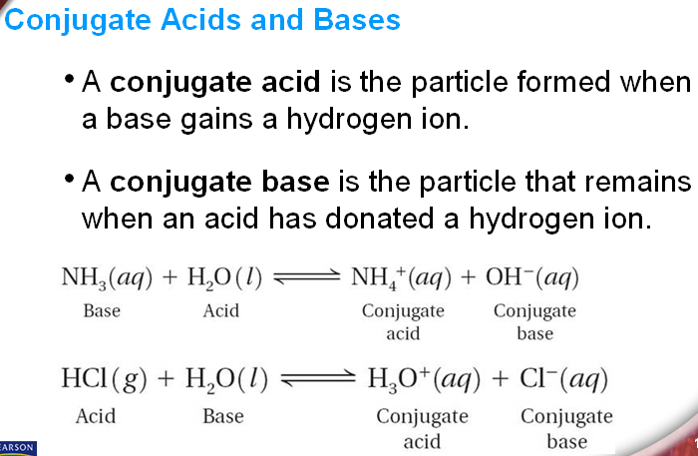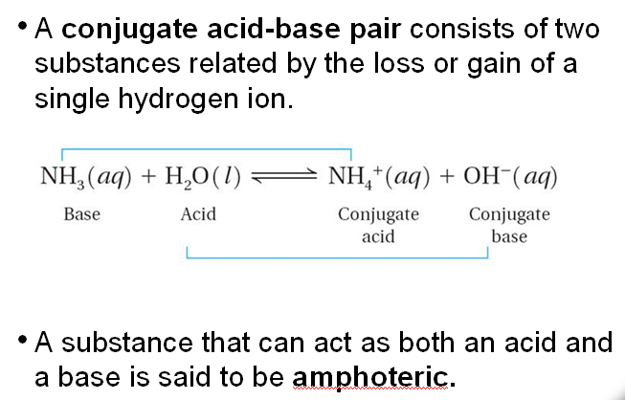

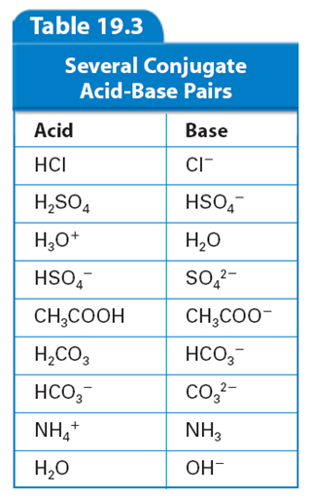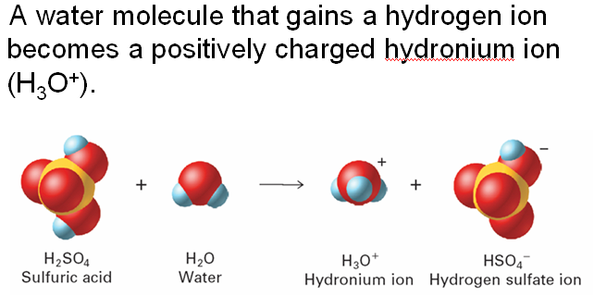

_________________________________________________________________________________________
Bronsted-Lowry Acid/Base: https://youtu.be/ZiokqP0aZ1E
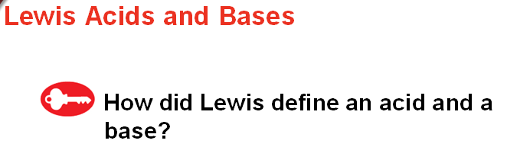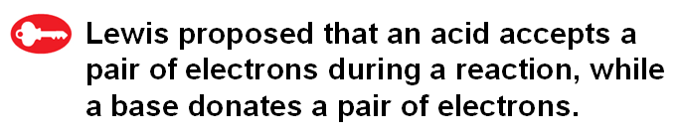
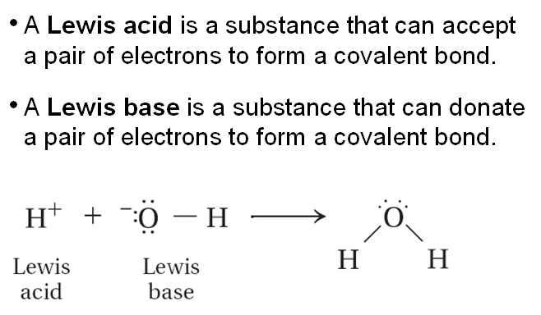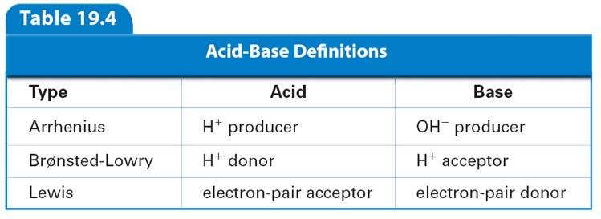
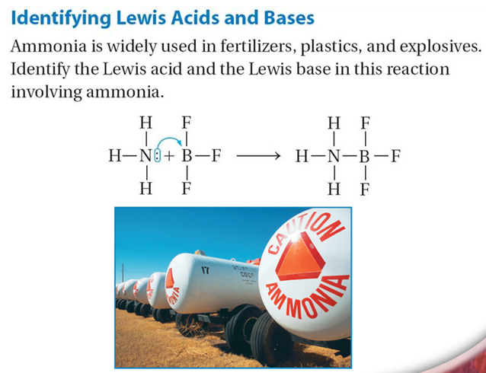
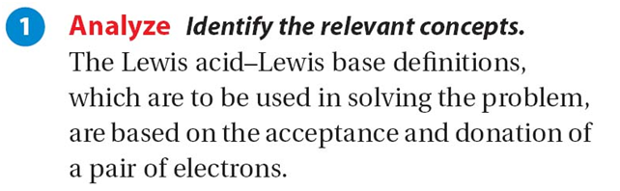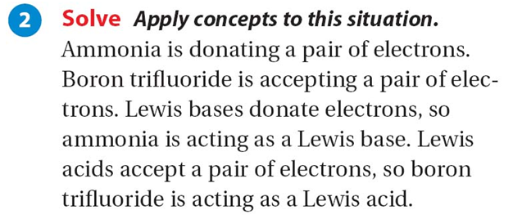
Lewis Acid/Base: https://youtu.be/u2Bd_U8YoO8

Acid Base Ionization: https://youtu.be/rKqYE5sZi1s

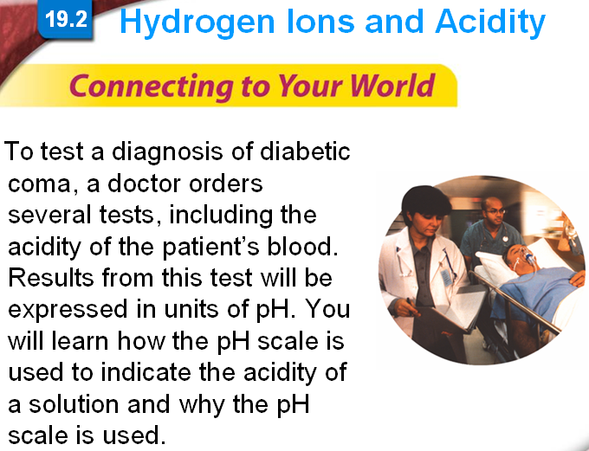

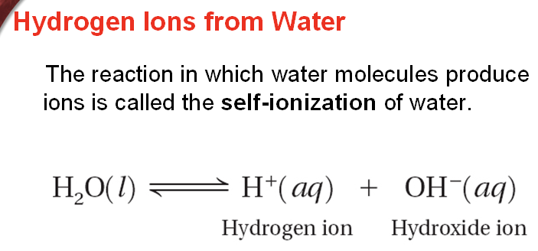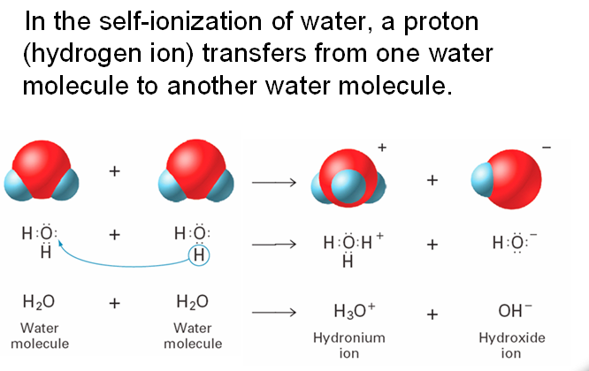
Self Ionization of Water: https://youtu.be/PVq6KdweowM
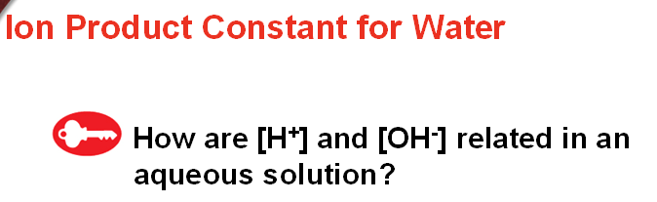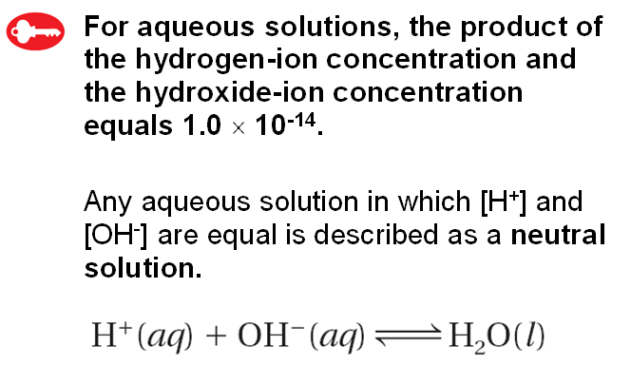

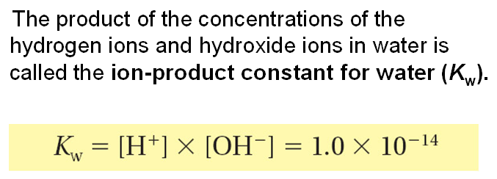

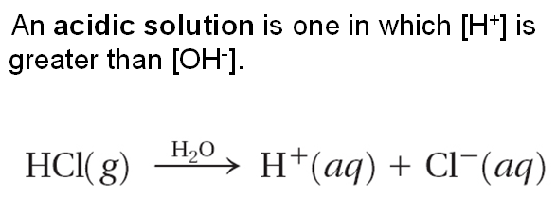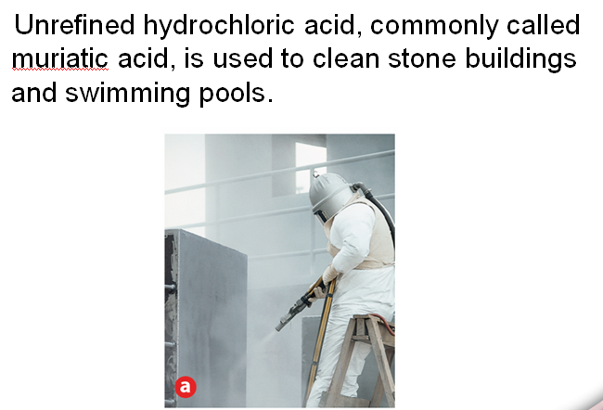

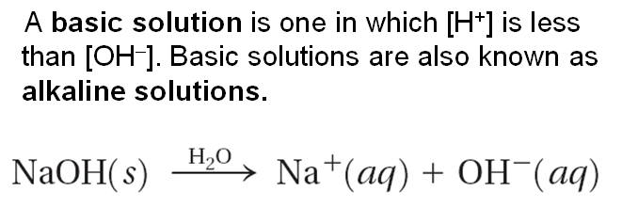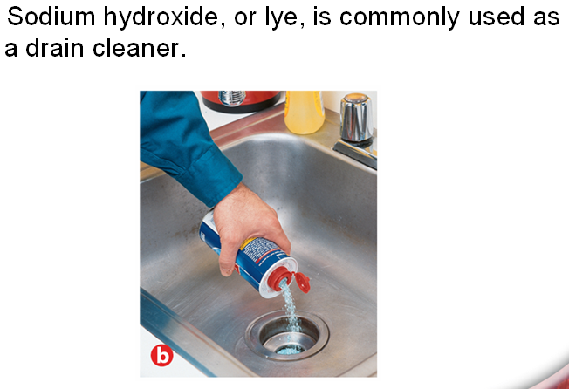

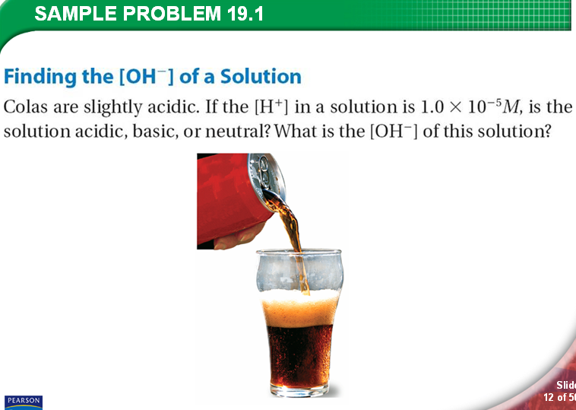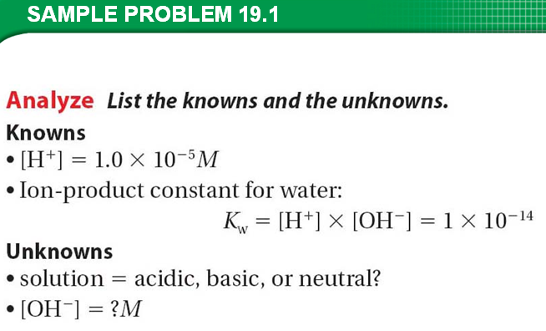

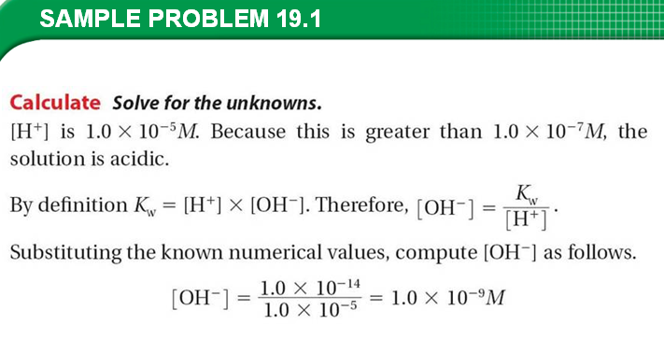

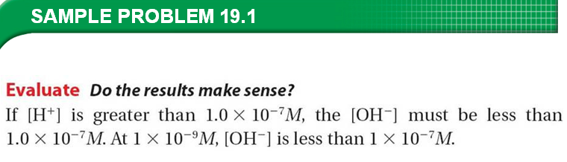
Practice Skill:
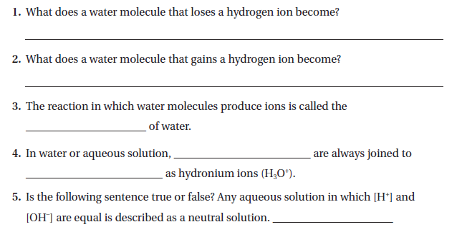
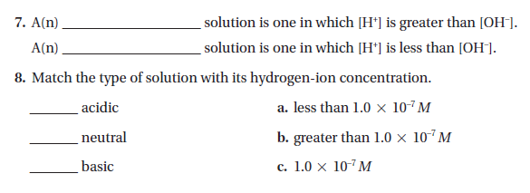
9.
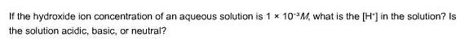
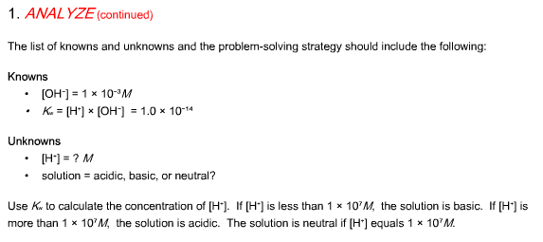

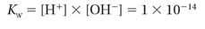
pH Scale: http://chemwiki.ucdavis.edu/Physical_Chemistry/Acids_and_Bases/Aqueous_Solutions/The_pH_Scale
http://www.bgfl.org/bgfl/custom/resources_ftp/client_ftp/ks3/science/acids/

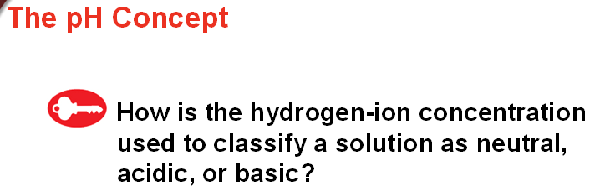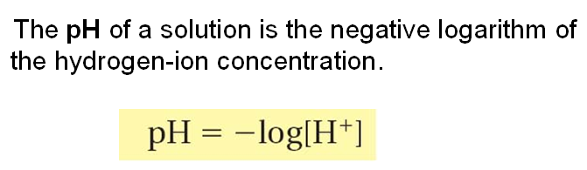

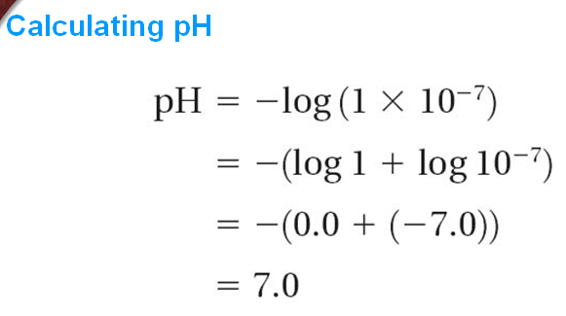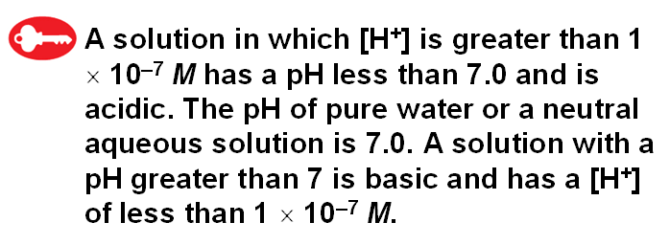

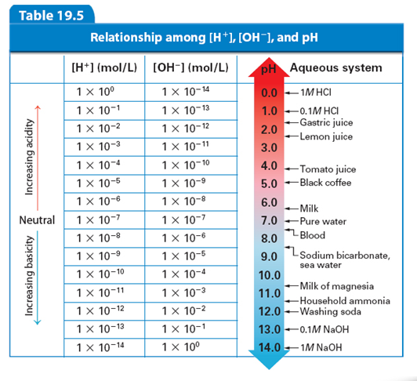

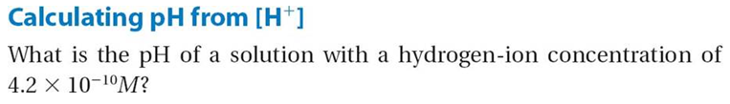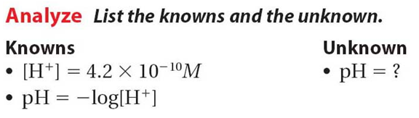

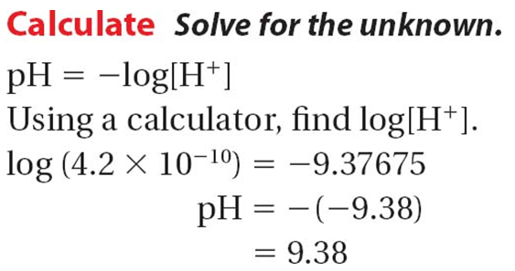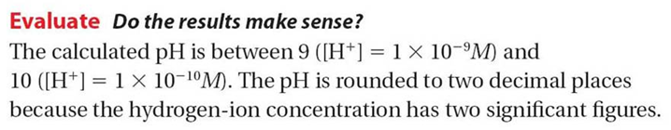

Practice Skill:
1.
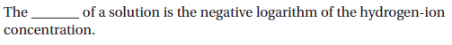
2.
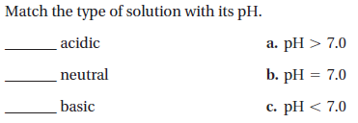
3.
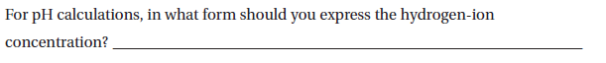
4.
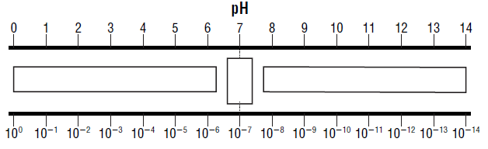
5.

6.
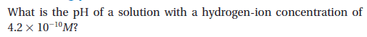

7.
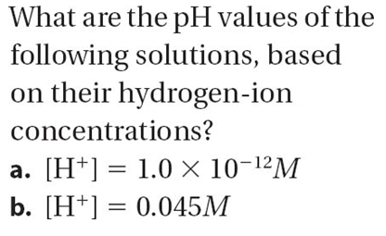
8.
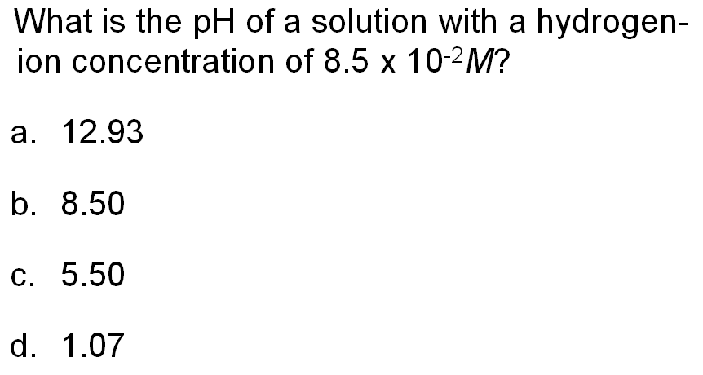
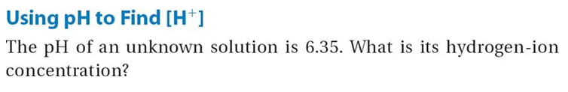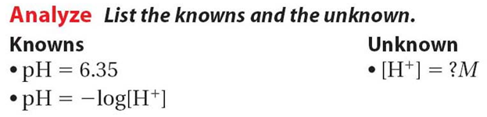

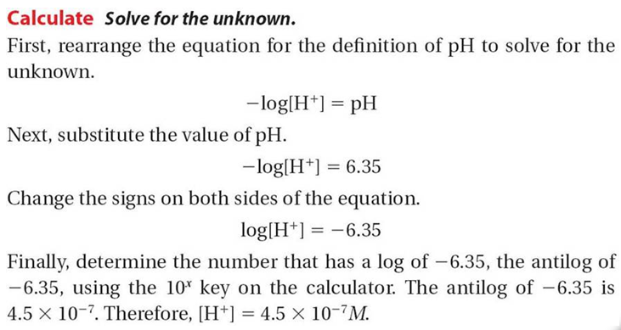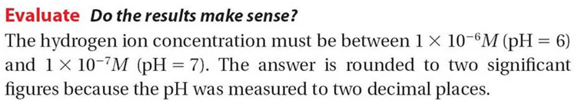

Practice Skill:
1.
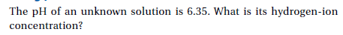

2. 3.
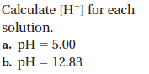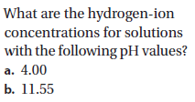

4. 5.
Calculate the [H+] of each Calculate the [H+] of each
solution. solution.
- pH = 7 a. 4.55
- pH = 14 b. 3.2

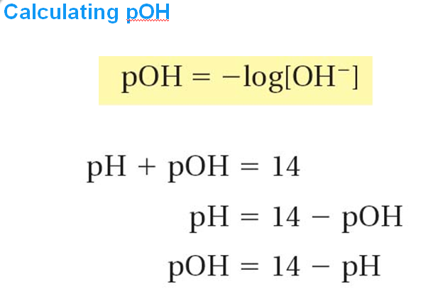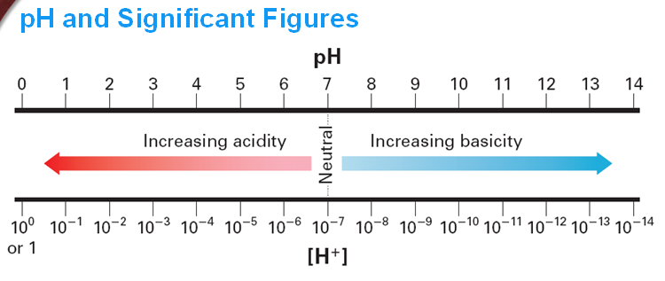

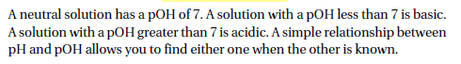

_____________________________________________________________________________________________

Practice Skill:
1.
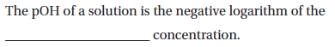
2.

3.
Calculate the pH of the following:

- [OH-] = 1 x 10 ⁻² M
- [OH-] = 1 x 10 ⁻⁸ M
- [OH-] = 1 x 10 ^{– 7} M

4.
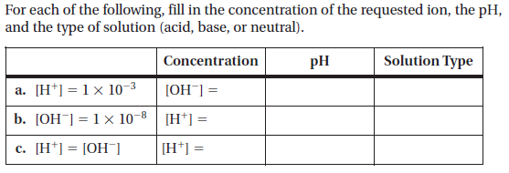

Common Acids & Bases:

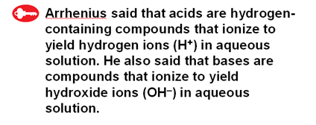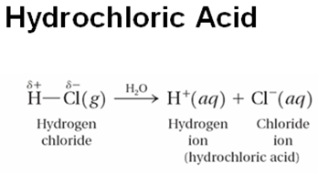

An inorganic acid is an acid that does not contain a carbon atom.
An oxy-acid is an inorganic acid that contains oxygen.
A carboxylic acid is an organic acid that contains carbon and oxygen.
_____________________________________________________________________________________________
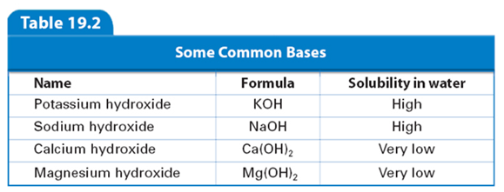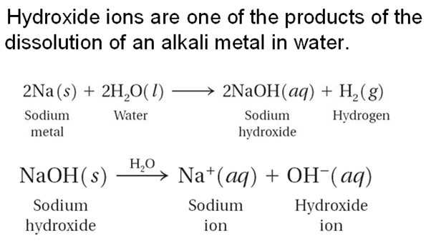

Hydroxides of alkali and alkaline earth metals contain elements from groups I and II respectively.

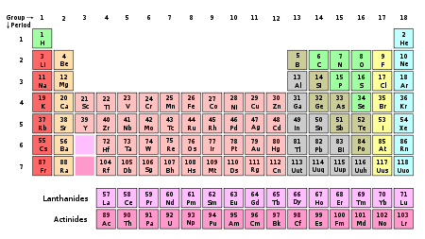

Practice Skill: You will identify the three types of acids and give a scientific argument for your choices. You will also identify a base and give a scientific argument for your choice.

A Scientific Argument includes:

The Claim (an explanation or an answer to a phenomenon)

Example: Phosphoric acid (H₃PO₄) is an inorganic oxy-acid.

The Evidence (the evidence supports the claim made based upon data and or observations)
Three pieces of evidence must be included.

Example:
- It is a hydrogen containing compound.
- In an aqueous solution it will ionize into hydrogen ions (H+).
- It does not contain carbon but does contain oxygen.

The Rationale (the reasoning that shows how the evidence supports the claim and why the evidence should count as support)

Example: According to the formula H₃PO_{4,} Phosphoric acid is inorganic oxy-acid because it does not contain carbon but it does contain oxygen. In water it will release hydrogen ions; it can release three of them.

Your turn:
- Explain what kind of an acid hydrochloric acid (HCl) is.

The Claim:

The Evidence:

The Reasoning:

- Explain why sulfuric acid (H₂SO₄) is an inorganic oxy-acid.

The Claim:

The Evidence:

The Reasoning:

- Explain why carbonic acid (H₂CO₃) is a carboxylic acid.

The Claim:

The Evidence:

The Reasoning:

- Explain why potassium hydroxide (KOH) is a base.

The Claim:

The Evidence:

The Reasoning:

- Explain why sodium hydroxide (NaOH) is a base.

The Claim:

The Evidence:

The Reasoning:

As a reminder:
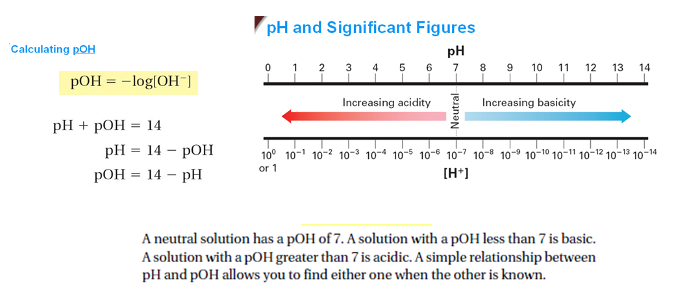

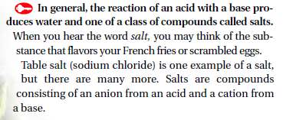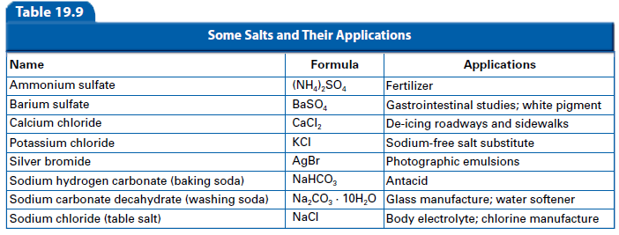
A Salt:
A salt is neither an acid nor a base. Salts are formed when acids and bases neutralize each other forming the salt and water. Example:
Hydrochloric acid (HCl) + Sodium hydroxide (NaOH) Sodium chloride (NaCl) + Water (H₂O)
The universal aqueous acid-base definition of the Arrhenius concept is described as the formation of water from hydrogen and hydroxide ions, or hydrogen ions and hydroxide ions from the dissociation of an acid and base in aqueous solution:
H⁺(aq) + OH⁻(aq) H₂O
(In modern times, the use of H⁺ is regarded as a shorthand for H₃O⁺, since it is now known that the bare proton H⁺ does not exist as a free species in solution.)
This leads to the definition that in Arrhenius acid-base reactions, a salt and water is formed from the reaction between an acid and a base.^{[6]} In other words, this is a neutralization reaction.
acid⁺ + base⁻ → salt + water
The positive ion from a base forms a salt with the negative ion from an acid. For example, two moles of the base sodium hydroxide (NaOH) can combine with one mole of sulfuric acid (H₂SO₄) to form two moles of water and one mole of sodium sulfate.
2 NaOH + H₂SO₄ → 2 H₂O + Na₂SO₄

Practice Skill:
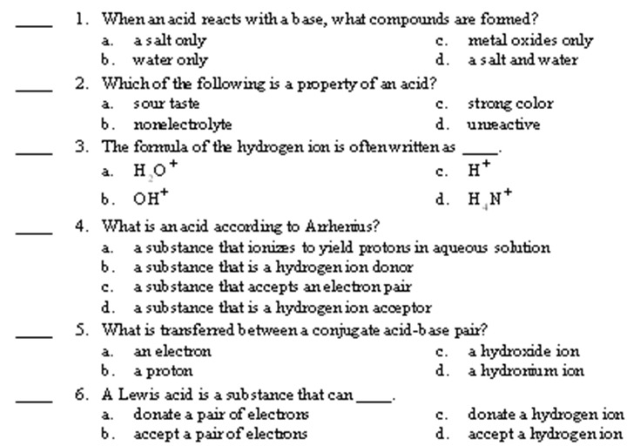
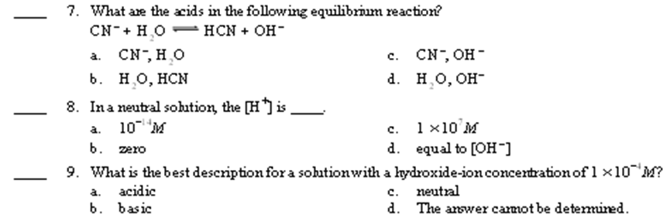

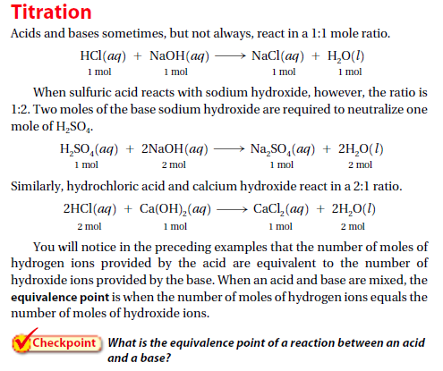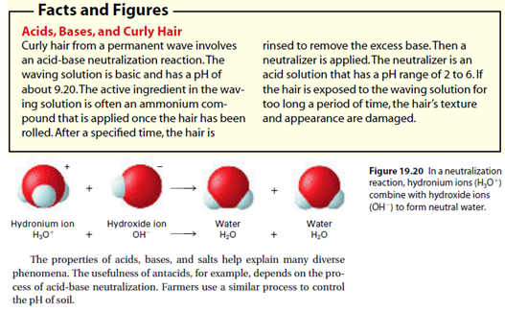

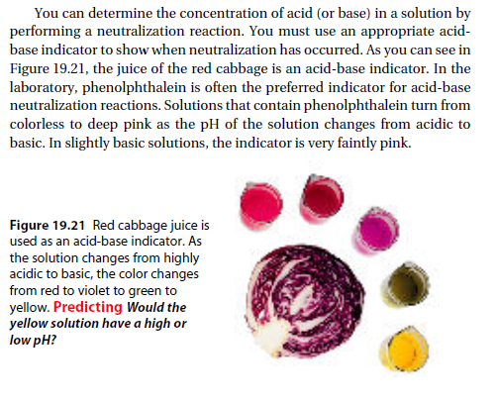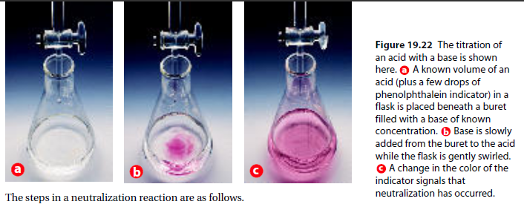
Practice Skill:
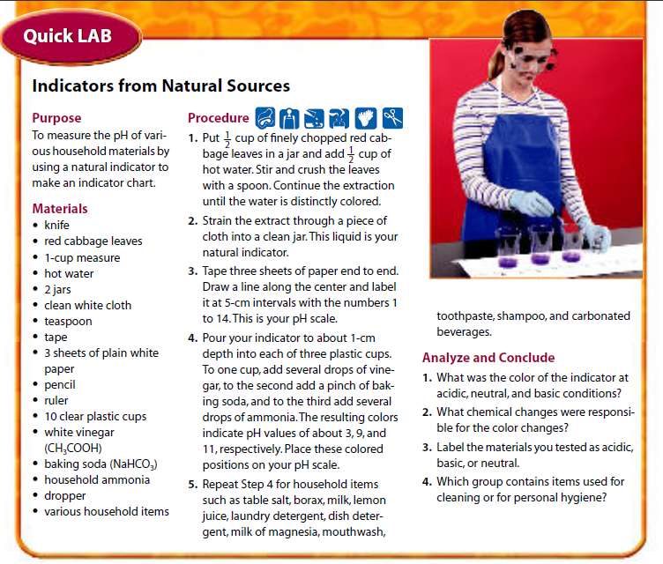
Acids in the Atmosphere
The burning of fossil fuels has worldwide implications. Scientists predict that every region on Earth will be affected, in some way, by increasing concentrations of carbon dioxide in the atmosphere. Unfortunately, this is not the only wide-ranging concern associated with fuel burning. The effects of fuel combustion can be experienced hundreds of kilometers away from the original source, when by-products of combustion (along with other air pollutants) combine with water to produce acid rain.
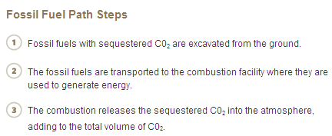
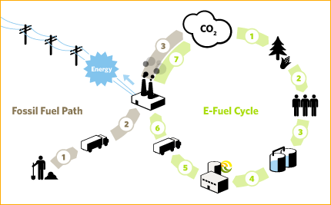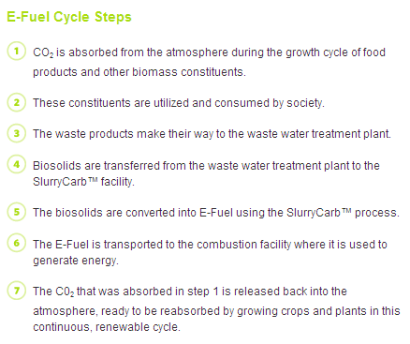

ACID RAIN
What is acid rain? To answer that question, it is worth noting that “acid rain” does not have to be rain; it can be any form of atmospheric precipitation. Acid rain is defined as fog, sleet, snow, or rain with a pH lower than about 5.6, which is the average pH of natural precipitation in the absence of air pollution. You probably recall that pure water is neutral, with a pH of 7. Why, then, does natural precipitation have a pH less than 7. Water samples, although they may be clean and healthful, are rarely pure. Even water that evaporates from Earth’s surface condenses and dissolves atmospheric gases, such as nitrogen, oxygen, and carbon dioxide. The pH of rainwater is normally slightly acidic, about 5.6, mainly due to the reaction of carbon dioxide with water, forming carbonic acid, H₂CO₃:

CO₂ (g) + H₂O (l) H₂CO₃ (aq)

This dilute solution of carbonic acid then falls to Earth as rain, snow, or sleet. Other natural events can contribute to the acidity of precipitation. Volcanic eruptions, forest fires, and lightning bolts produce sulfur dioxide (SO₂), sulfur trioxide (SO₃), and nitrogen dioxide (NO₂). These gases can then react with atmospheric water in much the same way that carbon dioxide does:
SO₂ (g) + H₂O (l) H₂SO₃ (aq)
Sulfurous acid

SO₃ (g) + H₂O (l) H₂SO₄ (aq)
Sulfuric acid

2 NO₂ (g) + H₂O (l) HNO₃ (aq) + HNO₂ (aq)
Nitric acid Nitrous acid

The result, as the previous equations suggest, is the formation of acidic precipitation. If rain customarily is acidic, why does acid rain pose a problem? The fact that this precipitation is more acidic than normal leads to the problems associated with acid rain.

Impact of Acid Rain
Why should we be concerned about acid rain? The reality is that sulfur oxides and nitrogen oxides emitted from power plants, various industries, and fossil-fuel-burning vehicles react with water vapor to form acids that lower the pH of rainwater--- at times to 4.5 or lower in the northeastern United States. Similar changes in pH have been observed for precipitation in Scandinavia, Central Europe, and other areas downwind from large industrial centers and power plants. Excessively acidic rain can lower the pH of lakes and streams enough to kill fish eggs and other aquatic life. Acid rain also damages plants by leaching needed mineral from the soil.

Effects: http://www.teachersdomain.org/asset/lsps07_int_acidlake/

Problems caused by acid rain are not limited to effects on natural ecosystems. Most buildings and other structures contain metal, limestone, or concrete, which are all materials susceptible to damage by acids. Statues and monuments (such as the Parthenon in Greece) that have stood for centuries; show signs of significant surface damage, due, in part, to acid rain. Acid attacks calcium carbonate in limestone, marble, and cement according to this equation:
H₂SO₄(aq) + CaCO₃(s) CaSO₄(s) + H₂O(l) + CO₂(g)
Sulfuric Acid Calcium Calcium Water Carbon
(in acid rain) Carbonate Sulfate Dioxide

Calcium sulfate is much more soluble in water than is calcium carbonate. Thus, as calcium sulfate forms, it washes away, uncovering fresh solid calcium carbonate that reacts further with acid rain, this is how the structures are damaged.
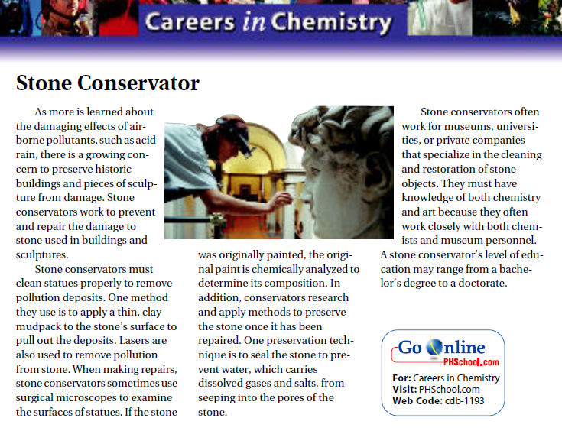

USGS Link:
http://pubs.usgs.gov/gip/acidrain/contents.html
Read through the ‘Introduction’ links to become more familiar with the issues of acid rain.

Read through a few of the links on ‘A Field Guide to Buildings in Our Nation’s Capital’ and choose one building or monument that is being destroyed by acid rain; you will write a Biopoem on one of these. Note because some of the buildings are made of granite they are not being destroyed by acid rain:

CaCO₃(s) + H₂SO₄(aq) CaSO₄(s) + CO₂(g) + H₂O(l)
(breakdown and deterioration)

Granite(s) + H₂SO₄(aq) No Reaction

Also note that acid rain effects are described in two ways:
Dissolution | Alteration
When acid rain reacts with buildings or monuments made of marble, limestone, or concrete the calcite (CaCO₃) in those materials reacts with acid rain and damages these structures. | When buildings or monuments are exposed to acid rain, you see roughened surfaces, some of the material maybe broken off, and carved detailing lost.  Stone surface material may be lost all over or only in spots that are more reactive or exposed more to acid rain.

Practice Skill:
A Biopoem is poetry about someone that describes them in 11 lines. In your case you will choose a building or monument of our Nation’s Capital and describe the effects of acid rain on that building or monument.

Format:

- The first line will describe the building or monument.
- The second line will describe four traits about the building or monument.
- Third line will be of a relative of the building or monument.
- Fourth line will describe what the building or monument cherishes: Lover of ____________
(list 3 things or people)
- Fifth line will describe what the building feels: Who feels ___________ (list 3 things)
- Sixth line will describe what the building or monument needs: Who needs __________ (list 3 things)
- Seventh line will describe what the building or monument fears: Who fears ___________ (list 3 things)
- Eight line will describe what the building or monument offers: Who gives ___________ (list 3 things)
- Ninth line will describe what the building or monument hopes for: Who would like to see __________
(list 3 things)
- Tenth line will describe where the building or monument is found: Resident of ___________ (where building or monument is found)
- The eleventh line will proclaim the name of the building or monument.

Example:

I am Peace,
Carved sandstone, dark and igneous,
Born of Italians in Carrara.
I love for all to see me, take pictures of me, and to remember me.
I feel the acid pour down, lower pH; gnaw at my beauty and symbol.
I need care, protection, passed legislations.
Growing old, being forgotten, and crumbled ashes left behind,
Yet in my solitude I bring you peace, acceptance, and beauty.
Celebrate! Sing and Dance for me.
I am yours people of the United States of America,
I am the Peace Monument.

References:
Salts: http://en.wikipedia.org/wiki/Acid%E2%80%93base_reaction
Fossil Fuel Paths: www.enertech.com/environment/renew_energy.html
Chemistry Wilbourne 1993
Chemistry Wilbourne 2008
Chm Com NCS 2000
Titrations: http://ull.chemistry.uakron.edu/analytical/AB_titrations/
http://en.wikipedia.org/wiki/Titration
http://chemistry.about.com/od/acidsbases/Acids_Bases_and_pH.htm
http://chemistry.about.com/od/acidsbases/a/aa082304a.htm

