|  |  |  |
| --- | --- | --- |
| **Code** | **Unit 9-Thermochemistry and Solutions**  **Content Expectation** | **Textbook Reference** |
| C2.1x | Chemical Potential Energy:Potential energy is stored whenever work must be done to change the distance between two objects. The attraction between the two objects may be gravitational, electrostatic, magnetic, or strong force. Chemical potential energy is the result of electrostatic attractions between atoms. |  |
| C2.1c | Compare qualitatively the energy changes associated with melting various types of solids in terms of the types of forces between the particles in the solid. | Section(s) 9.8,15.5,16.7  Page(s) 210,353,383 |
| C2.2x | Molecular Entropy: As temperature increases, the average kinetic energy and the entropy of the molecules in a sample increases. |  |
| C2.2d | Explain convection and the difference in transfer of thermal energy for solids, liquids, and gases using evidence that molecules are in constant motion. | Section(s) 9.10  Page(s) 214 |
| C3.1x | Hess’s Law: For chemical reactions where the state and amounts of reactants and products are known, the amount of energy transferred will be the same regardless of the chemical pathway. This relationship is called Hess’s law. |  |
| C3.1c | Calculate the ΔH for a chemical reaction using simple coffee cup calorimetry. | Section(s) 8.7  Page(s) 185 |
| C3.1d  Priority | Calculate the amount of heat produced for a given mass of reactant from a balanced chemical equation. | Section(s) 8.7  Page(s) 185 |
| C3.4x | Enthalpy and Entropy: All chemical reactions involve rearrangement of the atoms. In an exothermic reaction, the products have less energy than the reactants. There are two natural driving forces: (1) toward minimum energy (enthalpy) and (2) toward maximum disorder (entropy). |  |
| C3.4g | Explain why gases are less soluble in warm water than cold water. | Section(s) 16.3  Page(s) 373 |
| C4.7x | Solutions: The physical properties of a solution are determined by the concentration of solute. |  |
| C4.7a | Investigate the difference in the boiling point or freezing point of pure water and a salt solution. | Section(s) 16.7  Page(s) 383 |
| C5.4 | Phase/Change Diagrams: Changes of state require a transfer of energy. Water has unusually high-energy changes associated with its changes of state. |  |
| C5.4A  Priority | Compare the energy required to raise the temperature of one gram of aluminum and one gram of water the same number of degrees. | Section(s) 7.5  Page(s) 154 |
| C5.4B  Priority | Measure, plot, and interpret the graph of the temperature versus time of an ice-water mixture, under slow heating, through melting and boiling. | Section(s) 9.9,9.10  Page(s) 213,214 |
| C5.5x | Chemical Bonds: Chemical bonds can be classified as ionic, covalent, and metallic. The properties of a compound depend on the types of bonds holding the atoms together. |  |
| C5.5e | Relate the melting point, hardness, and electrical and thermal conductivity of a substance to its structure. | Section(s) 13.5,13.6,14.14  Page(s) 307,309,343 |

**Vocabulary**

|  |  |
| --- | --- |
| **Boiling point elevation**  **Calorie**  **Change of state**  **Chemical bond**  **Concentration**  **Convection current**  **Convection heating**  **Crystalline solid**  **Electrostatic attractions**  **Enthalpy**  **Entropy**  **Equilibrium** | **Exothermic reaction**  **Freezing point depression**  **Hess’s Law**  **Ionic motion**  **Joules**  **Kinetic energy**  **Mass to energy conversion**  **Potential energy**  **Release of energy**  **Solute**  **Specific heat**  **Transforming matter and/or energy** |

**Big Idea:**

The flow of energy, measured by temperature, influences the behavior of matter.

**Core Concepts:**

* All chemical and physical changes involve energy transfer.
* The amount of heat transferred in a chemical/physical change can be predicted (calculated) using a balanced chemical equation. It can also be measured quantitatively through experimental means and graphically represented.

**Chemical Potential Energy: Electrical Forces and Bonding**. A **chemical bond** is an attraction between atoms or molecules and allows the formation of chemical compounds, which contain two or more atoms.Chemists are fascinated by the manner in which atoms come together to form molecules and lattices; and molecules come together to form condensed phases of matter. The coming together of atoms, oppositely charged ions, and molecules is a consequence of **electrical forces.** An electrostatic attraction is the electrical force exerted on the electrons of one particle by the nucleus (or nuclei) of the other. All physical and chemical bonding is the result of molecular forces that are electrical in origin.

**Specific Concepts:**

* Forces between atoms and molecules are electrical, and are described by Coulomb's Law.
* There are only two types of energy, **kinetic (energy of motion) and potential (energy of position).** All energy possessed by atoms and molecules is one of these two types.
* Potential energy arises from forces between bodies. Potential energy of molecules arises from electrical forces between them.
* Intramolecular forces, forces within a compound-(ionic bonds, covalent bonds, and metallic bonds) and intermolecular forces, forces between compounds-(dipole-dipole, dispersion, ion dipole, hydrogen bonds) are fundamentally very similar, described essentially by Coulomb's Law (positive & negative attractions).

The electromagnetic force (remember there are three forces-gravitational, electromagnetic, and nuclear) is responsible for all interactions between atoms and compounds. It is responsible for:

* The attraction of electrons to the atomic nucleus
* The bonding together of atoms in a molecule (covalent compound)
* The attraction between oppositely charged ions in an ionic compound
* The attraction between compounds that leads to liquefaction and solidification
* The flow of electrical current
* Your inability to push your finger or hand through a wall

**C2.1c**: **Energy of position-potential energy:** In **Region 1**, the particles are very separated from each other and have higher potential energy than when they are bonded to each other. Here the forces of attraction are nearly zero (potential energy is nearly 0) and the state of matter for Region 1 would be a gas. At the beginning of **Region 2**, the particles are coming closer to each other, enough to exert a force and potential energy is decreasing. At this point we would see a liquid. To **the left of Region 2**, attractive forces are at a maximum, the particles have formed a bond and potential energy is the lowest. At this point we would see the solid phase. In **Region 3**, the particles are so close to each other that the nuclei repel and potential energy increases at a rapid rate (this is what keeps you from putting your finger through a wall). 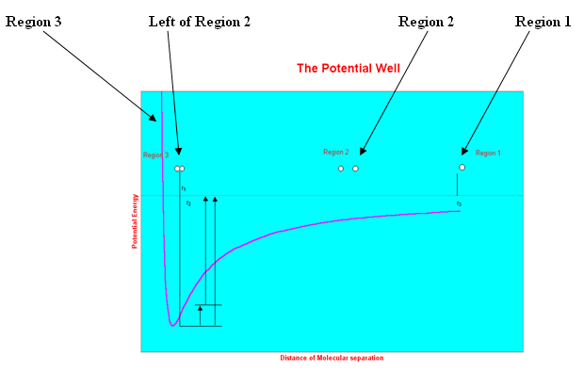**C2.2d: Molecular Entropy**: As temperature increases, the average kinetic energy and the entropy (disorder) of the molecules in sample increases. Recall that entropy is a measure of disorder. Solids have a lower entropy (particles are more ordered) than gases (particles are less ordered). Remember that conduction is the transfer of heat by direct contact of particles of matter. Heat is transferred by conduction when adjacent atoms vibrate against one another, or as electrons move from one atom to another as in the case of metals. **Heat transfer** is the transition of thermal energy from a hotter mass to a cooler mass. When an object is at a different temperature than its surroundings or another object, *transfer of thermal energy*, also known as *heat flow*, or *heat exchange*, occurs until the body and the surroundings reach thermal equilibrium; this means that they are at the same temperature. Heat transfer always occurs from a higher-temperature object to a cooler-temperature. **Convection** is the movement of molecules within fluids (liquids & gases). Convective heat transfer takes place through diffusion as the particles in the liquid or gas exhibit rotational kinetic energy. **Heat Transfer (**flash interactive**):** [**http://www.teachersdomain.org/asset/lsps07_int_heattransfer/**](http://www.teachersdomain.org/asset/lsps07_int_heattransfer/)

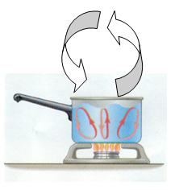 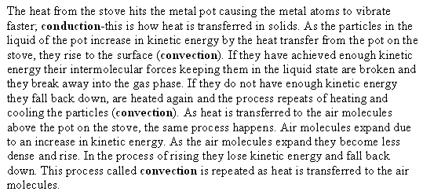

**Practice Skill:**

1. The table below compares melting points and bond types of four different substances.

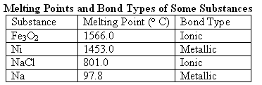

Which substance has the strongest forces between its particles?

1. Fe3O2 B. Ni

C. NaCl D. Na

1. Arrange the following solids in order of increasing strength of attractive forces.

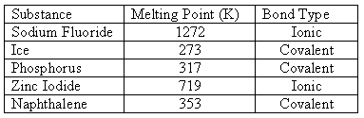

1. Sodium Fluoride, Ice, Phosphorus, Zinc Iodide, Naphthalene
2. Sodium Fluoride, Zinc Iodide, Naphthalene, Phosphorus, Ice
3. Ice, Phosphorus, Naphthalene, Zinc Iodide, Sodium Fluoride
4. Naphthalene, Zinc Iodide, Phosphorus, Ice, Sodium Fluoride

3. Explain why ionic crystals melt at much higher temperatures than typical covalent molecular crystals.

1. Ionic crystals have stronger attractive forces than the hydrogen bonding, dipole-dipole and dispersion forces that hold covalent molecular crystals together.
2. Ionic crystals have weaker attractive forces than the hydrogen bonding, dipole-dipole and dispersion forces that hold covalent molecular crystals together.
3. Solids consist of closely packed particles held together by intermolecular forces. These particles are able to move back and forth about fixed positions.
4. Particles in a crystalline solid have a random disordered arrangement. The more random the arrangement the higher the melting point.

4. Thermal energy can be easily transferred in the form of current movement in a gas. Which term correctly describes this transfer of energy?

* 1. Conduction B. Convection

C. Evaporation D. Radiation

5. A warm stove loses heat by conduction to the cooler air in contact with it. Explains what happens when the heat from the stove is transferred to the air molecules.

1. Air molecules expand due to an increase in kinetic energy. As the air molecules expand they become less dense and rise. In the process of rising they lose kinetic energy and fall back down. This process called convection is repeated as heat is transferred to the air molecules.
2. Two systems at the same temperature are said to be in a state of thermal equilibrium. When this happens there is no exchange of heat and so heat exists only in transfer between two systems.
3. Heat is internal thermal energy that flows from one body of matter to another or from a system at a higher temperature to a system at lower temperature. Temperature can be defined as a measure of the average molecular kinetic energy of a system.
4. Air molecules contract due to an increase in kinetic energy. As air molecules contract they become denser and rise. In the process of rising they gain kinetic energy and fall back down. This process called convection is repeated as heat is transferred to the air molecules.

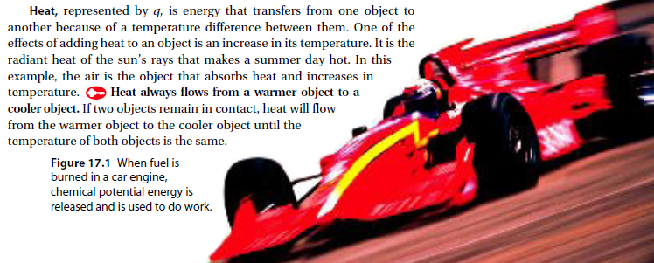

**C3.1c:**

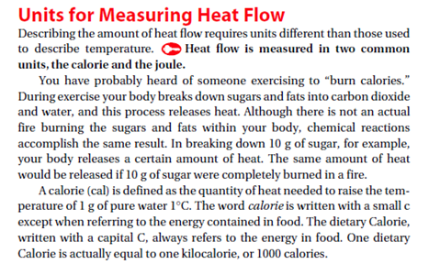 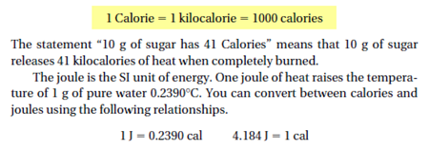

**1 kJ = 1000 J** **1g of H2O = 1mL of H2O**

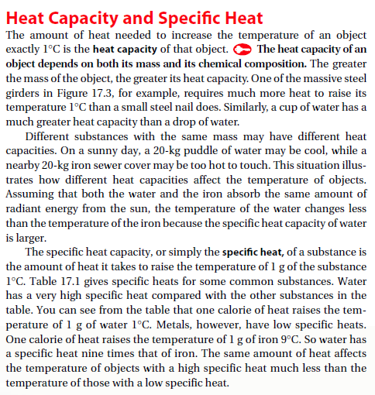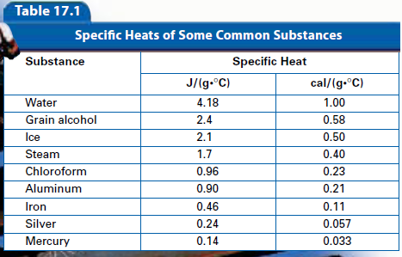

By looking at the table we can see it’s going to take more heat to

raise the temperature of water than it will to raise the temperature

of the rest of these substances.

Do you know how many calories are in a macadamia nut?

<http://www.teachersdomain.org/asset/rr10_vid_calori/>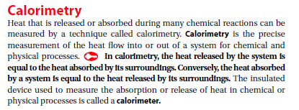 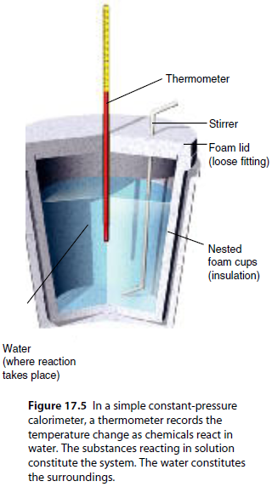

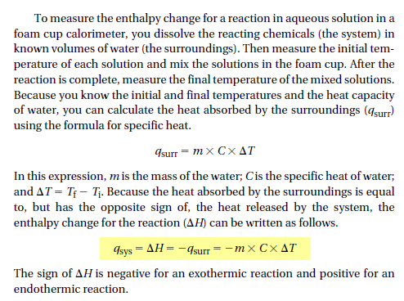

**Enthalpy**: The heat content of a system at constant pressure is the property called enthalpy (H). The heat released or absorbed by a reaction at constant pressure is the same as the change in enthalpy, symbolized as **∆H**.

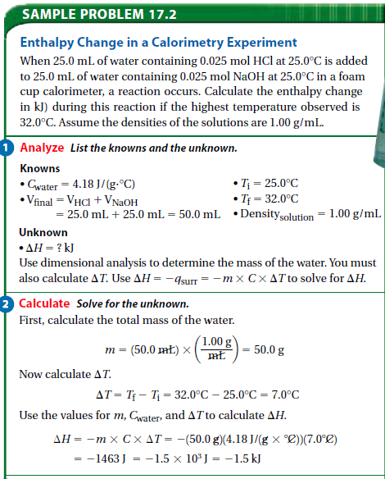

**Practice Skill:**

1. When 50 mL of water containing 0.50 mol of HCl at 22.50C is mixed with 50 mL of water containing 0.50 mol of NaOH at 22.50C in a calorimeter, the temperature of the solution increases to 26.00C. How much heat in kJ was released by this reaction?

2. A small pebble is heated and placed in a foam cup calorimeter containing 25 mL of water at 250C. The water reaches a maximum temperature of 26.40C. How many joules of heat were released by the pebble?

3. To find the heat change for an organic reaction, a chemist must use hexane as the solvent in her calorimetry experiment. If the reaction causes the temperature of 0.0700 kilograms of hexane to decrease by 3.57 o C, what is the heat change for the reaction? (Hexane has a specific heat capacity of 2.26 kJ/kg • o C)

1. 0.111 kJ B. 0.565 kJ
   1. 5.90 kJ D. 115.0 kJ

4. The specific heat of silver is 0.24 . How many joules of energy are needed to warm 4.37 g of silver

from 25.0C to 27.5C?

A. 2.62 J B. 0.14 J

C. 45.5 J D. 0.022 J

5. What is the amount of heat required to raise the temperature of 200.0 g of aluminum by 10C?

(specific heat of aluminum = 0.21 )

A. 4200 cal B. 42,000 cal

C. 420 cal D. 420,000 cal

6. When 45 g of an alloy, at 25C, are dropped into 100.0 g of water, the alloy absorbs 956 J of heat. If the final temperature of the alloy is 37C, what is its specific heat?

A. 0.423  B. 1.77 

C. 9.88  D. 48.8 

**C3.1d:**

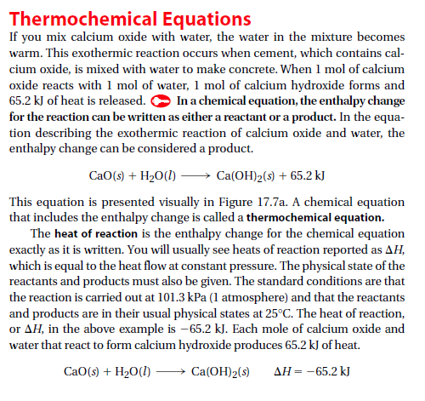

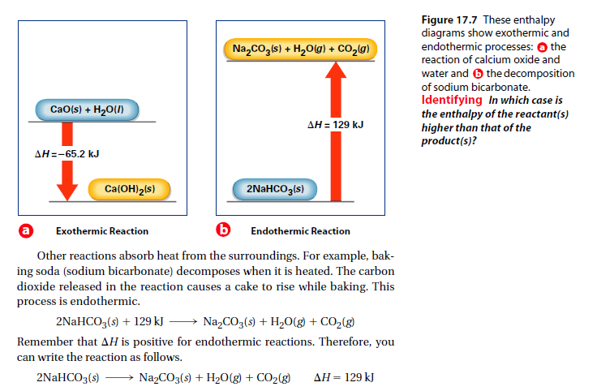

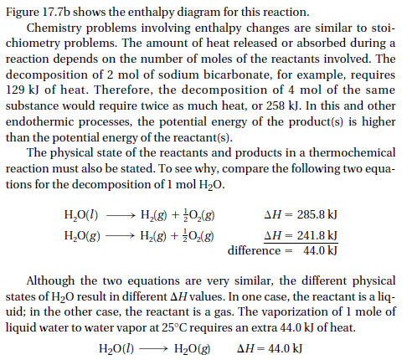

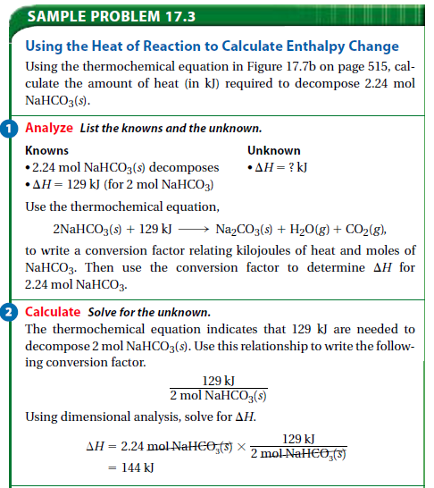 

**Practice Skill:**

1. When carbon disulfide is formed from its elements, heat is absorbed. Calculate the amount of heat in kJ absorbed when 5.66g of carbon disulfide is formed.

C(s) + 2S(s) 🡪 CS2(*l*) **∆H = 89.3 kJ**

* 1. The production of iron and carbon dioxide from iron (III) oxide and carbon monoxide is an exothermic reaction. How many kilojoules of heat are produced when 3.40 mol of Fe2O3 reacts with an excess of CO?

Fe2O3(s) + 3CO(g) 🡪 2Fe(s) + 3CO2(g) + **26.3kJ**

3. Calculate the energy required to produce 7.00 mol ClO on the basis of the following balanced equation.

2Cl(*g*) + 7O(*g*) + 130 kcal  2ClO(*g*)

A. 7.00 kcal B. 65 kcal

C. 130 kcal D. 455 kcal

4. Calculate the energy released when 24.8 g NaO reacts in the following reaction.

NaO(*s*) + 2HI(*g*)  2NaI(*s*) + HO(*l*)

*H* = –120.00 kcal

A. 0.207 kcal B. 2.42 kcal

C. 48.0 kcal D. 3.00  10 kcal

Extension of **C3.1d:**

<https://youtu.be/u7aTBxA7sL8>

**Hess’s Law**

Sometimes it is hard to measure the heat change of a reaction, like when the reaction takes place over a long period of time, or the reaction is an intermediate step in a series, or even when you may not want to destroy the starting material in the reaction. Under these circumstances Hess’s law allows you to determine the heat of reaction indirectly. In Hess’s law you add a series of desired reactions along with their heats of combustion to achieve the overall desired reaction.

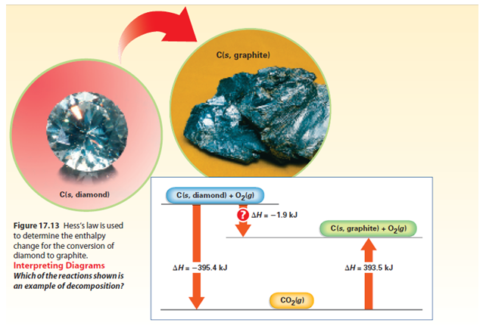

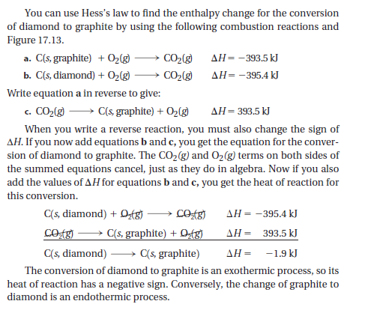

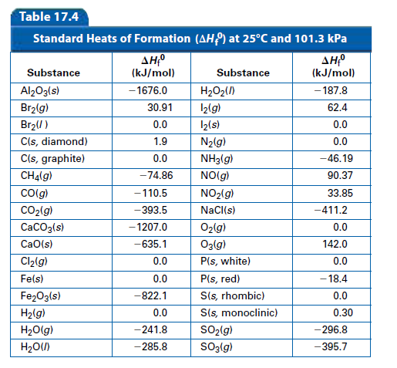

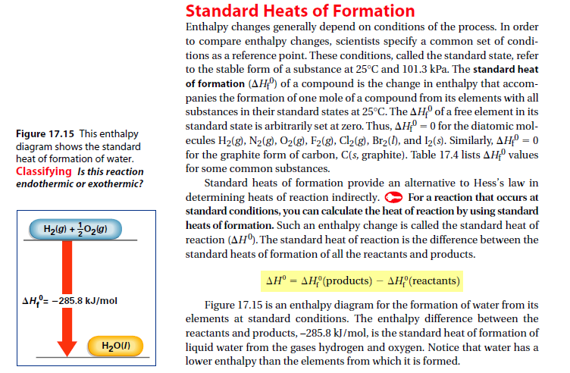

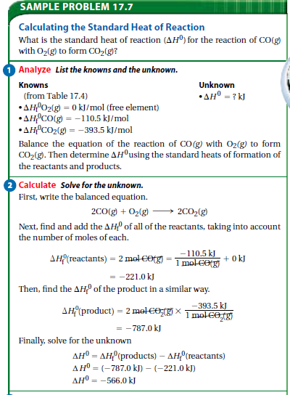

**Practice Skill:**

1. Hess's law ____.

a. makes it possible to calculate *H* for complicated chemical reactions

b. states that when you reverse a chemical equation, you must change the sign of *H*

c. determines the way a calorimeter works

d. describes the vaporization of solids

2. Using a table that lists standard heats of formation, you can calculate the change in enthalpy for a given chemical reaction. The change in enthalpy is equal to ____.

a. *H* of products minus *H* of reactants

b. *H* of products plus *H* of reactants

c. *H* of reactants minus *H* of products

d. *H* of products divided by *H* of reactants

3. Use the information below to calculate *H* for the following reaction.

**2NO(*g*)  NO(*g*)**

2N(*g*) + 2O(*g*)  2NO(*g*) *H* = 67.7 kJ

N(*g*) + 2O(*g*)  NO(*g*) *H* = 9.7 kJ

* 1. Calculate ∆H for the following reactions:
     1. Br2(g) 🡪 Br2(l)
     2. CaCO3(s) 🡪 CaO(s) + CO2(g)
     3. 2NO(g) + O2(g) 🡪 2NO2(g)

**C3.4g: Enthalpy and Entropy:** All chemical reactions involve rearrangement of the atoms. In an exothermic reaction, the products have less energy than the reactants. There are two natural driving forces: (1) toward minimum energy (enthalpy) and (2) toward maximum disorder (entropy).

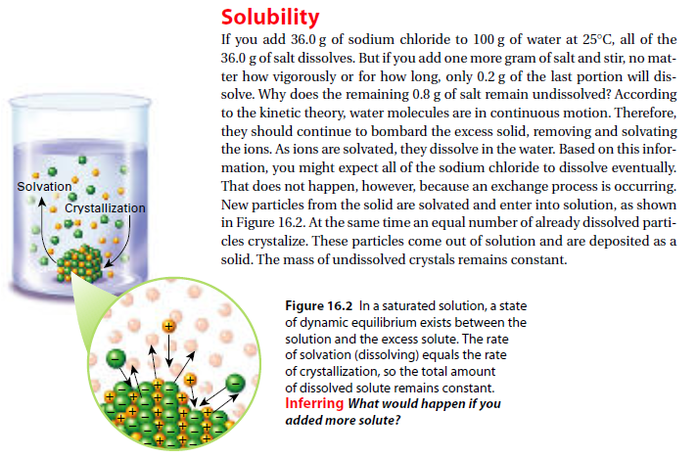

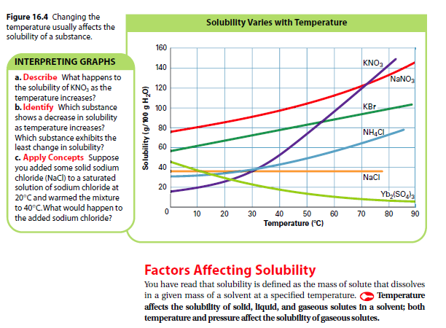

**Practice Skill:**

**Use the following space to answer the questions under: Interpreting Graphs**

* + 1. **Describe:**
    2. **Identify:**
    3. **Apply Concepts:**

**Temperature:** The solubility of most solid substances increases as the temperature of the solvent increases. Figure 16.4 shows how the solubility of several substances changes as temperature increases. For a few substances, solubility decreases with temperature.

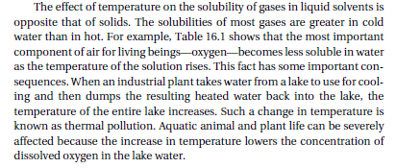

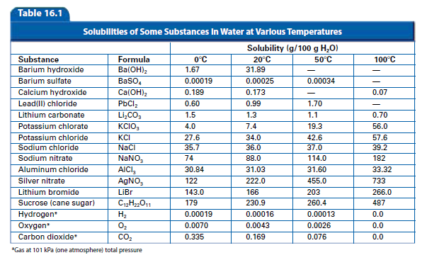  
Recall that entropy is the amount of disorder. As temperature increases entropy increases. Dissolved gases have less entropy than un-dissolved gases so as temperature increases the change is forced toward the gaseous phase, the increase in disorder. What this means is that kinetic energy is higher at higher temperatures (more disorder- more entropy: +∆S) and this condition allows the gases to escape.

**Practice Skill:**

1. Immediately after opening a bottle of club soda, a student constructs the setup shown below.

**Club soda on a Hot Plate**

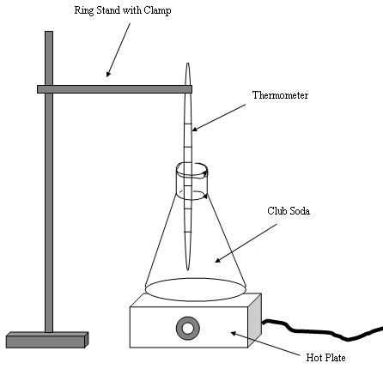

Right away, the flask with the club soda begins to increase in temperature. The student observes that as the temperature increases, more bubbles of carbon dioxide come out of solution. Which of the following best explains this observation?

1. The carbon dioxide becomes more soluble in water as the temperature increases.
2. The carbon dioxide converts from the solid phase to the gas phase as the temperature increases.
3. Because gases coming out of solution favor a positive entropy (more disorder), more gas will escape the solution as the temperature increases.
4. Because gases coming out of solution favor a more ordered system (negative entropy), more carbon dioxide will escape the solution as the temperature increases.

2. Observe the graph below and explain why CO2 is less soluble at higher temperatures.

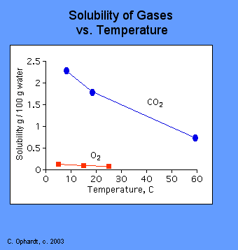

1. Kinetic energy is higher at higher temperatures allowing for more CO2 gas molecules to escape.
2. Kinetic energy is lower at higher temperatures and the CO2 gas molecules will not escape.
3. As the temperature increases the solubility of a gas increases as shown by the downward trend in the graph.
4. As the temperature decreases the solubility of a gas decreases as shown by the downward trend in the graph.

**C4.7a: Solutions**: The physical properties of a solution are determined by the concentration of solute.

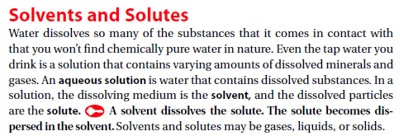

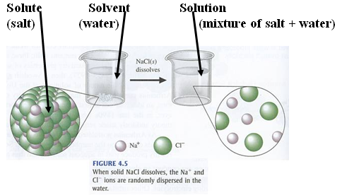

Notice how the dissolving process takes place in order to break the ionic crystal NaCl apart:

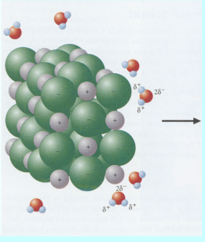 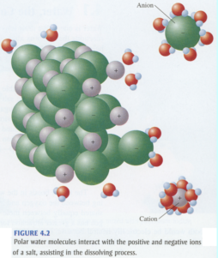

Positive ends of the water molecule surround the Cl- .Negative end of the water molecule surround Na+.

**Boiling and Freezing Points:**

Colligative Properties: <https://youtu.be/WrIg-rUmtfk>

A property that depends only upon the number of solute particles and not upon their identity is called a colligative property.



**Freezing-point depression** describes the phenomenon in which the freezing point of a liquid (a [solvent](http://en.wikipedia.org/wiki/Solvent)) is depressed when another compound is added, meaning that a [solution](http://en.wikipedia.org/wiki/Solution) has a lower freezing point than a pure [solvent](http://en.wikipedia.org/wiki/Solvent). This happens whenever a non-volatile solute is added to a pure solvent, such as water. The phenomenon may be observed in [sea water](http://en.wikipedia.org/wiki/Sea_water), which due to its salt content remains liquid at temperatures below 0°C (32°F), the freezing point of [pure water](http://en.wikipedia.org/wiki/H2O).

**Boiling Point Elevation:** Boiling point elevation occurs when the boiling point of a solution becomes higher than the boiling point of a pure solvent. The temperature at which the solvent boils is increased by adding any non-volatile solute. A common example of boiling point elevation can be observed by adding salt to water. The boiling point of the water is increased.

Boiling point elevation, like [freezing point depression](http://chemistry.about.com/od/solutionsmixtures/a/freezingpointde.htm), is a colligative property of matter. This means it depends on the number of particles present in a solution and not on the type of particles or their mass.

**Practice Skill:**

1. What is a colligative property of a solution?

2. What are three colligative properties of solutions?

3. What factor determines how much the freezing point and boiling point of a solution will differ from the freezing point and boiling point of the pure substance? (for example water vs. salt solution)

4. Would a dilute or a concentrated sodium fluoride solution have a higher boiling point? Explain.

5. An equal number of moles of KI and MgI2 are dissolved in equal volumes of water. Which solution has the lower freezing point? Explain.

6. During the winter in Michigan, a salt (potassium chloride) is put on roads to prevent icy conditions. Which statement accurately describes the reason for this practice?

1. The water does not freeze since the salt causes an increase of the freezing point of the pavement.
2. The water does not freeze since the salt causes a decrease of the freezing point of the pavement.
3. The water does not freeze since the salt causes a decrease of the freezing point of the water.
4. The water does not freeze since the salt causes an increase of the freezing point of the water.

7. Temperatures below 0oC are needed to make ice cream. Rock salt is added to ice in a hand crank ice cream maker. Explain why rock salt is added to the ice.

1. A freezing point depression occurs and the temperature of the ice-water mixture decreases a few degrees below 0oC.
2. A freezing point elevation occurs and the temperature of the ice-water mixture decreases a few degrees below 0oC.
3. The freezing point of a solution is higher than the freezing point of the pure solvent.
4. The boiling point of a solution is higher than the boiling point of the pure solvent.

**C5.4A: Heat Capacity:**

As mentioned previously on page 6, heat capacity is the amount of heat needed to increase the temperature of an object exactly 10C . Heat capacity depends on both the **size** and **chemical composition** of an object. For example, a pond has a greater heat capacity than a cup of water. Think about it this way; if you have a glass of water next to a pond and the sun is shining on both of them, which one will heat up the fastest?

 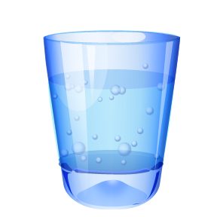 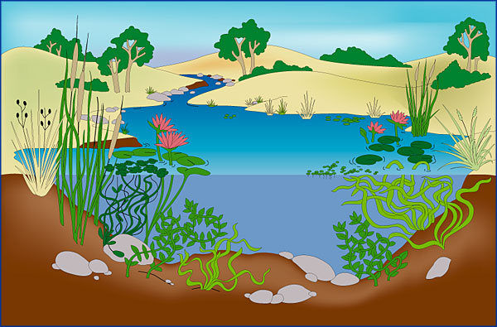

Also, if you had a cup made of wood and one of metal and the sun was shining on both of them, which one wood heat up the fastest? The metal would, because it has the lower heat capacity.

  

More energy is needed to increase the temperature of the pond water by 10C than the energy needed to increase the water in the glass by 10C because the water in the pond has a higher heat capacity than the water in the glass. It takes less energy to increase the temperature of the metal cup than it does to increase the temperature of the wooden cup because the metal cup has a lower heat capacity.

**Specific heat** capacity is the amount of energy needed to raise 1 g of an object by 10C. The higher the specific heat capacity the smaller the temperature change will be for a given quantity of heat added. Refer to table 17.1 on page 6, you can see that water has a very high specific heat compared with other substances. Metals have low specific heats in general. The same amount of heat affects the temperature of objects with a high specific heat much less than the temperature of those with a low specific heat.

Large Specific Heat Capacity of Water: <http://www.hk-phy.org/contextual/heat/tep/temch/island_e.html>

Heat Capacity of Water-Simple Experiment: <http://www.worsleyschool.net/science/files/boilwater/page.html>

Phase Diagrams: <https://youtu.be/zSwG59d8OCc>

Heating Curves: <https://youtu.be/qlizkLCSXmQ>

Heating Curves: As heat is added to a solid, the substance changes from a solid to a liquid and finally to a gas. The temperature of the substance follows a particular pattern at different points during the heating process. A graph of the temperature change versus the heat added is called a heating curve. 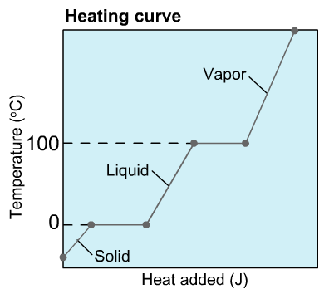As heat is added to ice its temperature will rise until it reaches 00C, at which point it will begin to melt. Even though heat continues to be supplied, the temperature will not increase as all of the energy is targeted at breaking all of the intermolecular forces of the solid state and the temperature will remain constant until all of the ice enters the liquid phase (at 00C solid and liquid coexist). Once the entire solid melts, the added heat directly increases the temperature of the water until it reaches 1000C. At this point the water begins to boil and liquid and gas coexist (temperature remains at 1000C as all of the energy is needed to break the intermolecular forces of attraction in the liquid state) until all of the liquid has been converted to gas and the temperature will begin to increase.

**Practice Skill:**

1. Look at the chart of specific heat capacities and compare the energy required to raise the temperature of one gram of aluminum and one gram of water the same number of degrees.

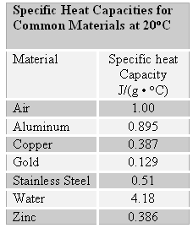

1. The lower a material’s specific heat capacity the less its temperature increases when a certain amount of heat is added. It will take more energy to raise the temperature of aluminum.
2. The higher a material’s specific heat capacity the more its temperature increases when a certain quantity of energy is added. It will take less energy to raise the temperature of aluminum.
3. The higher the specific heat capacity, the smaller the temperature change increase will be for a given quantity of added energy. It will take more energy to raise the temperature of water.
4. The higher the specific heat capacity, the smaller the temperature change increase will be for a given quantity of added energy. It will take less energy to raise the temperature of water.

2. Study the following table of specific heat capacities.

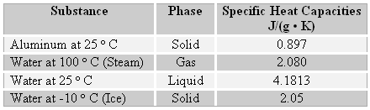

On a sunny day at 25 o C if the sun is shining on a 100 g of water and a 100 g of aluminum, which one will be the hottest?

1. The aluminum will be hotter because it has a higher heat capacity.
2. The aluminum will be hotter because it has a lower heat capacity.
3. The water will be hotter because it has a higher heat capacity.
4. The water will be hotter because it has a lower heat capacity.

3. Examine the following graph and choose the correct response

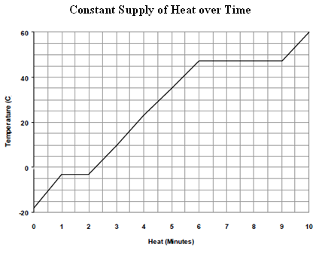

1. The boiling point of this substance is 25 o C and under normal conditions at room temperature the substance is a solid.
2. The boiling point of this substance is 47 o C and under normal conditions at room temperature the substance is a liquid.
3. The boiling point of this substance is 25 o C and under normal conditions at room temperature the substance is a gas.
4. The boiling point of this substance is 47 o C and under normal conditions at room temperature the substance is a gas.

4. The graph below shows the heating curve of a sample of water, H2O, as it is heated at a constant rate.

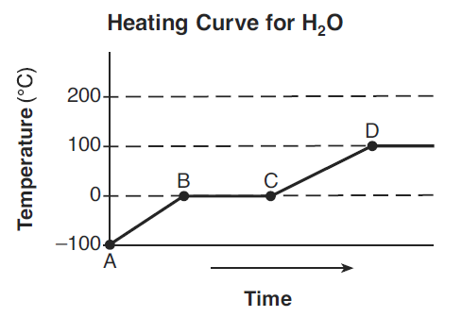

Along which line segment is the average kinetic energy of the H2O molecules increasing?

1. between B & C and C & D B. between A & B and B & C

C. between A & B and C & D D. between B & C only

5. Examine the following graph.

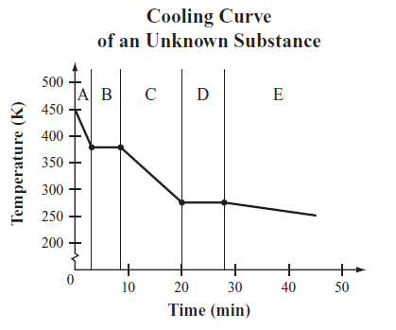

Along which line segment does the average kinetic energy for this unknown substance stay the same?

1. B and D B. A, C, and E

C. A, B, and C D. E only

6. Label **solid, liquid,** and **gas** on the following phase diagram.

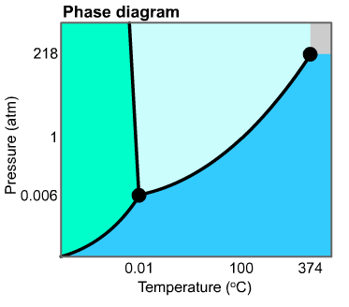

7. Label where solid & liquid coexist and where liquid & gas coexist on the following phase diagram.



8. For the following heating curve diagram label:

a. solid state

b. solid & liquid state

c. liquid state

d. liquid & gas state

e. gas state

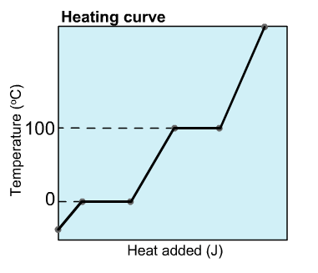

**C5.4B, C5.5e: Chemical Bonds:** Chemical bonds can be classified as ionic, covalent, and metallic. The properties of a compound depend on the types of bonds holding the atoms together. **For example, the stronger the bond the higher the melting point.**

**Network Covalent** > **Ionic** > **Metallic** > Hydrogen Bond > Dipole-Dipole > London Dispersion

**All Covalent**

Intermolecular Forces: <https://youtu.be/S8QsLUO_tgQ>

Metallic bonds have the ability to conduct electricity and heat efficiently because of free flowing valence electrons.

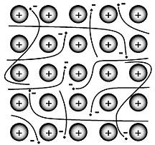 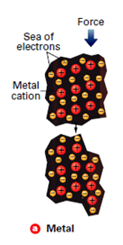

In addition this same property allows metals to be malleable and ductile. Metals are malleable, which means that they can be hammered or forced into shapes. They are ductile, which means they can be drawn into wires. A sea of drifting valence electrons insulates the metal cations from one another. When a metal is subjected to pressure, the metal cations easily slide past one another and this keeps the metal in one piece.

**Practice Skill:**

1. A scientist obtains a sample of a pure-liquid compound and records several measurements while examining the sample. Which measurement, by itself, provides the most important information regarding the structure of the molecules that make up the liquid compound?

1. boiling point B. mass

C. volume D. temperature

2. A chemist performs the same tests on two homogeneous white crystalline solids, A and B. The results are shown in the table below.

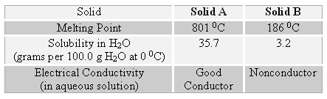

The results of these tests suggest that

A. both solids A & B are ionic and good conductors of electricity.

B. both solids A & B are covalent and poor conductors of electricity.

C. solid A is ionic & a good conductor of electricity and solid B is covalent & a poor conductor.

1. solid A is covalent & a good conductor and solid B is ionic & a poor conductor.
2. Rank the following substances in order from highest boiling point to lowest boiling point:

He, NH3, NF3, NaCl

1. Circle the substance that has the lowest boiling point.

HF, F2, FCl

5. Circle the substance that has the highest boiling point.

NaCl, F2, Cu

**References:**

Prentice Hall Chemistry Textbook 2008

<http://en.wikipedia.org/wiki/Chemical_bond>

[**http://www.wpi.edu/Academics/Depts/Chemistry/Courses/General/concept6.html**](http://www.wpi.edu/Academics/Depts/Chemistry/Courses/General/concept6.html)

**Convection & Conduction:** [**http://en.wikipedia.org/wiki/Heat_transfer**](http://en.wikipedia.org/wiki/Heat_transfer)

[**http://en.wikipedia.org/wiki/Convection**](http://en.wikipedia.org/wiki/Convection)

[www.ghaley.com/heattransfer.html](http://www.ghaley.com/heattransfer.html)

Solutions: [www.ltcconline.net/stevenson/2008CHM101Fall/C...](http://www.ltcconline.net/stevenson/2008CHM101Fall/CHM101LectureNotes20081022.htm)

Equilibrium and phases: <http://itl.chem.ufl.edu/2045_s00/lectures/lec_f.html>

<http://www.dt.uh.edu/academic/colleges/sciences/naturalscience/documents/1308Chapter14TroEquilibriumWEB.ppt>

Norton Chemistry: <http://www.wwnorton.com/college/chemistry/gilbert2/> (under choose a chapter)

Freezing Point Depression: <http://en.wikipedia.org/wiki/Freezing-point_depression>

Boiling Point Elevation: <http://chemistry.about.com/od/solutionsmixtures/a/boilingpointele.-NxZ.htm>