Name _________________________ Date _______________ Block __________
The Effects of Exercise on Cellular Respiration

C5.7C Describe tests that can be used to distinguish an acid from a base.
BACKGROUND INFORMATION http://youtu.be/UXVOVyXWQ_Y https://youtu.be/fuOMKWBDAT0
Bromothymol blue is a chemical indicator that changes color as the pH of a solution changes. It is yellow in acidic solutions and blue in basic and neutral solutions. When carbon dioxide is dissolved in water, it creates carbonic acid, pH~5.7. This reaction occurs as rainwater absorbs carbon dioxide. When else might you see examples of this occurrence?
One of the products of Cellular Respiration is carbon dioxide. As cells produce CO2 in cellular respiration, it is carried by our blood cells to our lungs where it is exhaled. You can measure the rate your cells carry out cellular respiration by measuring how quickly you produce carbon dioxide. You will first determine your resting rate of cellular respiration, and then you will determine your rate after exercise.

Pre-Lab Questions:
1. How is breathing related to cellular respiration? ________________________________________

________________________________________________________________________________

2. Hypothesize: How will exercise affect the rate of cellular respiration?
________________________________________________________________________________

________________________________________________________________________________

3. How can Bromothymol blue pH help you measure your rate of cellular respiration?
________________________________________________________________________________

________________________________________________________________________________

MATERIALS
stopwatch
drinking straw
bromothymol blue solution
2-250 mL beakers
graduated cylinder
SAFETY GOGGLES

PROCEDURE
1. Fill the beaker with 40 mL water and 10 mL Bromothymol blue solution.
2. Assign one person to be the timer, and one person to perform the experiment.
3. When the timer says “START”, the experimenter will exhale through the straw into the bromothymol
blue solution until the color changes from blue to green.

Do NOT inhale the solution! Exhale from your lungs!

4. Your partner will stop the time as soon as the color changes.
5. Record the time it took for the color change in the observation table below. This is the control group.
6. Rinse out the beaker, and refill with 40 mL water and 10 mL bromothymol blue solution.
7. Now have the experimenter do jumping jacks or a similar exercise for 1 minute. You should feel a little
winded when you are finished!
8. Using the same straw, exhale into the solution the same way as in the control group and record how
long it takes for the solution to change color.
9. Write down the time it took for the color change in the observation table below.

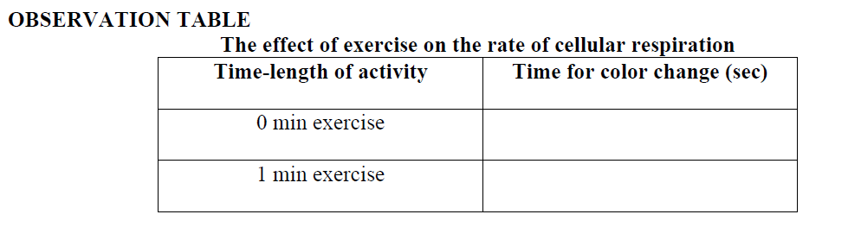

ANALYZE AND APPLY
1. Make a graph of your results. Determine if the graph should be a line graph or a bar graph. Carefully
decide which variables belong on the X axis and Y axis.
Remember to provide a title and to label the X and Y axis.

2. Compare the time it took the bromothymol blue solution to change color before exercise and after
exercise. Explain why there was a difference.
3. Using your graph, predict the time of color change if the experimenter did exercise for 2 minutes.
4. In this investigation, we measured the amount of carbon dioxide produced to find the rate of cellular
respiration. What else could we measure to find out the rate of cellular respiration?
5. Explain why it is so important to exhale completely when doing exercise.

Teacher Background
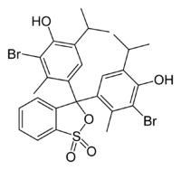
For this lab use: 15mL H₂O + 2 Drops of Bromothymol Blue (or you may experiment with a combination that works better)

