Chemistry Syllabus (school year)
(school name)
(teacher name & room number)
(email)
(phone number)
Course Description: Chemistry is a branch of science dealing with forms of energy, energy transfer & conservation, properties of matter, and changes in matter. Students will do laboratory work including inquiry, reflection, and social implications. It is necessary to have passed algebra 1 & 2 with a C or better in order to successfully complete this course.
Grading Plan
Categories & Weight  Notebook ------}  Assignments---} 60%  Labs –-----------}  Tests/Quizzes – 25%  Final Exam – 15% | Scale  A = 100 – 90%  B = 89 – 80%  C = 79 – 70%  D = 69 – 60%  E = 59 – 0% | Grades will be posted on Synergy, please make sure you have your student/parent password to view your current grade. Included in grades will be class participation, students’ ability/willingness to follow class procedures, laboratory investigations (including lab etiquette and lab journal), and participation in research/presentations.

Course Specifics:
As we strive to increase the level of rigor and prepare our students to compete and be successful in a global economy, students are expected to come to class with their notebook and pencil/pen everyday on time. In the notebook students will include their daily Objective, Do Now, Practice Skill, and Homework along with any necessary notes. Most lab work will be done in a composition notebook, if the pre-lab is not complete, the student will not be able to do the lab. All work must be handed in on time, late work will not be accepted, unless the student is absent (please let me know of any extenuating circumstances). For each day a student is absent, the student has that many days to complete the assignment(s), this is not to exceed 5 days. Makeup tests/quizzes must be taken before or after school, no exceptions.

Attendance/Tardy Policy per Semester: (For detailed information refer to student handbook.)
An absence is arrival to class after the first 20 minutes of the class period or failure to remain in class for at least 30 minutes unless a valid pass is provided by the principal, an assistant principal, counselor, or a teacher. Any student reaching 15 non-excused absences will have their grade lowered by 1 letter grade. Illnesses will be excused only with a physician’s note. A maximum of 3 days will be excused with an obituary note for the death of an immediate family member (parent, sibling, and grandparent).

Students must be in the classroom and in their seat when the tardy bell rings. A valid pass can only be provided by the principal, an assistant principal, counselor, or a teacher in order for a tardy to be excused.
3rd Tardy = Referral
4th Tardy = 1 absence with classes closed pending parent conference
5th-7th Tardy = Referral
8th Tardy = 1 absence with classes closed pending parent conference

Classroom
Procedures  We will listen while teacher or a student is explaining/discussing  We will not eat/drink in class  We will not write on desks  We will not use cell phones – unless part of class assignment  We will not bring jackets/coats to class  We will follow Dress Code as Outlined by the District  We will not use profanity as it is not professional to do so  As soon as you arrive, begin to write in your notebook | Consequences – may include the following, not necessarily in the order given;  Parent/Guardian contact  Behavior Specialist Referral  After school detention in room ______  Principal Referral

Course Topics/Units and Approximate Pacing Guide
SEMESTER ONE | NGSS | SEMESTER TWO | NGSS
Inquiry, Reflection, and Social Implication--all months  C1.1 Scientific Inquiry  C1.2 Scientific Reflection and Social Implications  Scientific Method----------------------------------Sept  Metric Measurement  Scientific Notation  Significant Digits  Unit 1 - Atomic Theory: Physical, chemical and nuclear changes are explained using the location and properties of subatomic particles.  C3.5(a) Mass defect  C4.8 (A, B, C) Atomic Structure  C4.10 (A, B, C, e) Neutral Atom, Ions, and Isotopes | HS-PS1-8  HS-PS1-1 | Unit 7 – States of Matter---------------------Feb  States of matter can be explained by attraction between particles under various conditions of temperature and pressure.  C2.2 (A, B) Molecules in Motion  C2.2 (c) Molecular Entropy  C3.3 (A, B) Heating Impacts  C4.3 (A, B) Properties of Substances  C4.5 (a, b, c) Ideal Gas Law | HS-PS3-2  HS-PS3-2  HS-PS3-2
Unit 2 - Periodic Table ----------------------------Oct  The periodic table organizes all known elements and provides useful information for making predictions in chemistry.  C4.9(A, b) Periodic Table  C5.2(g) Balancing Equations  C5.5(A, B, d) Chemical Bonds | HS-PS1-1  HS-PS1-7  HS-PS1-2  HS-PS2-6 | Unit 8 – Advanced-----------------------------Mar  Bonding Concepts: Many physical properties of substances can be determined by knowing the type of intermolecular forces that exists between particles.  C4.3(c, d, f, g) Solids  C5.4 (c, d, e) Changes of State | HS-PS3-2
Unit 3 - Quantum Mechanics-------------------Nov  Quantum theory provides a foundation for the atomic model and understanding of electron behavior and arrangement.  C2.4 (a, c, d) Electron Movement  C4.8 (e, f, g, h, ,i) Electron Configuration  Unit 4 – Introduction to Bonding: Attractions between atoms increase their stability.  C2.1(a) Chemical Potential Energy  C3.2 (b, c) Enthalpy Chemical Reactions  C4.4 (a, b) Molecular Polarity  C5.8 (A, B, C) Carbon Chemistry | HS-PS4-1  HS-PS3-5  HS-PS1-1  HS-PS3-5  HS-PS1-3  HS-PS2-6 | Unit 9 – Thermochemistry ------------------Apr  and Solutions: The flow of energy, measured by temperature, influences the behavior of matter.  C3.1 (c, d) Hess’s Law  C5.4 (A, B) Phase/Change Diagrams  Unit 10 – Acid/Base: Hydrogen ion concentration determines pH of the solution which allows its classification as acidic, basic, or neutral.  C5.7 (A, B, C, D, E) Acids and Bases  C5.7 (g, h) Bronsted-Lowry | HS-PS3-4  HS-PS1-4  HS-PS3-1
Unit 5 – Nomenclature and Formula----------Dec  Stoichiometry: Elements form compounds in predictable ratios that can be named systematically.  C4.1 (a) Molecular Formulae  C4.2 (A, B, c, d) Nomenclature  C4.6 (a, b) Moles | HS-PS1-7 | Unit 11 – Redox/Equilibrium---------------May  Electron transfers impacts humans in both positive and negative ways. In a closed system, reversible reactions achieve equilibrium which is dependent on pressure, temperature and concentration conditions.  C5.3 (a, b) Equilibrium  C5.6 (c, e) Reduction/Oxidation Reactions | HS-PS1-6
Unit 6 – Equations and Stoichiometry---------Jan  Chemical reactions are described by balanced chemical equations which obey the Law of Conservation of Mass.  C3.4 (A) Endothermic and Exothermic Reactions  C3.4 (c) Enthalpy and Entropy  C5.2 (A, B) Chemical Changes  C5.2 (d) Balancing Equations  C5.6 (b) Reduction/Oxidation Reactions | HS-PS1-4  HS-PS3-5  HS-PS1-7  HS-PS1-2 | Unit 12 – Thermodynamics------------------Jun  The spontaneity of a reaction is determined by the change in Gibbs free Energy which is dependent on temperature and the changes in enthalpy and entropy.  C3.1 (a, b) Hess’s Law  C3.2a Enthalpy  C3.4B Endothermic and Exothermic Reactions  C3.4d Enthalpy and Entropy | HS-PS1-4  HS-PS1-5

Laptop Cart Procedure

DISTRIBUTION OF THE LAPTOPS AND THEIR PROPER RETURN TO THE CART:
1. (teacher name) will assign a laptop to the student(s). Students will be required to sign-out the laptop and sign it back in when finished.

2. If a laptop is damaged, please contact (teacher name) immediately. If not, it will be assumed as your damage. Do not use a damaged laptop.

3. If a laptop will not logon to the network, tell (teacher name), then, restart the laptop. Make sure the wireless switch on the laptop is turned on. The “Wi-Fi” indicator on the laptop will be lit if the switch is on. If the restart did not cure the issue, let (teacher name) know.

4. Never download any games or music or plug anything other than the USB flash drive into the laptop. Failure to follow these procedures will result in future laptop problems.

5. When you are finished with the laptop, make sure you logoff and SHUT DOWN the laptop. Laptops that are not SHUT DOWN properly can result in future problems. The laptop should be completely off before it is placed back on the cart.

6. Please make sure each laptop is properly returned to the correct shelf on the cart.

Chemistry Syllabus (school year)
(school name)
(teacher & room number)
(email)
(phone number)

Chemistry Syllabus (school year)
(school name)
(teacher & room number)
(email)
(phone number)
All students are required to return this form!

________________________________________
Print Student’s Full Name

Parent/Guardian’s Name: _________________________________________

Home Phone: __________________________________________________

Cell Phone: ____________________________________________________

E-mail Address: ________________________________________________

Please read the entire syllabus, sign and return.

I have read and understand the classroom and laptop rules and know what is expected.

____________________________________________________________
Parent Signature

____________________________________________________________
Student Signature

Date Signed: ________________

Any comments the instructor should know:

__________________________________________________________________________________________

__________________________________________________________________________________________

__________________________________________________________________________________________

__________________________________________________________________________________________

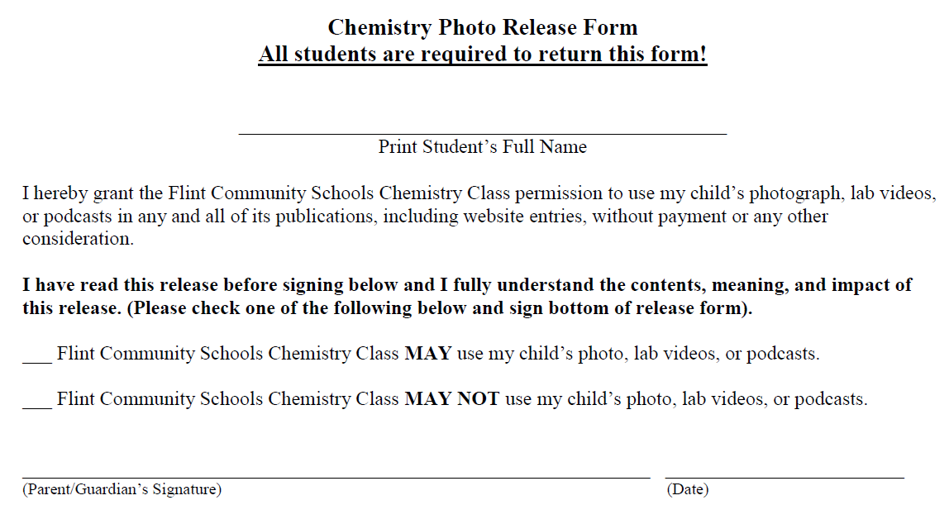

Chemistry Syllabus (school year)
(school name)
(teacher & room number)
(email)
(phone number)

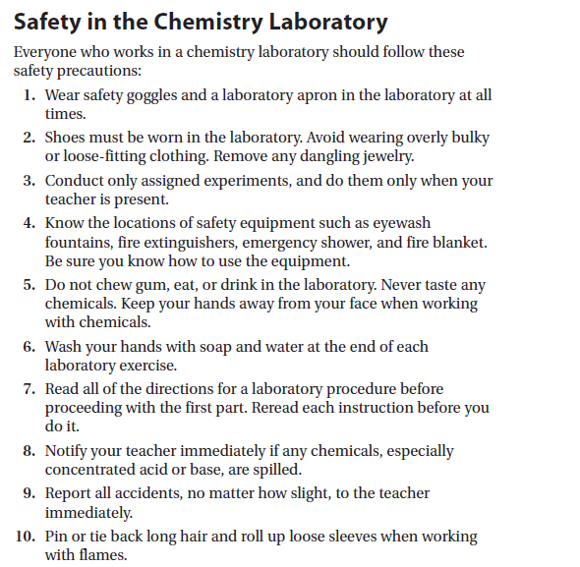
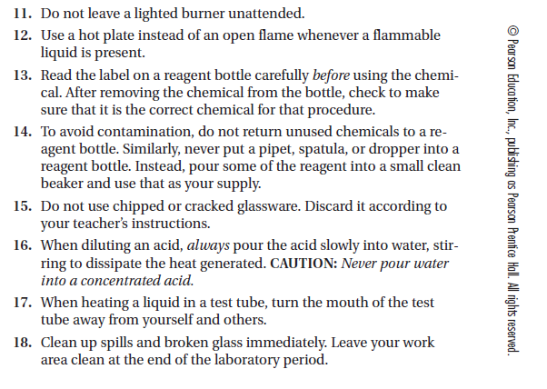

HCS (Hazard Communication Standard) Pictograms & Hazards
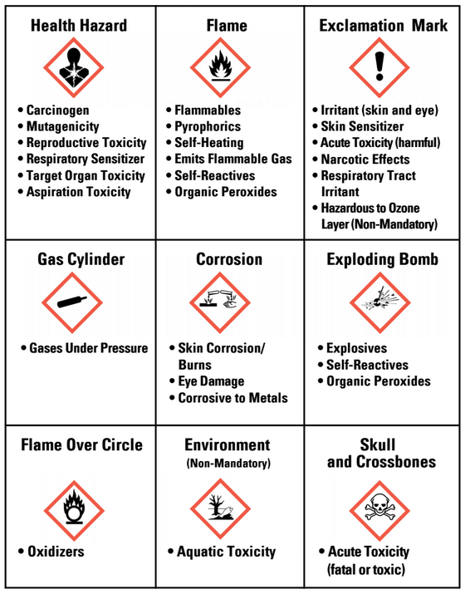
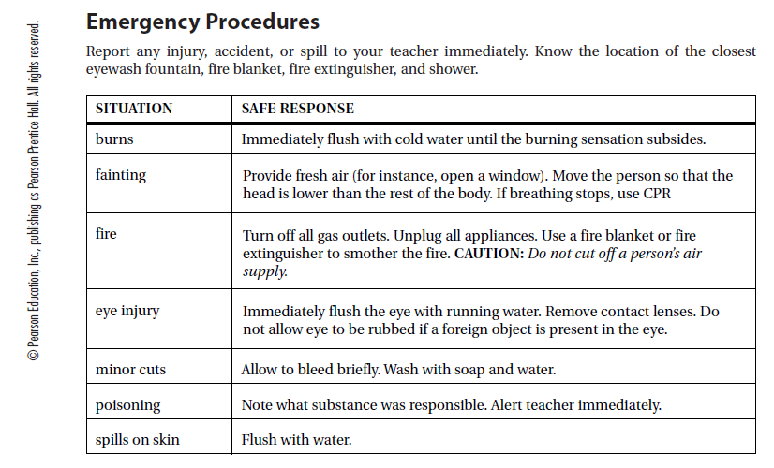

Safety Contract (school year)
(school name)
(teacher name & room number)
(email)
(phone number)

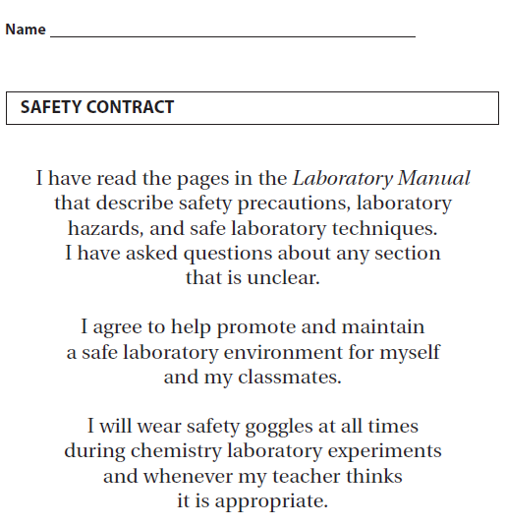

Student Name ___________________________________________________

Student Signature_________________________________________________

Parent/Guardian Signature _________________________________________

Date ___________________________________________________________

