Code | Unit 8 – Advanced Bonding Concepts  Content Expectation | Textbook Reference
C4.3x | Solids Solids can be classified as metallic, ionic, covalent, or network covalent. These different types of solids have different properties that depend on the particles and forces found in the solid.
C4.3c | Compare the relative strengths of forces between molecules based on the melting point and boiling point of the substances. | Section(s) 14.14,15.5  Page(s) 343,353
C4.3d | Compare the strength of the forces of attraction between molecules of different elements. (For example, at room temperature, chlorine is a gas and iodine is a solid.) | Section(s) 14.3  Page(s) 340
C4.3e | Predict whether the forces of attraction in a solid are primarily metallic, covalent, network covalent, or ionic based upon the elements’ location on the periodic table. | Section(s) 13.4,13.6,14.1-14.3  Page(s) 304,309,317-320,274  & Teacher Supplement
C4.3f | Identify the elements necessary for hydrogen bonding (N, O, F). | Section(s) 14.3  Page(s) 340
C4.3g | Given the structural formula of a compound, indicate all the intermolecular forces present (dispersion, dipolar, hydrogen bonding). | Section(s) 14.10,14.13  Page(s) 335,340
C4.3h | Explain properties of various solids such as malleability, conductivity, and melting point in terms of the solid’s structure and bonding. | Section(s) 5.1-5.3  Page(s) 85-89
C4.3i | Explain why ionic solids have higher melting points than covalent solids. (For example, NaF has a melting point of 995°C while water has a melting point of 0° C.) | Section(s) 5.4,14.14, Table 5-1  Page(s) 89,343,91  & Teacher Supplement
C5.4x | Changes of State All changes of state require energy. Changes in state that require energy involve breaking forces holding the particles together. The amount of energy will depend on the type of forces.
C5.4c | Explain why both the melting point and boiling points for water are significantly higher than other small molecules of comparable mass (e.g., ammonia and methane). | Section(s) 14.13  Page(s) 341
C5.4d | Explain why freezing is an exothermic change of state. | Section(s) 8.7,9.9  Page(s) 185,213  & Teacher Supplement
C5.4e | Compare the melting point of covalent compounds based on the strength of IMFs (intermolecular forces). | Section(s) 14.13,14.14  Page(s) 340,343

Vocabulary
Atomic weight  Boiling point  Chemical bond  Dipole-dipole bond  Dispersion forces  Endothermic process  Exothermic process  Hydrogen bonding | Ion  Ionic solid (crystal)  Melting point  Metal  Network solid  Relative mass  Release of energy  Temporary dipole
Why do different substances have different melting and boiling points? A melting point is the temperature at which a solid becomes a liquid and a boiling point is the temperature at which a liquid becomes a gas. Intermolecular forces are the forces of attraction between elements or compounds. The stronger the intermolecular forces of attraction are between the elements or compounds the higher the melting or boiling points have to be. The higher the melting or boiling point, the higher the energy input must be to bring these substances to the liquid or gas state.

There are three types of strong bonds and three types of weak bonds: The three strong bonds are network covalent bonds, ionic bonds and metallic bonds. The three types of weak bonds are van der Waals forces of attraction (all covalent bonds); hydrogen bonding, dipole-dipole forces, and London dispersion forces.

Melting points and boiling points between members of the same group of family: Taking a look at group 7, the halogens, F₂ and Cl₂ attract each other mainly by means of London dispersion forces. Fluorine and chlorine have relatively few electrons and are therefore gases at ordinary room temperature and pressure because of their especially weak London dispersion forces. The larger number of electrons in bromine generates stronger London dispersion forces. Bromine molecules therefore attract each other sufficiently to make bromine a liquid at ordinary room temperature and pressure. Iodine has an even larger number of electrons so it is a solid at room temperature and pressure because it has the strongest London dispersion forces between its molecules.

Recall that metals are located on the left side of the ‘stair case’ and nonmetals are located to the right of the ‘stair case’. A metallic bond exists between metal elements, an ionic bond between a metal and a nonmetal, and a covalent bond between a nonmetal and a nonmetal. In any bond formed there is a movement of valence electrons.
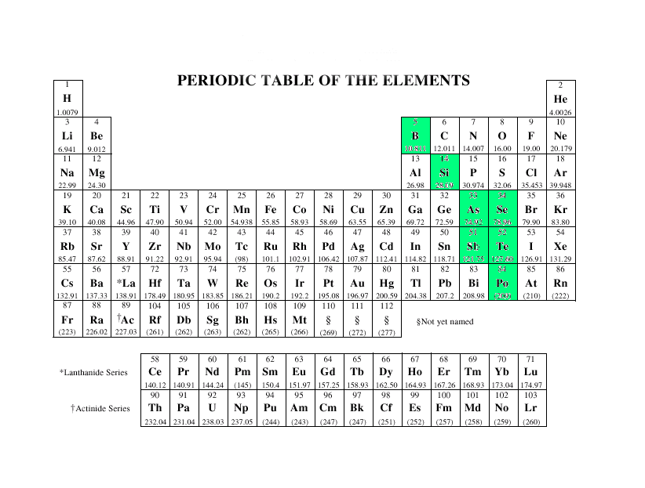
Oder of bonding from strongest to weakest of intermolecular forces of attraction between elements or compounds of different types of bonding is shown below:
Network Covalent > Ionic > Metallic > Hydrogen Bond > Dipole-Dipole > London Dispersion

All Covalent

Type of Force | Examples | Order of Melting and Boiling Points
Network Covalent Bonds | Covalently bonded atoms in a lattice structure: Diamonds (tetrahedral C network), Quartz –SiO₂, Silicon Carbide- SiC:  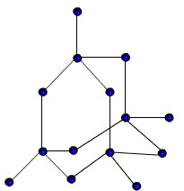 | Decreasing Melting Point & Boiling Point
Ionic Bonds | Ionic bonds in a lattice structure, between a metal and a nonmetal: NaCl, MgO, LiF:  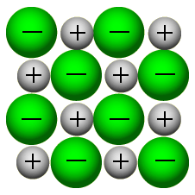
Metallic Bonds | Bonds between metal elements: Mg, Cu, Fe:  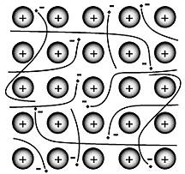
Hydrogen Bonding  (covalent bonds) | H from one molecule attracted to F, O, or N of another molecule:  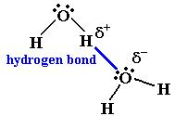
Dipole-Dipole Forces  (covalent bonds) | Forces between neutral polar molecules where the positive end of one molecule is attracted to the negative end of the other:  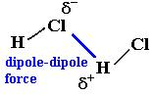
London Dispersion Forces  (covalent bonds) | Forces between neutral non-polar molecules. Molecules can have induced temporary dipoles due to random movement of electrons and the induced positive end of one molecule will be attracted to the induced negative end of the other molecule:  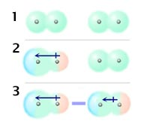

Structure of Metals and Nonmetals: http://preparatorychemistry.com/Bishop_Molecules.htm
Predicting Relative Boiling Points: http://preparatorychemistry.com/Bishop_attraction_strengths.htm

Water and Hydrogen Bonding:
20 Sec Story of Hydrogen Bonding: http://www.youtube.com/watch?v=LGwyBeuVjhU
The hydrogen bond is really a special case of dipole forces. A hydrogen bond is the attractive force between the hydrogen attached to an electronegative atom of one molecule and an electronegative atom of a different molecule. Usually the electronegative atom is oxygen, nitrogen, or fluorine, which has a partial negative charge. The hydrogen then has the partial positive charge. 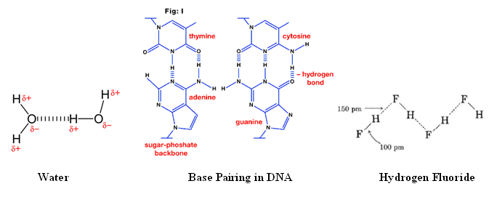
Practice Skill:
- The table below shows the boiling points of butane, a common fuel used in disposable lighters, and water.
Compound | Boiling Point
Butane | - 0.5 ⁰ C
Water | 100.0 ⁰ C

Based on these boiling points, which statement about the forces in these molecules is correct?

- Butane has stronger ionic bonds than water.

- Water has stronger ionic bonds than butane.

- Butane has stronger intermolecular forces than water.

- Water has stronger intermolecular forces than butane.

- The hydrocarbons in the table below are all liquids at room temperature. Compare the relative strengths of the forces between these molecules.

Name | Molecular Formula | Melting Point (⁰ C) | Boiling Point (⁰ C)
Pentane | C₅H₁₂ | -130 | 36
Hexane | C₆H₁₄ | -95 | 69
Heptane | C₇H₁₆ | -91 | 98
Octane | C₈H₁₈ | -57 | 125

Of these molecules:

- Octane has the highest intermolecular forces.

- Octane has the lowest intermolecular forces.

- Hexane has the highest intermolecular forces.

- Hexane has the lowest intermolecular forces.

- Which statement best explains why chlorine is a gas at room temperature and iodine is a solid at room temperature?

  - Chlorine has stronger dispersion forces than iodine.

  - Iodine has stronger dispersion forces than chlorine.

  - Chlorine has stronger covalent bonds than iodine.

  - Iodine has stronger ionic bonds than chlorine.

- Observe the following table and explain why at room temperature different compounds can exist in different phases.
Name | Formula | State of Matter
Methane | CH₄ | Gas
Octane | C₈H₁₈ | Liquid
Triacontane | C₃₀H₆₂ | Solid

Of the molecules depicted:

- Methane is a gas because it has the strongest intermolecular forces.

- Octane is a liquid because it has the weakest intermolecular forces.

- Triacontane is a solid because it has the strongest intermolecular forces.

- It is impossible to distinguish based upon composition of the molecules their intermolecular forces.
- Refer to the following diagram and predict whether the forces of attraction in a solid substance composed purely of a d-block element are primarily metallic, covalent, or ionic.
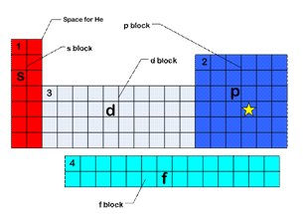
  - Ionic B. Metallic

C. Non-polar covalent D. Polar covalent

- In the following diagram a bond between an s-block element and a p-block element would be primarily:
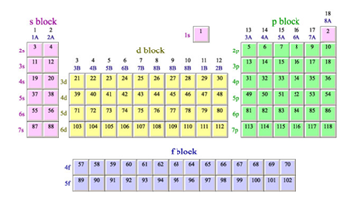
  - Ionic B. Metallic

C. Non-polar covalent D. Polar covalent

- Refer to the following diagram, a compound formed between carbon and a halogen would be primarily:

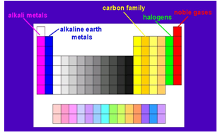
  - Covalent B. Ionic

C. Metallic D. Not enough information given.

- Which elements within a molecule containing hydrogen allow for the formation of hydrogen bonds?

  - C, S, and O B. C, U, and N

- F, O, and N D. F, N, and P

9. In the diagram below, identify the elements necessary for hydrogen bonding between the DNA bases.
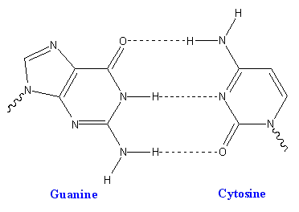

- P and C B. O and N

C.C and N D. S and C

10. Identify the type of intermolecular force that exists between water molecules.
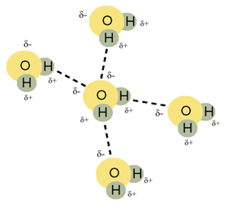
- dispersion force B. ionic bonding

- C. covalent bonding D. hydrogen bonding

11. Look at the following structures and identify which one has all of the following intermolecular forces present (dispersion, dipolar, hydrogen bonding).

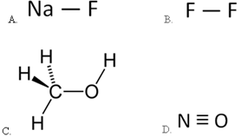

Properties of Solids:
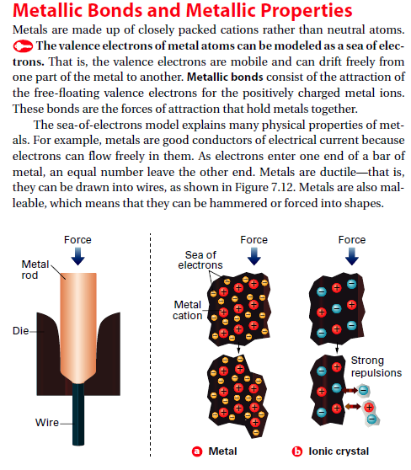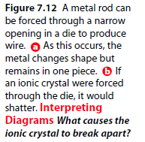
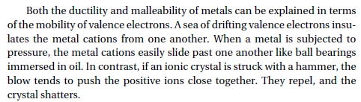
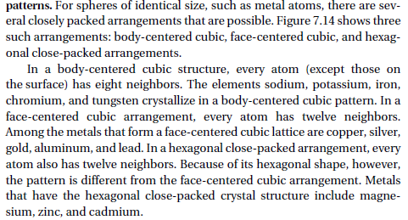
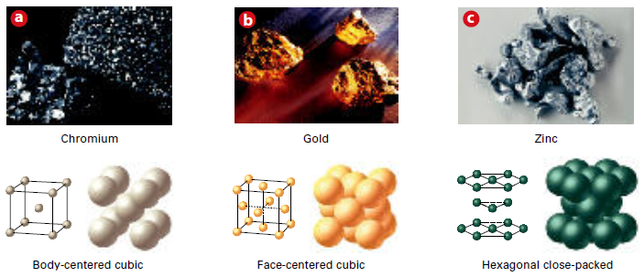
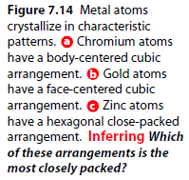
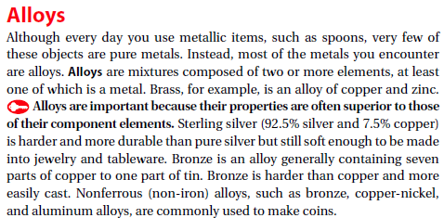

Melting Points of Ionic Solids vs. Covalent Compounds
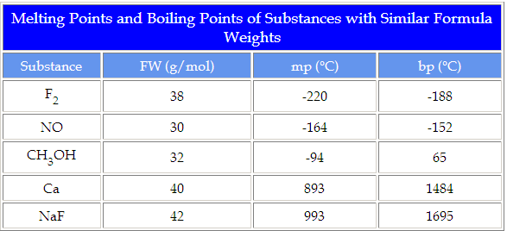
All the substances in this table have similar formula weights thus they have similar London dispersion forces. If the only attractions between substances have to do with size, then they should have similar melting points and boiling points. They do not. Let us look more closely at the nature of the substance to see if we can relate the structure of the material with its properties.
Fluorine and Nitrogen Monoxide
Fluorine and nitrogen monoxide are similar in size and thus have similar London forces. Fluorine is a non-polar covalent molecule while nitrogen monoxide is a polar covalent molecule - it has a positive and a negative end, like a magnet. Since nitrogen monoxide has the higher melting point and boiling point, it must have the stronger intermolecular forces. Given the same size, polar covalent molecules must have stronger forces of attraction than non-polar covalent molecules. These forces of attractions are called dipole-dipole forces.
Nitrogen Monoxide and Methanol
Nitrogen monoxide and methanol are similar in size and thus have similar London forces. Nitrogen monoxide and methanol are polar covalent molecules and thus have dipole-dipole forces. Since methanol has the higher melting point and boiling point, it must have the stronger intermolecular forces. The difference in these molecules is the presence of a certain extremely polar bond present in methanol that is not present in nitrogen monoxide. This is the oxygen - hydrogen bond.
Oxygen is more electronegative than hydrogen and pulls the electron density in the oxygen - hydrogen bond towards it. This leaves very little electron density around the hydrogen since hydrogen has no core electrons. The part of hydrogen directed away from the oxygen - hydrogen bond has very little electron density shielding the nucleus. Thus that part of the hydrogen nucleus which is exposed can interact with the non-bonding electrons on another methanol molecule. This interaction of a non-bonding pair with hydrogen attached to an electronegative element such as oxygen is called a hydrogen bond.
Calcium and Sodium Fluoride
A large jump in melting points and boiling points is observed when we turn from covalent compounds to metals and ionic compounds. Both metals and ionic compounds involve the interaction of particles with full charges.
- Metals. Metal ions interact with the sea of electrons that surround them. This attraction must be very strong as the melting point and boiling point of calcium is much higher than the covalent compounds which share a similar formula weight.
- Ionic Compounds. Substances which bear full charges, anions and cations, are attracted very strongly as evidenced by the melting point and boiling point of sodium fluoride.
Polar covalent molecules have stronger intermolecular forces than non polar covalent molecules, making NO have a higher boiling point than F₂. Both NO and CH₃OH have dipole-dipole forces but CH₃OH has an additionally strong force, the hydrogen bond, making it have the highest boiling point of the three represented

Practice Skill:
1. How can you describe the arrangement of atoms in metals?

2. Why are alloys more useful than pure metals?

3. Describe what is meant by ductile and malleable.

4. Why is it possible to bend metals but not ionic crystals?

5. An engineer needs a metallic substance that is malleable. Which statement describes this property?
- This property enables a substance to conduct an electric current.

- This property enables a substance to be pulled into a thin wire.

- This property makes a substance very hard and brittle.

- This property enables a substance to be shaped into a pliable, flat sheet.

6. The reason that iron can conduct electricity is because it
- can be flattened into sheets

- combines with oxygen to form rust

- has highly mobile electrons in its valence shell

- can be drawn into a wire

7. Explain why water has a lower melting point than sodium chloride.
- Water is a covalent compound and sodium chloride is an ionic compound. Ionic compounds have the strongest intermolecular forces of attraction because they have higher electronegativity differences.

- Water is an ionic compound and sodium chloride is a covalent compound. Covalent compounds have the strongest intermolecular forces of attraction because they have higher electronegativity differences.

- Water is a covalent compound and sodium chloride is an ionic compound. Ionic compounds have the strongest intermolecular forces of attraction because they have lower electronegativity differences.

- Water is an ionic compound and sodium chloride is a covalent compound. Covalent compounds have the strongest intermolecular forces of attraction because they have lower electronegativity differences.
8. Sodium fluoride has a melting point of 995 ⁰C while water has a melting point of 0 ⁰C. Why is the melting point of sodium fluoride so much higher than the melting point of water?

- The radioactivity of NaF is higher than that of H₂O.

- The molecular weight of NaF is hither than that of H₂O.

- The forces between the atoms of each molecule are stronger for H₂O than for NaF.

- The forces between the ions of NaF are stronger than the forces between the molecules of H₂O.
Changes of State: Intermolecular forces are the forces of attractions that exist between molecules in a compound. These cause the compound to exist in a certain state of matter: solid, liquid, or gas; and affect the melting and boiling points of compounds as well as the solubilities of one substance in another.
The stronger the attractions between particles (molecules or ions), the more difficult it will be to separate the particles. When substances melt, the particles are still close to one another but the forces of attraction that held the particles rigidly together in the solid state have been sufficiently overcome to allow the particles to move. When substances boil, the particles are completely separated from one another and the attractions between molecules are completely overcome. The energy required to cause substances to melt and to boil, and thus disrupt the forces of attraction, comes from the environment surrounding the material. If you place a piece of ice in your hand, the ice will melt more quickly than if it is placed on a cold counter top. The energy required to melt the ice comes from your hand, your hand gets colder and the ice gets warmer.

Chemistry of Water: http://witcombe.sbc.edu/water/chemistryproperties.html
Ice Floats-The solid state of most things are much denser than the liquid state and therefore sink. Usually what happens when a solid is formed is that the molecules become more tightly packed together. When things melt, the molecules move apart and get liquid. But water is weird - the solid state is less dense than the liquid. To understand why, we'll have to take a close-up look at the molecular arrangement of solid water (ice) and liquid water. Look at the following and compare the boiling points:

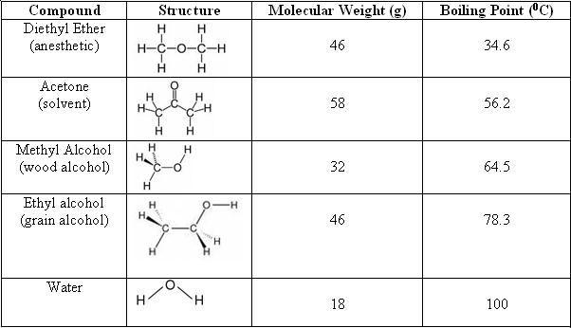
Water is way out of line! It boils at an extremely high temperature for its size. Why? It is because of the extensive network of Hydrogen bonds. Those H-bonds are cohesive forces - they want to hold the water molecules together - and there are a lot of them! The process of boiling requires that the molecules come apart: a process that takes a lot more energy than expected. The freezing point is much higher than expected again because of the hydrogen bonding. To get the water molecules to undergo the transition from liquid to solid is relatively easy. Liquid water has only 15 percent more H-bonds than solid water. If water were "normal", it would be a gas at room temperature. That would mean; no lakes, no rain, no body fluids!

Why is the freezing of water an exothermic process? http://www.chemcool.com/regents/physicalbehaviorofmatter/aim10.htm
Many chemical and physical changes do not involve a change in temperature (kinetic energy); instead, they involve a change in potential energy. For example, the molecules in liquid water release energy at 0°C and continue to release energy until all of the liquid water is transformed into ice at 0°C. The change doesn't involve a change in temperature - the kinetic energy of the molecules is unchanged. Instead, the molecules undergo a decrease in potential energy - a change in their relative positions.
During phase changes, intermolecular forces of attraction are either formed or broken. For example, evaporating water involves breaking various intermolecular forces of attraction between the water molecules. When water vapor condenses, intermolecular forces form producing liquid water. During freezing stronger intermolecular forces of attraction are formed. Remember that bond breaking is an endothermic process (it requires the absorption of energy) and bond formation is an exothermic process (it requires the release of energy). Therefore when water freezes it is an exothermic process because stronger intermolecular forces form releasing energy into the surroundings.

Comparing the Melting Points of Covalent Compounds:
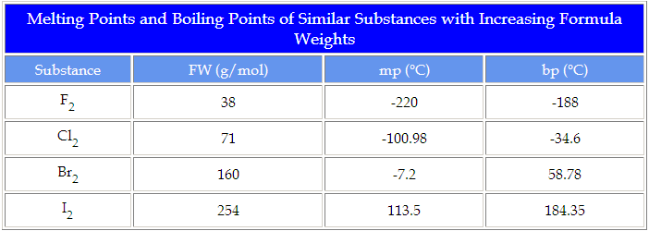

As the size of the halogens increases, the melting and boiling points increase. The energy required to move and separate the molecules from one another increases as the size of the molecules increases. If it takes more energy to separate the molecules, the attractions between molecules must be greater. The types of intermolecular forces responsible for the increase in melting points and boiling points of these non-polar covalent compounds are called London forces or dispersion forces. The larger the molecule, the greater the number of electrons available to create a temporary dipole are, and thus results in a stronger force of attraction leading to a higher melting or boiling point.

Practice Skill:
1. Water has a much higher boiling point than methane (CH₄). Which statement best explains why water’s boiling point is higher than methane’s?

  - There is hydrogen bonding between water molecules, but not between methane molecules.

  - There is covalent bonding between water molecules, but not between methane molecules.

  - Methane has ore hydrogen atoms per molecule than water.

  - Water has a higher molecular weight than methane.

2. Examine the following graph:
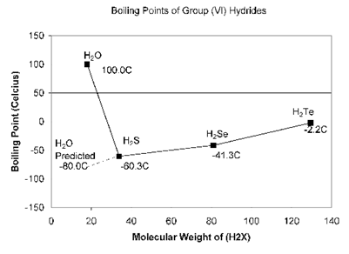
In comparison to other group 6 hydrides explain why water has a much higher boiling point than predicted.

- H₂O boils at a higher temperature because it has the highest molecular weight among hydrides.

- H₂O boils at a higher temperature because of its strong intermolecular forces known as hydrogen bonds.

- H₂O boils at a higher temperature because it has a lower molecular weight than H₂S or H₂Se.

- H₂O boils at a lower temperature because of its strong intermolecular forces known as hydrogen bonds.

3. Explain why the freezing of water is an exothermic change.

- As water freezes heat must be added.

- As water freezes heat is given off.

- As the water freezes there is no change in the amount of heat content.

- As water freezes limited changes of state take place resulting in heat exchange.

4. A change of state involves a solid meting or a liquid freezing. Explain what happens when a liquid freezes.

- Heat must be continually removed from the liquid in order for the molecules to slow down and freeze. This is known as an exothermic process.

- Heat must be continually removed from the liquid in order for the molecules to slow down and freeze. This is known as an endothermic process.

- Heat must be continually added to the liquid in order for the molecules to speed up and freeze. This is known as an exothermic process.

- Heat must be continually added to the liquid in order for the molecules to speed up and freeze. This is known as an endothermic process.

5. Which statement correctly describes why the freezing of water is an exothermic reaction?

- Water molecules speed up and lose kinetic energy.

- Water molecules speed up and gain kinetic energy.

- Water molecules slow down and lose kinetic energy.

- Water molecules slow down and gain kinetic energy.

6. Which of these lists shows substances in order of increasing melting point?

- H₂O, SO₂, O₂, Ca(OH)₂

- O₂, SO₂, H₂O, Ca(OH)₂

- H₂O, Ca(OH)₂, SO₂, O₂

- Ca(OH)₂, SO₂, H₂O, O₂

7. All substances in this table have similar formula weights.

Substance | g/mol | Boiling Point ( ⁰ C)
F₂ | 38 | -188
NO | 30 | -152
CH₃OH | 32 | 65

If the only forces of attraction between these substances have to do with size then they should all have similar melting points. Explain why they do not have similar melting points.

- Polar covalent molecules have stronger intermolecular forces than non polar covalent molecules, making F₂ have a higher boiling point than NO. Both NO and CH₃OH have dipole-dipole forces but CH₃OH has an additionally strong force, the hydrogen bond, making it have the highest boiling point of the three represented.

- Polar covalent molecules have weaker intermolecular forces than non polar covalent molecules, making NO have a lower boiling point than F₂. Both NO and CH₃OH have dipole-dipole forces but CH₃OH has an additionally strong force, the hydrogen bond, making it have the highest boiling point of the three represented.

- CH₃OH has more atoms in the molecule making for stronger London forces causing a higher boiling point.

- Polar covalent molecules have stronger intermolecular forces than non polar covalent molecules, making NO have a higher boiling point than F₂. Both NO and CH₃OH have dipole-dipole forces but CH₃OH has an additionally strong force, the hydrogen bond, making it have the highest boiling point of the three represented.

- Indicate which of the following will have a higher melting point and give an explanation for your choice.

F₂, Cl₂, Br₂, I₂

_________________________________________________________________________________________
_________________________________________________________________________________________
_________________________________________________________________________________________

References:
http://cost.georgiasouthern.edu/chemistry/general/molecule/forces.htm
http://witcombe.sbc.edu/water/chemistryproperties.html
http://www.cdli.ca/courses/chem3202/unit03_org02_ilo01/b_activity.html

