Introducing Measurements in the Laboratory

Objectives

The objectives of this laboratory are:
a) To use a metric ruler to measure the dimensions of regular geometric shapes, and to use these measurements to
determine the areas of the shapes.
b) To measure the volume of a sample of water using a graduated cylinder and a beaker in order to compare their
precision.
c) To measure the mass of an item using a triple-beam balance and an analytical (electronic) balance in order to
compare their precision; also, to determine the mass of a powder by weighing by difference.

Background
Our knowledge of chemistry and chemical processes largely depends on our ability to obtain correct information about matter. Often this information is quantitative, in the form of measurements. In this lab, students will be introduced to some common measuring instruments so that they can practice making measurements, and to learn about instrument precision. In Part A of this lab, a metric ruler will be used to measure length in centimeters (cm). In Part B, a beaker and a graduated cylinder will be used to measure liquid volume in milliliters (mL). In Part C, an electronic balance and a triple-beam balance will be used to measure mass in grams (g).

Since all measuring devices are subject to some error, it is impossible to make exact measurements. Scientists record all the digits of a measurement that are known exactly, plus the first one that is uncertain. These digits are collectively referred to as significant digits. Digital instruments, such as an electronic balance, are designed to limit themselves to the correct number of significant digits, and their readings are properly recorded as given. However, when using analog instruments such as rulers and thermometers, the experimentalist is responsible for determining the correct number of significant figures. These instruments are properly read to one place beyond the graduations of the scale.

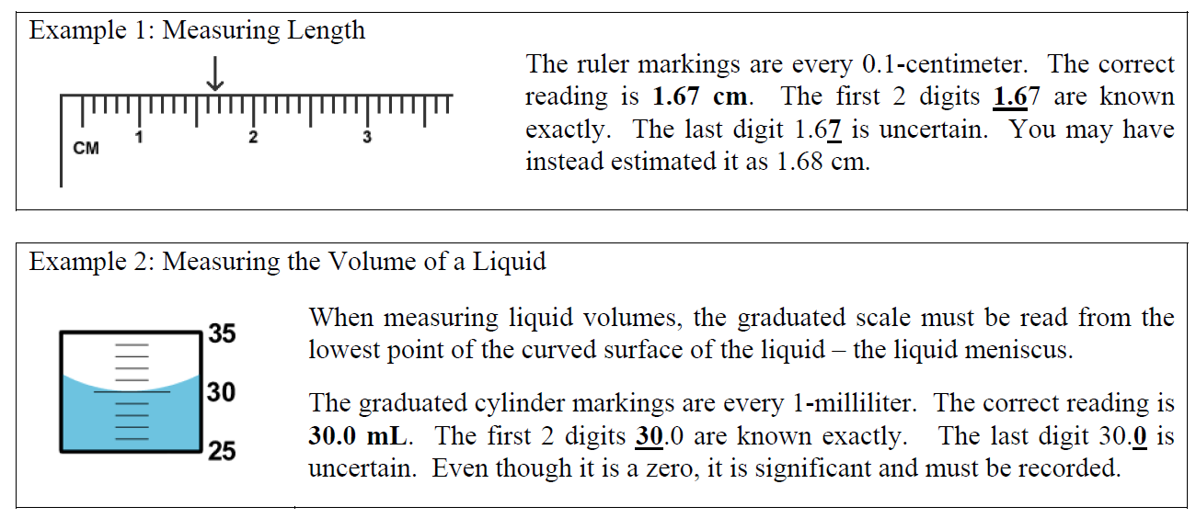
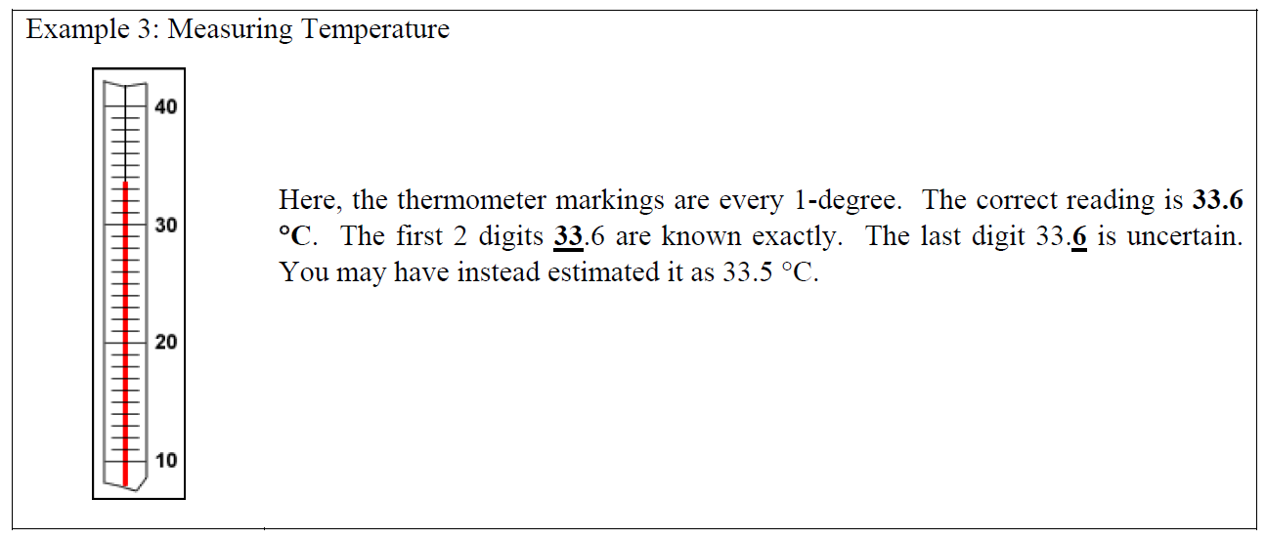
Note that the measuring devices used in this lab may have different scale graduations than the ones shown in these examples. Thus, be sure to make it a regular habit to check the scales on all equipment.

When making measurements, it is important to be as accurate and precise as possible. Accuracy is a measure of how close an experimental measurement is to the true, accepted value. Precision refers to the degree of uncertainty in a measurement. For example, a mass measurement of 48.26 g has an uncertainty of ±0.01 g, while a measurement of 48.3 g has an uncertainty of ±0.1 g. Since the measurement of 48.26 g has less uncertainty, it is the more precise measurement. In general, the more decimal places provided by a device, the more precise the measurement will be.

Since measurements are often used in calculations to obtain other values of interest, it is important to consider the number of significant figures that should be recorded for the results of such calculations. If multiplying or dividing measured values, the result should be reported with the lowest number of significant figures used in the calculation. If adding or subtracting measured values, the result should be reported with the lowest number of decimal places used in the calculation.

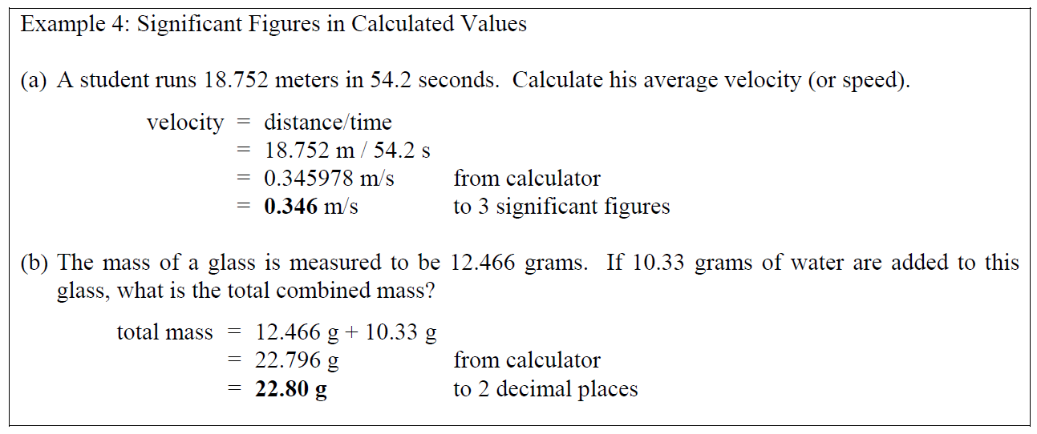
Melting point is a physical property. When a solid is heated continuously, a point will eventually be reached where it undergoes a physical change and becomes a liquid. The temperature at which liquid first appears is defined as the melting point of that substance. Since all pure substances have unique melting points, a measured melting point can be used to identify an unknown substance by comparing it with a list of known substances and their accepted, true melting points.

The accuracy of a measured value, such as a melting point, may be evaluated by a calculation of percent error. Percent error is a common way of reporting how close a measured experimental value (EV) is to the true value (TV):
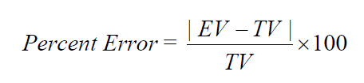
Accurate measurements will typically have low percent errors of <5%.

Procedure

Safety
Be careful when using glassware.

Materials and Equipment
Metric ruler*, shape sheet, electronic balance, large test tube, 100-mL beaker, 100-mL graduated cylinder, triple-beam balance, 250-mL Erlenmeyer flask, electronic balance, sugar, Bunsen burner, thermometer, 400-mL beaker, stand and ring clamp, small watch glass, wire gauze, capillary tube, latex tubing, scoopula and unknown solids.

Part A: Measuring the Dimensions of Regular Geometric Shapes

1. Read steps 2 & 3 below and create a table to record all data.
2. Obtain a ruler and the “shape sheet” from your teacher, and then use the ruler to measure the dimensions of the two geometric shapes on it. Measure the length and width of the rectangle, and the diameter of the circle. Record these measurements on your report form.
3. Use your measurements to calculate the areas of the assigned geometrical shapes and record this information in your report form.
• Area of a rectangle = l x w
• Area of a circle = πr²
(where r = radius = ½ the diameter)

Part B: Measuring the Volume of a Sample of Water
1. Read steps 2 - 5 below and create a table to record all data.
2. Obtain a large test tube from your instructor. Fill this test-tube to the brim with tap water, then carefully transfer it to a 100-mL beaker with scale markings on it. Measure and record the volume of water in the beaker.
3. Again, fill the same test-tube to the brim with tap water, and then carefully transfer it to a 50-mL beaker with scale markings on it. Measure and record the volume of water in the beaker. Do these measured volumes have the same number of significant figures?
4. Again, fill the same test-tube to the brim with tap water, and then carefully transfer it to a 100-mL graduated cylinder. Measure and record the volume of water in the graduated cylinder. Do these measured volumes have the same number of significant figures?
5. Finally, fill the same test-tube to the brim with tap water, and then carefully transfer it to a 10-mL graduated cylinder. Measure and record the volume of water in the graduated cylinder. Do these measured volumes have the same number of significant figures?

Part C: Measuring the Mass of Solids
Comparing the Precision of two types of Balances
1. Read steps 2 - 7 below and create a table to record all data.
2. Use a triple-beam balance to obtain the mass of a 250-mL Erlenmeyer flask. Measure and record the mass.
3. Now use an electronic balance to obtain the mass of the same Erlenmeyer flask. Measure and record the mass.
Do these measured masses have the same number of significant figures?

Weighing by Difference
4. Using the electronic balance again, obtain the mass of a 100-mL beaker. If you already used this same beaker in Part B, make sure that you carefully dry it before weighing it.
5. Add two spoonful’s of sugar to this beaker, using your scoopula. Do not do this over the balance! Then obtain the new combined mass of both the beaker and the sugar. Be sure to use the same electronic balance as before. Measure and record the mass.
6. When finished, dispose of the sugar used in the sink.
7. Use your two measurements to determine the mass of sugar (only) weighed out.

Shape Sheet:

