NAME _________________________________________________________ DATE _____________ HOUR ________
Flash Interactive: String Theory- A Sense of Scale http://www.pbs.org/wgbh/nova/elegant/scale.html
Throughout the world the metric system, or SI (System Internationale), is used as the standard system of measurement.
 | 1000 | 100  1 x 10² | 1 x 10¹ | 1  1 x 10⁰ | 0.1 | 0.01 | 1 x 10⁻³ |  |  | 0.000001  1 x 10⁻⁶ |  |  | 1 x 10⁻⁹
 | Kilo | Hecto | Deka | Unit | deci | centi | milli |  |  | micro |  |  | nano
Length | Km | Hm | Dm | M  meter | dm | cm | mm |  |  | μm |  |  | nm
Volume | KL | HL | DL | L  liter | dL | cL | mL |  |  | μL |  |  | nL
Mass | Kg | Hg | Dg | G  Gram | dg | cg | mg |  |  | μg |  |  | ng

SIGNIFICANT FIGURES
Significant figures are digits that have some reliability or are actually obtained from a measurement.
All digits from 1 to 9 are always significant. However, 0 is sometimes significant and sometimes not significant.

Use the following rules to determine if a 0 is significant or not significant.

- All nonzero digits are significant: 1.234 g has 4 significant figures and 1.2 g has 2 significant figures.
- Zeros between nonzero digits are significant: 1002 Kg has 4 significant figures and 3.07 mL has 3 significant figures.
- Leading zeros to the left of the first nonzero digits are not significant; these zeroes only indicate the position of the decimal point: 0.001 ⁰C has only 1 significant figure and 0.012 g has 2 significant figures.
- Trailing zeroes that are also to the right of a decimal point are significant: 0.0230 mL has 3 significant figures and 0.20 g has 2 significant figures.
- When a number ends in zeroes without a decimal point the zeroes are not significant: 190 miles has 2 significant figures but 190. miles has 3 significant figures and 50,600 calories has 3 significant figures but 50,600. calories has 5 significant figures.

The potential ambiguity in the last rule can be avoided by the use of scientific notation.
5.06 × 10⁴ calories (3 significant figures)
5.060 × 10⁴ calories (4 significant figures)
5.0600 × 10⁴ calories (5 significant figures)

Practice Skill: Indicate the number of significant figures in the following numbers.
1. | 1756 |  |  | 5. | 14.00 |  |  | 9. | 76.015 |  |  | 13. | 505.1
2. | 2.67 |  |  | 6. | .0013 |  |  | 10. | 500 |  |  | 14. | 2200
3. | 3016 |  |  | 7. | 300.0 |  |  | 11. | 620. |  |  | 15. | .0001
4. | 42301 |  |  | 8. | 10.0300 |  |  | 12. | 27,010 |  |  | 16. | 00.020

An answer in a mathematical calculation using measured numbers can only be as accurate as the least accurate number used in determining it.

Example A: 2.3 x 467.01 = 1074.123 or more correctly, 1100

The reason 1100 is the correct answer is that 1074.123 has 7 significant figures. The 2.3 and the 467.01 have 2 and 5 significant figures respectively. The result of multiplication or division of these two numbers can only be as accurate as 2 significant figures. The 7 figure answer that is shown on a calculator implies a greater accuracy than is possible with the limited numbers used.
The result in a calculation can only be as accurate as the number with the least number of significant figures.

Practice Skill: Rewrite the answer to problems below giving the correct answer rounded off to the proper number of significant figures.
1. | 6.21 x 2.3 = 14.283 |  |  | 5. | 4.001 x 2.2 = 8.8022 =
2. | 1.555 x .003 = 0.004665 |  |  | 6. | 55.010 x 2660 = 146326.6
3. | 0.355 x .022 = 0.00781 |  |  | 7. | 0.0301 x 211 = 6.3511
4. | 4.033 x .0005 = 0.0020165 |  |  | 8. | 2.20 x 101.0 = 222.2

Practice Skill: Complete the following calculations and round the answers to the correct number of significant figures.
9. | 3.01 x 10⁵ X 20 x 10² = |  |  | 13. | 2.0 x 10⁻³ X 2.8 x 10⁴ =
10. | 4.35 x 10¹¹ X 3.6 x 10³ = |  |  | 14. | 6.11 x 10⁴ X 3.0 x 10³ =
11. | 3.32 x 10⁻³ / 2.0 x 10⁵ = |  |  | 15. | 4.01 x 10³ / 4.00 x 10-² =
12. | 4.4 x 10²³ / 2.8 x 10⁻⁵ = |  |  | 16. | 6.02 x 10²³ /1.1 x 10⁻¹¹ =

Practice Skill: How Does Your Project Measure Up?
Weight in Metrics
In your scientific investigation you may have to find the weight of an object. A kilogram is the base unit of measurement for weight. You may use one of the instruments shown here to determine the weight or an object.
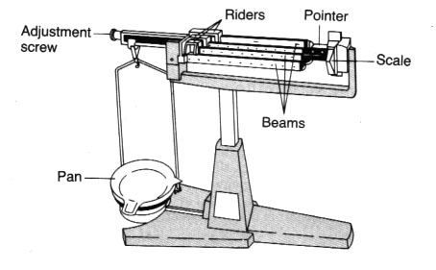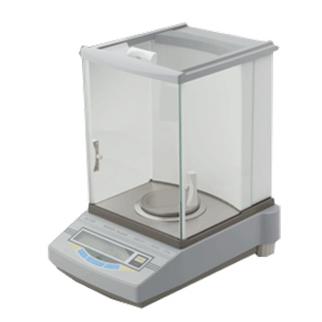
Triple Beam Balance Electronic Balance

Milligram = mg  Gram = g  Kilogram = kg |  | 1,000 mg = 1g  1, 000 g = 1 kg

First make a prediction of the weight of the objects. Then use your balance to weigh the following objects.
Object | Prediction (g) | Actual Measurement (g), (mg), (kg)
1. 2 paper clips
2. a penny
3. 50 mL beaker
4. 250 mL Erlenmeyer Flask
5. 50 mL graduated cylinder
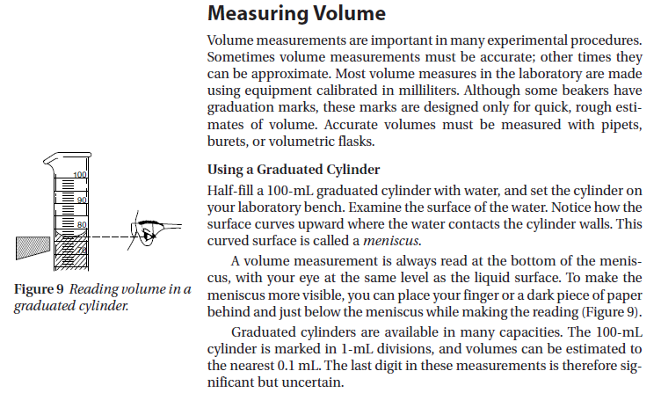
Every measurement has a degree of uncertainty associated with it. The uncertainty derives from the measuring device and from the skill of the person doing the measuring; this is known as uncertainty in measurement. The values of the measurement marks on the cylinders vary: sometimes one mark equals 1 mL but other times it is 2, 5, or 10 mL; the uncertainty measurement will depend on the cylinder you are using. Generally we can determine the uncertainty measurement of a measuring device by taking the smallest division on it and dividing it by 10. For example the smallest division of the graduated cylinder in figure 9 is 1 mL; 1 ÷ 10 = 0.1; 0.1 mL is the uncertainty in measurement denoted with a +/- sign. The recorded reading for figure 9 would be 76 +/- 0.1 mL The smallest division on the triple beam balance is 0.01; 0.01 ÷ 10 = 0.001; the uncertainty is therefore +/- 0.001 g.

Practice Skill: Read & record the level of liquid in 4 different graduated cylinders.
Graduated Cylinder | Volume
10 mL | +/- (mL)
50 mL | +/- (mL)
100 mL | +/- (mL)
1000 mL | +/- (mL)

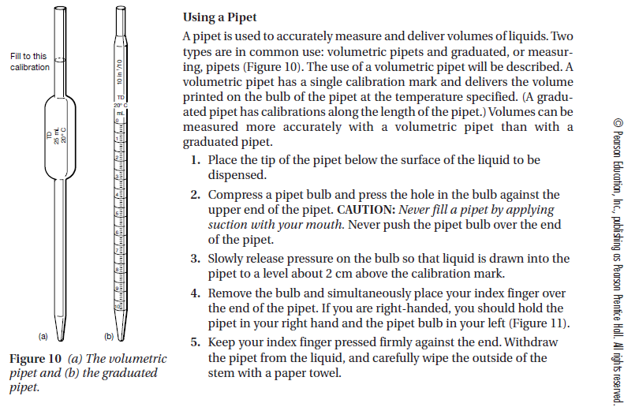
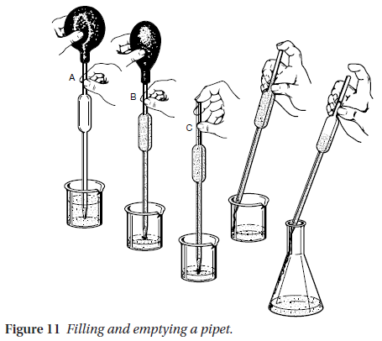
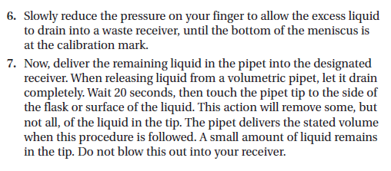

Scientific Processes Flash Interactive: http://www.teachersdomain.org/asset/drey07_int_scprocess/

C1.1C, C1.1E, C1.1h: Activity 2: Diet Soda vs. Regular Soda

Lab Table #______ Group Names:_____________________________________________

______________________________________________

______________________________________________

______________________________________________

1. Which has more carbonation, diet soda or regular soda? Why do you think this?

2. In which will you be able to measure the most foam, diet soda or regular soda?

Design an experiment that shows which liquid will have the most foam:

3. What is the problem/question?

4. State your hypothesis.

5. Explain the purpose of your experiment.

6. List the materials you will need.

7. List the safety precautions you will need to follow.

8. List the steps you will follow in performing this experiment.

9. Design the data table you will need.

10. After performing your experiment write your concluding thoughts.
Your Claim: (this is the answer to the question)

2-3 Pieces of Evidence: (this is the proof that supports your claim)

Your reasoning: (this is a small essay containing your statement, supporting proofs along with any scientific explanations and language, and your conclusions)

Practice Skill:
1. A student conducts an experiment in class in which he measures the effect of change in temperature on the expansion of a balloon. Which of the following questions would the student be best prepared to answer after conducting the experiment and researching the science supporting his results?

- How does heating a gas affect its chemical properties?
- How do weather conditions affect oxygen levels in lakes?
- How do certain types of gases dissolve in water?
- How do weather conditions affect the tire pressure of car tires?

2. A student’s hypothesis states that there is more carbonation in diet cola than in regular cola. In order to test her ideas, she carefully pours a can of each cola in a similar way into 1000 mL graduated cylinders and measures the height of the foam. The results are shown below.

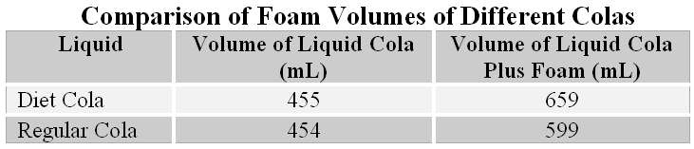

From this information, the student concludes that the data supports her hypothesis that diet cola has more carbonation than regular cola. Which of the following best describes the student’s conclusion?

- It is a valid conclusion since it is based on many trials.
- It is a valid conclusion since it is based on only one trial.
- It is not a valid conclusion since it is based on only one trial.
- It is not a valid conclusion since she used the same graduated cylinder when measuring both colas.

3. Bisphenol A (BPA) is an organic chemical that is widely used in the production of baby bottles, water bottles, and other plastic containers. Currently there is much debate among scientists about whether BPA may have long-term health effects on humans, such as an increased risk of acquiring diabetes.

A recent study by the food and Drug Administration (FDA) found that BPA does not pose any significant health risks to those who use products containing the chemical. Which of the following best describes how the scientific community should respond to the study by the FDA?

- Scientists should accept the BPA study as mostly factual.
- Scientists should promote further research of BPA by private and university institutions.
- Scientists should communicate to the public that unlimited use of BPA should be encouraged.
- Scientists should encourage citizens to invest money into companies that use BPA.

4. One way to state the law of conservation of matter and energy is to say that the amount of matter and energy in the universe is constant. Which of the following best explains why scientists support this law, even though they have not observed the entire universe?

- because the law has held true in every case investigated and in every known situation up to this point in time
- because more than one hypothesis making this claim has been supported by scientific investigation, and it has usually held true
- because current technology is not sufficient to support otherwise
- because current scientific method is without flaw, and supports absolute truths

