Name ______________________________________________ Date ___________________ Class __________________
SCIENTIFIC MEASUREMENT
3© Pearson Education, Inc., publishing as Pearson Prentice Hall. All rights reserved. Chapter 3 Scientific Measurement 65

SECTION 3.1 MEASUREMENTS AND THEIR UNCERTAINTY
Using different rulers, Bruce and Pete each measure the length of the same object three times.
1. Bruce’s three measurements are 19 cm, 20 cm, and 22 cm. Calculate the average value of his measurements and express the answer with the correct number of significant figures.

2. Pete’s three measurements are 20.9 cm, 21.0 cm, and 21.0 cm. Calculate the average value of his measurements and express the answer with the correct number of significant figures.

3. Multiply the answer to problem 1 by the answer to problem 2. Express the answer in scientific notation with the correct number of significant figures.

4. Whose measurements are more precise?

5. The actual length of the object is 20 cm. Whose measurements are more accurate?

6. What is the error of Pete’s average measurement?

7. What is the percent error of Pete’s average measurement?

8. Four boards each measuring 1.5 m are laid end to end. Multiply to determine the combined length of the boards, expressed with the correct number of significant figures.

SECTION 3.2 THE INTERNATIONAL SYSTEM OF UNITS (SI)
A fish tank measures 0.40 meter long by 0.20 meter wide by 0.30 meter high.
1. What is the width of the tank in centimeters?

2. What is the length of the tank in millimeters?

3. What is the volume of the tank in liters?

4. What is the mass of water, in grams, that would fill the tank halfway?

5. How many nanoseconds are there in one minute?

6. A chemical reaction takes place at 20⁰C. What is this temperature in kelvins?

7. A typical refrigerator keeps food at 277 K. What is this temperature in degrees Celsius?

SECTION 3.3 CONVERSION PROBLEMS
1. The population of San Francisco is 750,000 in an area of 49 square miles. What is the population density in San Francisco? Express your answer in people per acre. (1 mi² = 640 acres)

2. A sugar-free powdered drink mix sells for $2.99 per can. Each can of the mix contains 50.2 g of powder, which, when added to water, will make 8 quarts of drink. What is the cost of the powdered drink mix in dollars/lb?
(454 g = 1 lb)

3. A car is travelling at 60 miles per hour. Express this speed in kilometers per hour (km/h). (1 mi = 1.609 km)

4. A whole chicken sells for $7.06 and has a mass of 1.5 kg. A beef shank sells for $10.00 with a mass of 2.5 kg. Compare the per pound cost for each item. (1 kg = 2.2 lb)

5. How many seconds are there in a day? (1 day = 24 h)

6. The speed limit on a certain highway is 72 km/h. What is this speed in cm/s? (1000m = 1km; 100 cm = 1m)

7. Gold has a density of 19.3 g/cm³. What is the mass, in kilograms, of one cubic meter of gold? (1000g = 1kg)

8. An automobile can travel 40.0 miles on one gallon of gasoline. How many kilometers per liter is this?
(1.61 km = 1 mi; 1 L = 0.264 gal)

9. Suppose that gold is selling at $375/ounce. How many milligrams of gold could you buy for one cent?
(16 oz = 1 lb; 1 lb = 454 g)

SECTION 3.4 DENSITY
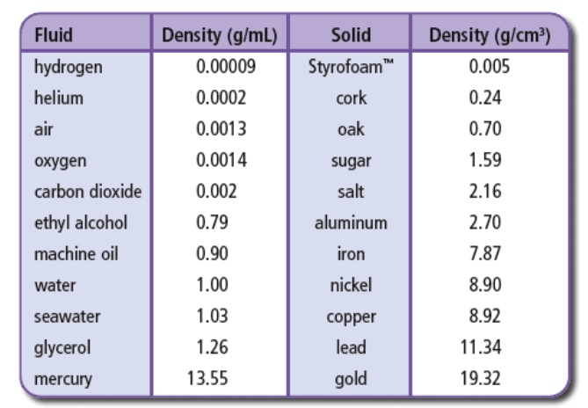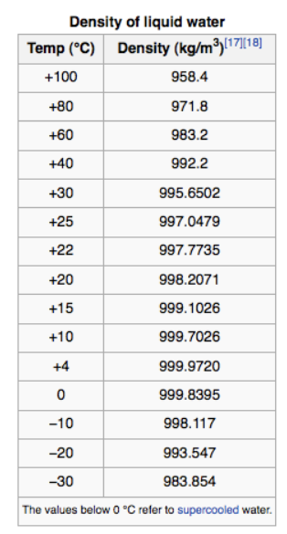
Use the data in above to solve problems 1–4.
1. What is the mass at 20⁰C of 5 liters of air? (1000L = 1m³)

2. A balloon filled with air is released in a room filled with carbon dioxide. Will the balloon float to the ceiling or sink to the floor?

3. What is the volume in liters of a kilogram of ice at 0⁰C? (1000L = 1m³)

4. What is the mass of a bar of aluminum measuring 1.0 cm by 1.0 cm by 10.0 cm? (1 000 000 cm³ = 1m³)

Density Table References:
http://www.bcscience8.com/pgs/quiz_section7_2.htm
http://butane.chem.uiuc.edu/pshapley/GenChem1/L21/2.html

