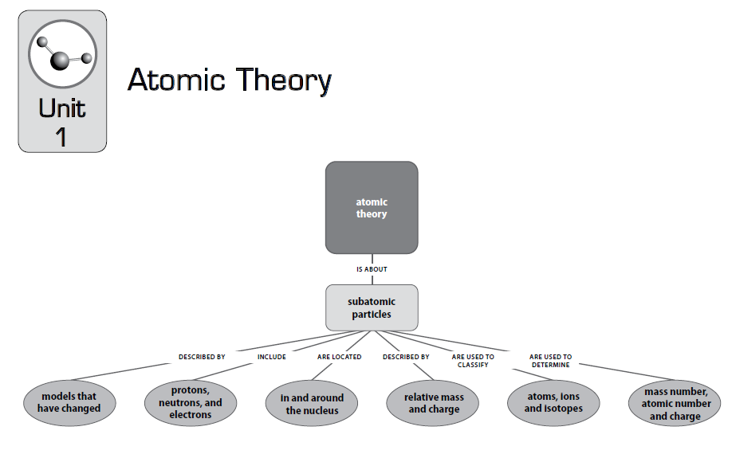

**Vocabulary**

|  |  |
| --- | --- |
| Atomic mass  Atomic nucleus  Atomic number  Atomic theory  Atomic weight  Charged object  Decay rate  Electrically neutral  Electron  Electron cloud  Elementary particle  Ion | Isotope  Nuclear reaction  Neutron mass to energy conversion  Proton  Radioactive dating  Radioactive decay  Radioactive isotope  Relative mass  Stable  Strong force  Transforming matter and/or energy  Weight of subatomic particles |

|  |  |  |
| --- | --- | --- |
| **Code** | **Unit 1-Atomic History Content Expectations** | **Textbook Reference** |
| **C2.5x** | **Nuclear stability** Nuclear stability is related to a decrease in potential energy when the nucleus forms from protons and neutrons. If the neutron/proton ratio is unstable, the element will undergo radioactive decay. The rate of decay is characteristic of each isotope; the time for half the parent nuclei to decay is called the half-life. Comparison of the parent/daughter nuclei can be used to determine the age of a sample. Heavier elements are formed from the fusion of lighter elements in the stars. | **Addison Wesley**  **Chemistry 3rd Ed**  **Ch 24** |
| **C2.5a** | Determine the age of materials using the ratio of stable and unstable isotopes of a particular type. | **Ch 25** |
| **C2.5x** | **Mass Defect** Nuclear reactions involve energy changes many times the magnitude of chemical changes. In chemical reactions matter is conserved, but in nuclear reactions a small loss in mass (mass defect) will account for the tremendous release of energy. The  energy released in nuclear reactions can be calculated from the mass defect using E = mc2. | **Ch 24 pp 580-581** |
| **C3.5a** | Explain why matter is not conserved in nuclear reactions. | **Ch 24 pp 580-581** |
| **C4.7x** | **Solutions** The physical properties of a solution are determined by the concentration of solute. |  |
| **C4.7b** | Compare the density of pure water to that of a sugar solution. | **Ch 2 pp 34-35** |
| **C4.8** | **Atomic Structure** Electrons, protons, and neutrons are parts of the atom and have measurable properties, including mass and, in the case of protons and electrons, charge. The nuclei of atoms are composed of protons and neutrons. A kind of force that is only evident at nuclear distances holds the particles of the nucleus together against the electrical repulsion between the protons. | **Ch 4 pp 75-76** |
| **C4.8A** | Identify the location, relative mass, and charge for electrons, protons, and neutrons. | **Ch 4 pp 75-76** |
| **C4.8B** | Describe the atom as mostly empty space with an extremely small, dense nucleus consisting of the protons and neutrons and an electron cloud surrounding the nucleus. | **Ch4 p 73** |
| **C4.8C** | Recognize that protons repel each other and that a strong force needs to be present to keep the nucleus intact. | **Teacher Supplement** |
| **C4.8D** | Give the number of electrons and protons present if the fluoride ion has a -1 charge. | **Ch 5 pp87-88** |
| **C4.10** | Neutral Atoms, Ions, and Isotopes A neutral atom of any element will contain the same number of protons and electrons. Ions are charged particles with an unequal number of protons and electrons. Isotopes are atoms of the same element with different numbers of neutrons and essentially the same chemical and physical properties. | **Ch 4 pp 76-78** |
| **C4.10A** | List the number of protons, neutrons, and electrons for any given ion or isotope. | **Ch 4 pp 76-78** |
| **C4.10B** | Recognize that an element always contains the same number of protons. | **Ch 4 pp 76-78** |
| **C4.10x** | Average Atomic Mass The atomic mass listed on the periodic table is an average mass for all the different isotopes that exist, taking into account the percent and mass of each different isotope. | **Ch 4 pp 76-78** |
| **C4.10e** | Write the symbol for an isotope, AXZ , where Z is the atomic number, A is the mass number, and X is the symbol for the element. | **Ch 4 p 79** |
| **C5.2** | Chemical Changes Chemical changes can occur when two substances, elements, or compounds interact and produce one or more different substances whose physical and chemical properties are different from the interacting substances. When substances  undergo chemical change, the number of atoms in the reactants is the same as the number of atoms in the products. This can be shown through simple balancing of chemical equations. Mass is conserved when substances undergo chemical change. The total mass of the interacting substances (reactants) is the same as the total mass of the substances produced (products). | **Ch 1 pp 5-9** |
| **C5.2C** | Draw pictures to distinguish the relationships between atoms in physical changes in terms of the properties of the reactants and products. | **Ch 1 p 6** |

**Big Ideas:**

* Order in the universe is exhibited through the location and function of subatomic particles and the likeness of atoms of individual elements.
* A strong force is needed to hold the nucleus together in all atoms.
* Radioactive dating is the direct function of the timed decay of radioactive atoms.

**C4.8A, C4.8B, C4.8C, C1.2i, 9_12.CC.3, 9_12.CT.1: If you were asked to draw the structure of an atom, what would you draw? Throughout history scientists have accepted five atomic models. Our perception of the atom has changed from the early Greek model because of clues or evidences that have been gathered through scientific experiments. As more evidence was gathered old models were discarded or improved upon. Your goal is to trace the atomic theory through history.**

**Practice Skill:**

You and your partner will use the sources provided to develop a timeline that outlines the key scientists and experiments associated with the development of modern atomic theory. Include the names of the scientists, pictures of experimental equipment or atomic models, and descriptions.

**Process**

<http://www.neshaminy.k12.pa.us/cms/lib6/PA01000466/Centricity/Domain/205/Scientists%20Atom%20Webquest.pdf>

**Webquest: Atomic Theories and Models**

**Early Ideas about Atoms**:

Go to <http://galileo.phys.virginia.edu/classes/252/atoms.html> and read the section on “Early Greek Ideas” in order to answer the following questions:

1. What was the “basic idea” about matter that Leucippus and Democritus proposed?
2. How did they use atoms to explain different physical properties?
3. How were the ideas of these two men received by Aristotle, and what was the result on the progress of

atomic theory for the next 2,000 years?

**John Dalton’s Atomic Theory**:

Go to <http://www.iun.edu/~cpanhd/C101webnotes/composition/dalton.html> and use the information there to answer the following questions:

1. When did Dalton form his Atomic Theory?
2. What are the four components of Dalton’s Atomic Theory?

**J.J. Thomson and the Electron**:

Go to <http://www.chemheritage.org/classroom/chemach/atomic/thomson.html> and use the information there to answer the following questions:

1. What is the year in which J.J. Thomson discovered the electron?
2. What was the evidence for “bodies much smaller than atoms”?
3. What was the model of the atom he proposed in 1904?

**Rutherford and Bohr Break the “Plum Pudding” Model:**

Go to <http://www.pbs.org/wgbh/aso/databank/entries/dp13at.html> and use the information found there to answer the following questions:

1. What was the “plum pudding” model of the atom and its electrons?
2. How much smaller was the nucleus, than the atom itself, according to Rutherford?
3. How did Bohr modify this model of the atom (i.e. what was his “revolutionary idea” about electrons)?

**Chadwick (and Rutherford) and the Neutron:**

Go to <http://www.pbs.org/wgbh/aso/databank/entries/dp32ne.html> and use the information found there to answer the following questions:

1. What makes up the atomic number?
2. What makes up the atomic mass?
3. What observation led Chadwick (and Rutherford) to conclude there must be something besides just the proton in the nucleus of atoms?
4. What is the something-besides-just-the proton called?

**History of the Atom Timeline**

Click the following link:

<http://www.cerritos.edu/ladkins/a106/A%20Brief%20History%20of%20the%20Atom.htm>

Use the information in this web page to fill in your History of the Atom Timeline. Use the following clues to help you. Make sure that all of the dates and all of the inventors are filled in. Use the timeline template as a guide to create a timeline poster of the history of the atom.

**Hints**

1. My famous quote was disputed by Aristotle, although time proved me correct.

2. In what date was it determined that matter can neither be created nor destroyed. Name the date and the scientist.

3. Name the date and inventor of the modern version of the Atomic Theory.

4. I was born in 1831 and showed that electricity and magnetism are scientifically related.

5. He developed the plum pudding model and also was the first to discover the ________.

6. In 1909 this scientist demonstrated that the atom is mostly empty space with a small positively charged nucleus

containing most of the mass and low mass negatively charged particles orbiting this nucleus. He was also credited

with naming ______ and ______ .

7. What date did Neils Bohr developed the first successful model of the atom?

**History of the Atom Timeline**

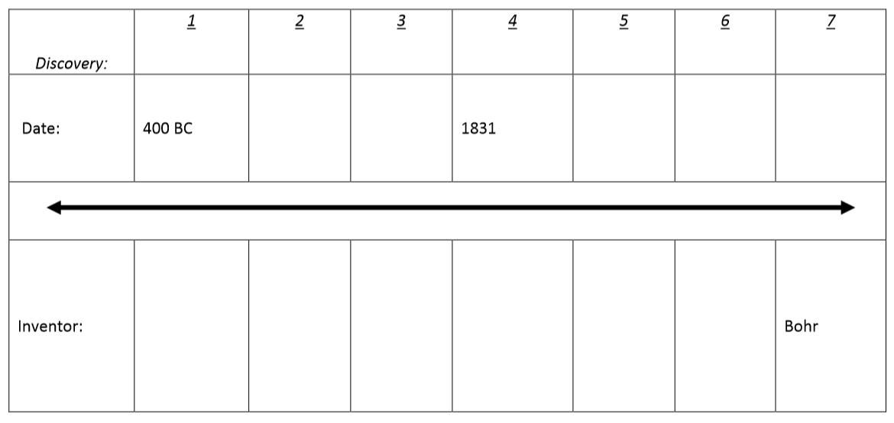

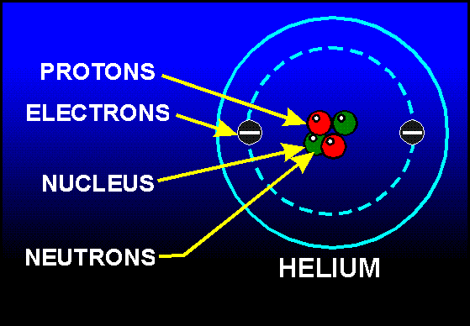

**C4.8A, C4.8B:**

**Atom Basics Go to:**

<http://www.chemtutor.com/struct.htm> and read the “And you thought you were strange” section to answer the following questions.

1. What are the three subatomic particles that all atoms are made of?
2. Where are each of the three particles located within the atom?
3. What is the electrical charge of each particle?

* **Interactive: All about Atoms**: <http://education.jlab.org/atomtour/index.html>
* **Quick Time Video: Atoms the Space Between:** <http://www.teachersdomain.org/asset/phy03_vid_atoms/>

**Practice Skill:**

1.

|  |  |  |  |
| --- | --- | --- | --- |
| **Particle** | **Location** | **Relative Mass** | **Charge** |
| Electrons |  |  |  |
| Protons |  |  |  |
| Neutrons |  |  |  |

2. **After the Gold Foil Experiment what was the description of the atom?**



**Claim:** (this is your thesis statement; it is the answer to the question)

**Evidence:** (2-3 bullet points that support your claim)

**Reasoning:** (this is your essay:

* Begin with your claim/thesis statement-1 complete sentence
* Support your claim with 2-3 complete sentences
* Include additional sentences that show scientific background information-describe the atom and its particles
* End with restating your claim

**C4.8C, C3.5a:**

* **Quick Time Video: Island of Stability:** <http://www.teachersdomain.org/asset/lsps07_vid_stability/>
* **Quick Time Video: String Theory Gravity-The Odd Man Out**

<http://www.pbs.org/wgbh/nova/elegant/media2/3012_q_06.html>

**Group work: Create a Claim Evidence Reasoning Poster**

**1.** **If protons repel each other and they are in the nucleus, why does the nucleus not fall apart?**

**Claim:** (this is your thesis statement; it is the answer to the question)

**Evidence:** (2-3 bullet points that support your claim)

**Reasoning:** (this is your essay explaining in great detail, backed with evidence and scientific reasoning the

answer to the question)

* Begin with your claim/thesis statement-1 complete sentence
* Support your claim with 2-3 complete sentences
* Include additional sentences that show scientific background information-describe the
* Rebuttal: what would happen if the opposite where true
* End with restating your claim

**Group work: Create a Claim Evidence Reasoning Poster**

2. **Why is matter not conserved in nuclear reactions?**

**Claim:** (this is your thesis statement; it is the answer to the question)

**Evidence:** (2-3 bullet points that support your claim)

**Reasoning:** (this is your essay explaining in great detail, backed with evidence and scientific reasoning the

answer to the question)

* Begin with your claim/thesis statement-1 complete sentence
* Support your claim with 2-3 complete sentences
* Include additional sentences that show scientific background information-describe the
* Rebuttal: what would happen if the opposite where true
* End with restating your claim

**C4.8A, C4.10B**: **Atomic Structure: Neutral Atoms**

<http://www.pbslearningmedia.org/asset/ess05_vid_fusion/>

**12**

**Mg**

**24.3**

12 Protons

12 Electrons

Atomic Number

Atomic Mass

**Magnesium**

12 Neutrons

(Neutrons = Atomic Mass – Atomic Number)

**12**

**Mg**

**24.3**

12 Protons

12 Electrons

Atomic Number

Atomic Mass

**Magnesium**

12 Neutrons

(Neutrons = Atomic Mass – Atomic Number)

The number of electrons in a neutral atom is also equal to the Atomic Number of that atom.

Recall that almost all of the mass of an atom is located in the nucleus. As a result of this;

|  |  |
| --- | --- |
| **Atomic Mass = Protons + Neutrons** | |
| **For all Atoms** | | **For Neutral Atoms** | |
| Atomic Number = Number of Protons | | Number of Protons = Number of Electrons | |
| Number of Neutrons = Atomic Mass – Number of Protons | |

**Practice Skill:** In the space provided fill in the missing quantities for neutral atoms in the chart.

|  |  |  |  |  |  |  |  |
| --- | --- | --- | --- | --- | --- | --- | --- |
| QUANTITIES FOR NEUTRAL ATOMS | | | | | | | |
| Name | | Symbol | Atomic Number | Protons | Neutrons | Atomic Mass | Electrons |
| 1 | Oxygen |  | 8 |  | 7 |  |  |
| 2 |  | Ar |  | 18 |  | 37 | 18 |
| 3 | Hydrogen | H |  |  | 0 |  | 1 |
| 4 |  | Na | 11 |  |  | 23 |  |
| 5 | Beryllium |  | 4 |  | 5 |  | 4 |
| 6 |  | Mg |  |  |  | 24 |  |
| 7 | Carbon | C |  |  | 7 |  |  |
| 8 | Zinc |  |  |  |  | 65 |  |
| 9 | Chromium | Cr | 24 |  |  | 49 | 24 |
| 10 |  | K | 19 |  | 18 |  | 19 |
| 11 | Barium |  | 56 |  |  | 136 | 56 |
| 12 | Lithium |  |  |  |  | 7 |  |
| 13 |  | B | 5 |  | 6 |  | 5 |
| 14 | Copper | Cu | 29 |  |  | 64 | 29 |
| 15 |  | Br |  | 35 | 45 |  |  |
| 16 | Iron |  |  | 26 | 30 |  |  |
| 17 | Sulfur | S | 16 |  | 17 |  | 16 |

**C4.8A, C4.8D, C4.10A, C4.10B**: **Atomic Structure: Ions**

<http://www.pbslearningmedia.org/asset/phy03_int_ptable/>

An ion is a charged atom. For an atom to become an ion it must first either lose or gain electrons.

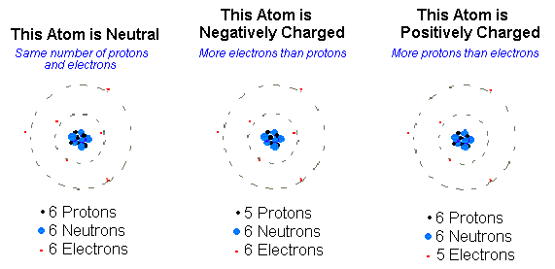

The total charge on the negative atom above is -1: since +5 protons plus -6 electrons = -1.The total charge on the positive atom is +1: since +6 protons plus -5 electrons = +1. If the atom gains 2 electrons the charge will be -2, if it gains 3 electrons the charge will be -3. Likewise if an atom loses 2 electrons the charge will be +2 and if it loses 3 electrons the charge will be +3.

**Keep in mind protons are positively charged and electrons are negatively charged.**

|  |
| --- |
| **For Ions** |
| Charge = Number Protons + Number Electrons |
| For example oxygen as a neutral atom has 8 protons & 8 electrons. When it becomes an ion it gains 2 electrons for a total of 10 electrons. The charge on an oxygen ion is -2 and it is written as a superscript. |
| O2- = (+8) + (-10) |

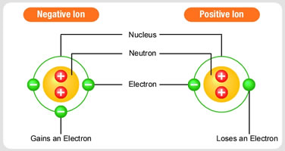

**Practice Skill:** In the chart below fill in the missing quantities.

|  |  |  |  |  |  |  |  |
| --- | --- | --- | --- | --- | --- | --- | --- |
| QUANTITIES FOR IONS | | | | | | | |
| Name | | Symbol | Atomic Number | Protons | Neutrons | Atomic Mass | Electrons |
| 1 | Oxygen |  | 8 |  |  |  | 10 |
| 2 |  | Ar |  |  |  |  | 18 |
| 3 | Hydrogen | H1+ |  |  | 0 |  |  |
| 4 | Sodium |  | 11 |  |  | 23 | 10 |
| 5 | Beryllium | Be2+ | 4 |  | 5 |  |  |
| 6 | Magnesium |  |  |  |  | 24 | 10 |
| 7 | Carbon | C4+ |  |  | 6 |  |  |
| 8 | Zinc |  |  |  |  | 65 | 28 |
| 9 | Chromium | Cr3+ |  | 24 |  |  |  |
| 10 | Potassium |  |  |  | 20 |  | 18 |
| 11 | Nickel |  |  |  | 31 |  | 26 |
| 12 | Lithium | Li1+ |  |  |  | 7 |  |
| 13 |  | B3+ |  |  |  | 11 |  |
| 14 | Copper |  | 29 |  |  |  | 28 |
| 15 |  | Br1- | 35 |  |  |  |  |
| 16 | Iron |  |  |  | 30 |  | 24 |
| 17 | Sulfur | S2- | 16 |  |  |  |  |
| 18 |  | Fe3+ |  |  | 30 |  |  |
| 19 | Nitrogen |  |  | 7 |  | 14 | 10 |
| 20 | Barium |  |  | 56 |  |  | 54 |

**C4.8A, C4.10A, C4.10B, C4.10e**: **Atomic Structure: Isotopes**

**Isotopes of an Element Have the Same Atomic Number**

All atoms of an element have the same atomic number and the same number of protons. However, atoms do not necessarily have the same number of neutrons. Atoms of the same element that have different numbers of neutrons are called isotopes. The Periodic Table depicts the average neutral atoms. As such the atomic masses shown are the average masses for those elements. Isotopes do not have average masses and are not shown on the Periodic Table. If you look on the Periodic Table you will see that uranium has an average atomic mass of 238. A very small percentage of uranium atoms also exist with a mass of 235. Uranium with a mass of 235 is an isotope of uranium. Isotopes can be written with the nuclear symbol, the mass as a superscript, and the atomic number as a subscript, both to the left of the symbol. Or they can be written with the name of the element followed by a hyphen and then the mass.

Notice where the mass is located

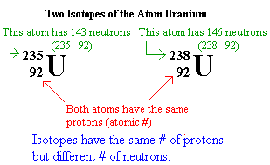 Or U-235 and U-238

**Practice Skill: Look at the periodic table (average atoms) and practice writing nuclear symbols with atomic mass & protons and with mass alone.**

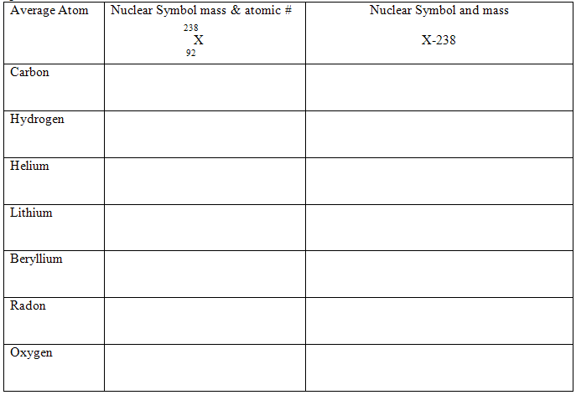

You will recognize an isotope by understanding that all isotopes of an element have the same atomic number but their atomic masses are not the same (masses not found on periodic table) because the number of neutrons of the atomic nucleus of each isotope varies.

|  |  |  |  |
| --- | --- | --- | --- |
| **For Isotopes** | | | |
| Number of Protons  (same as atomic number) | Number of Electrons  (same as number of protons) | Neutrons | Mass |
| Same | Same | Different | Different |

Remember: **Atomic Mass = Protons + Neutrons**

**Practice Skill:** For the chart below fill in the missing quantities.

|  |  |  |  |  |  |  |  |
| --- | --- | --- | --- | --- | --- | --- | --- |
| QUANTITIES FOR ISOTOPES | | | | | | | |
| Name | | Symbol | Atomic Number | Protons | Neutrons | Atomic Mass | Percent Abundance |
| 1 | Hydrogen-2 |  |  |  |  |  | 0.015 |
| 2 |  |  |  |  |  |  | negligible |
| 3 | Lead-204 |  |  |  |  |  | 1.40 |
| 4 | Carbon-13 |  |  |  |  |  | 1.11 |
| 5 |  |  |  |  |  |  | 22.10 |
| 6 | Nitrogen-15 |  |  |  |  |  | 0.37 |
| 7 |  |  |  | 8 |  | 18 | 4.22 |
| 8 | Oxygen-17 |  |  |  |  |  | 0.04 |
| 9 | Oxygen-18 |  |  |  |  |  | 0.20 |

2. If X is the symbol for an element, which two of the following symbols represent isotopes of the same element?

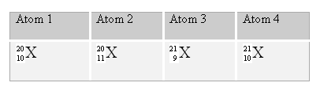

A. 1 and 2 C. 1 and 4

B. 3 and 4 D. 2 and 3

3.

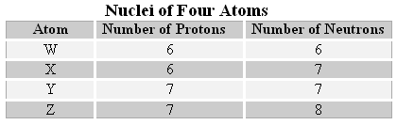

How many different elements are represented by the nuclei in the table above?

1. 1 C. 2
2. 3 D. 4

**C2.5a, C3.5a**: **Radio Carbon Dating Interactive:** <http://www.pbs.org/wgbh/nova/bible/radiocarbon.html>

**Nuclear Stability: Radioactivity and Half-Life of an Element**

The mass of any atom is less than the combined masses of its separated parts. This difference is known as **mass defect**. For helium  the mass of the nucleus (2 protons & 2 neutrons) is about 99.25% of the total mass of 2 individual protons and 2 individual neutrons (recall that the mass of electrons is so small that they can be left out of this calculation). According to the equation *E = mc2*, energy can be converted into mass and mass can be converted into energy. **Radioactivity** is the spontaneous disintegration (decay) of atoms of certain elements into atoms of other elements with the emission of smaller ionizing particles and radiation. In order for atoms to decay their nuclei have to be unstable. Unstable nuclei emit alpha (α) & beta (β) particles, and gamma (γ) rays. 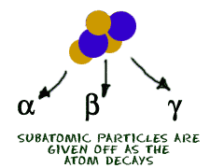 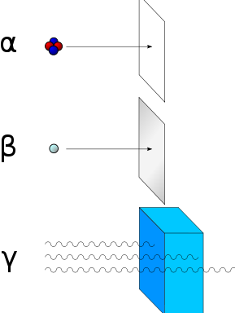

Alpha particles can be stopped by a sheet of paper and beta particles can be stopped by a sheet of aluminum. Gamma rays can be stopped by a thick layer of lead.

A radioactive sample decays at a constant rate. This rate of decay is measured in terms of its **half-life**. The half-life (t ½) is the time required for one half of the atoms of a radioisotope to emit radiation and decay to products. The following graph shows the decay curve for a radioactive element. Each half-life, one-half of the remaining original radioactive atoms have decayed into atoms of a new element.

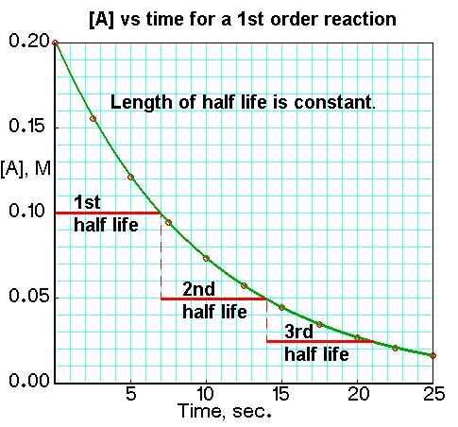 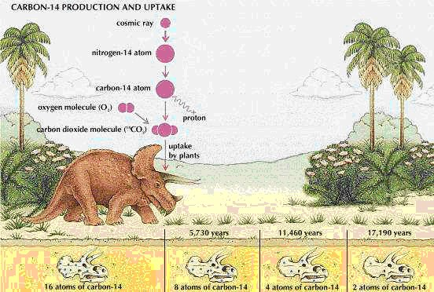

Most carbon atoms on earth exist as C-12. Very small percentages exist as C-14. Both C-12 and C-14 have the same number of electrons and as such react chemically in the same way. Both of these carbon isotopes are in carbon dioxide which is used by plants in photosynthesis. Animals eat plants so they contain the same ratio of C-14 to C-12 as plants do. C-14 is radioactive so it undergoes decay. When a plant or animal dies the C-14 that decays is not replaced. The half-life of C-14 is 5, 715 years. Once amounts of C-12 and C-14 are measured in ancient samples of plant or animal material the ratio of C-14 to C-12 is compared with the ratio of these isotopes in a sample of similar material whose age is known. Using radioactive dating with C-14 scientists can estimate the age of the material. Generally the more unstable a nucleus is the shorter its half-life is and the faster it decays.

Calculating Half-Life:

|  |
| --- |
| Amount Remaining  _________________ = Original Amount  1/2 x  X = Number of Half-Lives |

**Example 1**: N-13 emits beta radiation and decays to C-13 with a half-life (t1/2) equal to 10 minutes. Assume a starting mass of 2 g of N-13.

1. How long are 4 half-lives?
2. How many grams of that isotope will remain after 4 half-lives?
   1. If each half-life is 10 minutes then 4 of them will be (4 x 10) = 40 minutes. 40 minutes will be the number of half-lives.
   2. You are looking for the amount remaining from the original sample.

Amount remaining = Y

Original amount = 2 g

Number of half-lives = 4

1/2 x = (.5)4 = 0.0625

Plug these values into the equation:

___Y___ = 2 Y = (2) (0.0625) Y = 0.125 g

0.0625

**Example 2:** Mg-56 is a beta emitter with a half-life of 2.6 hours. What is the mass of Mg-56 in a 1-mg sample of the isotope after 10.4 hours?

Amount remaining = Y

Original amount = 1 mg

Number of half-lives = 10.4/2.6 = 4

1/2 x = (.5)4 = 0.0625

___Y___ = 1 Y = (1) (0.0625) Y = 0.0625 mg

0.0625

**Practice Skill:**

1. The half-life of calcium-47 is about 5 days. About how much of a 64-gram sample of this isotope remains after 20 days?

1. 32 g
2. 16 g
3. 4 g
4. 2 g

**C5.2C**: **Chemical versus Physical Changes**

Chemical and physical changes are based on knowing the difference between chemical reactions and changes in states of matter. A chemical change involves one or more substances changing into entirely new substances; the chemical composition changes. When iron (Fe) rusts it changes into iron oxide (Fe2O3). Iron no longer exists as single iron atoms but oxygen atoms combine with iron atoms to form a new substance we call rust.

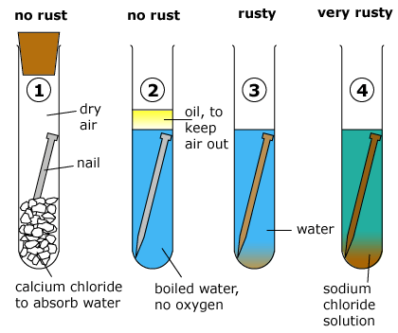

**With chemical changes the changes take place at the level of atoms.**

**Examples**: Chlorine (Cl) gas combines with sodium (Na) metal to form table salt (NaCl).

<https://youtu.be/oZdQJi-UwYs>

* Leaves changing color
* Cooking
* Ripening fruits & vegetables
* Rotting fruits & vegetables
* Photosynthesis
* Fireworks
* Burning

**A physical change is a change in which no new substance is formed.** **After a physical change the atoms are still in the same arrangement.** When ice is melted into a liquid and then boiled into steam, the chemical composition (H2O) does not change; how close or how far apart these water molecules are from each other does change. When you tear a piece of paper it’s still a piece of paper all that has changed is its physical appearance.

**Examples:** Dissolving a sugar cube in water is a physical change. Instead of the sugar (C12H22O11) crystals being clumped into a cube, they are evenly distributed in the water.

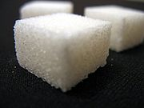 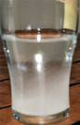

* Clay being modeled into anew shape
* Butter melting
* Rubbing alcohol evaporates on your hand
* Glass is broken
* A basketball deflates

**Practice Skill:**

**1.** Think about how you would draw chemical and physical changes at the level of atoms. Pair up with a partner

and share each other’s ideas. In the following spaces draw chemical and physical changes at the level of atoms.

|  |  |
| --- | --- |
| **Chemical Change** | **Physical Change** |
|  |  |

2. Is the following a chemical or a physical change?

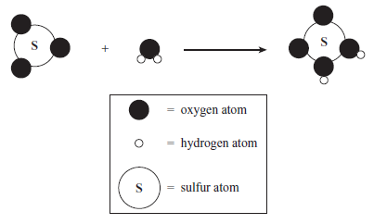**_______________________________**

3. What is happening in this diagram?

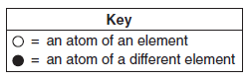 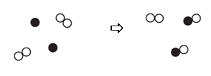

1. Chemical change
2. Physical change

4. Which of the following is not a physical change?

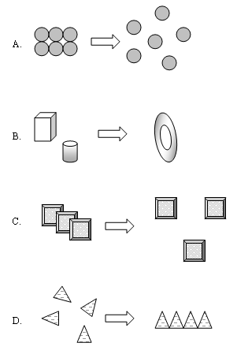

2. For the following question refer to table 1.

The concentration of carbon-14 in a piece of wood from an ancient burial mound indicates that two half-lives of this radioisotope have passed. Approximately how many years ago did this sample of wood die?

**Table -1 Half-Life of Several Radioactive Nuclides**

|  |  |
| --- | --- |
| **Nuclide** | **Half-life (years)** |
| carbon-14 | 5.73  103 |
| potassium-40 | 1.26  109 |
| radium-226 | 1.60  103 |
| thorium-230 | 7.54  104 |
| uranium-235 | 7.04  108 |

A. Not enough information given.

B. 11,460 years ago.

C. 15,000 years ago.

D. 460 years ago.

3. The half-life of phosphorus-32 is 14.30 days. How many milligrams of a 20.00 mg sample of phosphorus-32 will remain after 85.80 days?

1. 3.333 mg
2. 0.6250 mg
3. 0.3125 mg
4. 0.1563 mg

4. Which of the following **best** describes why matter is not conserved in some nuclear reactions?

1. The nucleus of the atom loses all of its electrical energy.
2. The nucleus of the atom absorbs potential energy.
3. Some of the matter absorbs heat energy.
4. Some of the matter is converted to energy.

5. Nuclear reactions differ from ordinary chemical reactions in that an infinitesimally small quantity of mass is lost. The lost mass is converted to

A. an ionizable gas.

B. decayed mass.

C. radiation energy.

D. decayed elements of a new atom.