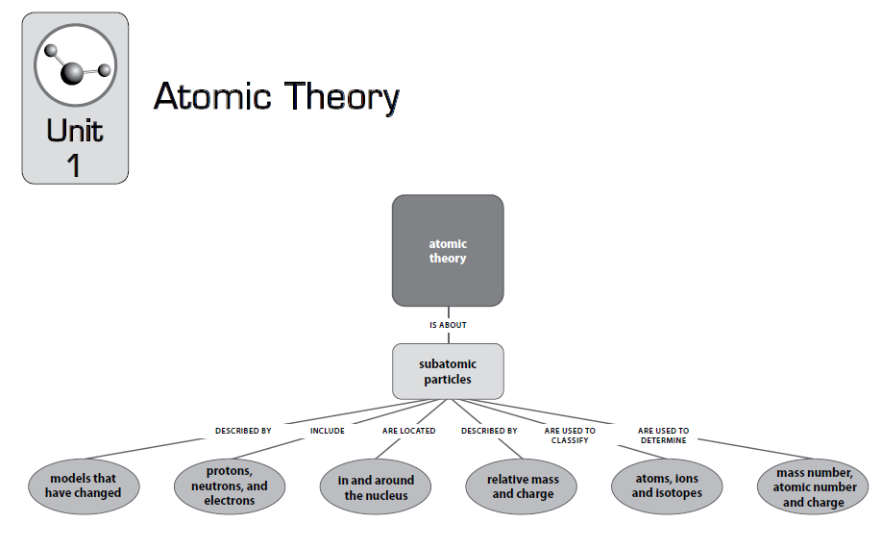

Vocabulary:
Actual mass  Atomic bonding principles  Avogadro’s hypothesis  Binary compound  Chemical bond  Chemical properties of elements  Covalent bond  Earth’s elements  Electrical conductivity  Electronegativity  Electron sharing  Electron transfer  Element family | Elements of matter  Energy sublevels  Periodic table of the elements  Ionic bond  Ionization energy  Lewis structures  Main energy level  Main group elements  Metalloids  Metallic bond  Orbital shape  Outer electron  Thermal conductivity

Red Highlights are Michigan Priority Standards
Code | Unit 2-Periodic Table | Textbook Reference
C4.9 | Periodic Table-In the periodic table, elements are arranged in order of increasing number of protons (called the atomic number). Vertical groups in the periodic table (families) have similar physical and chemical properties due to the same outer electron structures.
C4.9A | Identify elements with similar chemical and physical properties using the periodic table. | Section(s) 5.1,12.2  Page(s) 85,273
C4.9x | Electron Energy-Levels The rows in the periodic table represent the main electron energy levels of the atom. Within each main energy level are sublevels that represent an orbital shape and orientation.
C4.9b | Identify metals, non-metals, and metalloids using the periodic table. | Section(s) 12.2  Page(s) 273
C4.9c | Predict general trends in atomic radius, first ionization energy, and electronegativity of the elements using the periodic table. | Section(s) 12.2  Page(s) 273
C4.10x | Average Atomic-Mass The atomic mass listed on the periodic table is an average mass for all the different isotopes that exist, taking into account the percent and mass of each different isotope.
C4.10c | Calculate the average atomic mass of an element given the percent abundance and mass of the individual isotopes. | Section(s) 4.7  Page(s) 78
C4.10d | Predict which isotope will have the greatest abundance given the possible isotopes for an element and the average atomic mass in the periodic table. | Section(s)  Page(s) 75-77
C5.2x | Balancing Equations-A balanced chemical equation will allow one to predict the amount of product formed.
C5.2g | Calculate the number of atoms present in a given mass of element. | Section(s) 6.2  Page(s) 116
C5.5 | Chemical Bonds-Trends An atom’s electron configuration, particularly of the outermost electrons, determines how the atom can interact with other atoms. The interactions between atoms that hold them together in molecules or between oppositely charged ions are called chemical bonds.
C5.5A | Predict if the bonding between two atoms of different elements will be primarily ionic or covalent. | Section(s) 5.3,13.5  Page(s) 89,305  Chapter 14 Page 317
C5.5B | Predict the formula for binary compounds of main group elements. | Section(s) 5.9-5.12, 5.14  Page(s) 99-104, 107
C5.5x | Chemical Bonds-Chemical bonds can be classified as ionic, covalent, and metallic. The properties of a compound depend on the types of bonds holding the atoms together.
C5.5c | Draw Lewis structures for simple compounds. | Section(s) 14.1-14.4  Page(s) 317-322
C5.5d | Compare the relative melting point, electrical and thermal conductivity, and hardness for ionic, metallic, and covalent compounds. | Section(s) 13.5,13.6,14.14  Table 14.5  Page(s) 307,309,343

Big Ideas:
- Organization of elements in periodic table based on physical/chemical properties (Properties of Matter C4)
- Electron Energy Levels (Properties of Matter C4)
- Characteristic trends of elements (Properties of Matter C4)
- Average Atomic Mass: % abundance (Properties of Matter C4)
- Balancing Equations: calculating amount of product formed (Changes in Matter C5)
- Chemical Bonds-Trends: Bonding & characteristic properties (Changes in Matter C5)
- Avogadro’s Number (Changes in Matter C5)
- Chemical Bonds: Main group binary formulas, Lewis structures (Changes in Matter C5)

C4.9A, C4.9b: The Periodic Table

Scientific American Interactive Periodic Table: http://www.scientificamerican.com/article/chemistry-the-elements-revealed-interactive-periodic-table/
The periodic table is divided into several parts. These parts are useful to simplify the basic types of chemical reactions.
  - The table is divided into two general types of elements; metals and nonmetals. The dividing line is the step-like line drawn between Al & Si, Ge & As, Sb & Te, and Po & At. All elements to the left of the line are metals and all elements to the right are nonmetals.

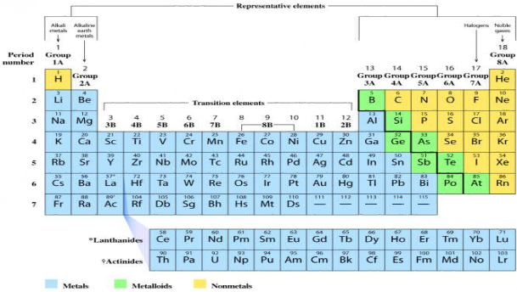

  - Practice Skill: Identify which of the following are metals or non-metals by checking the appropriate column.

Element | Symbol | Metal | Non-Metal | 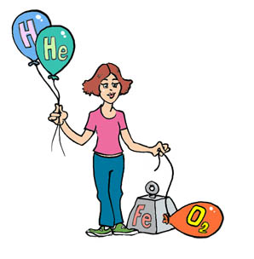
Lithium
Gold
Silver
Bromine
Fluorine
Sodium
Chlorine
Oxygen
Radium
Nitrogen
Silicon
Iodine
Copper
Titanium
Hydrogen
Sulfur
Barium
Calcium
Helium
Mercury
Iron
Magnesium
Xenon
Potassium
Tin
Argon

The elements in each vertical column have similar characteristics. These elements are called a family or group. They have similar chemical and physical properties. They undergo the same type of chemical bonding and follow a general pattern when undergoing physical changes. Look at Graphing the Periodic Table http://www.teachersdomain.org/asset/lsps07_int_graphperiodic/ under Plot Data for these trends.
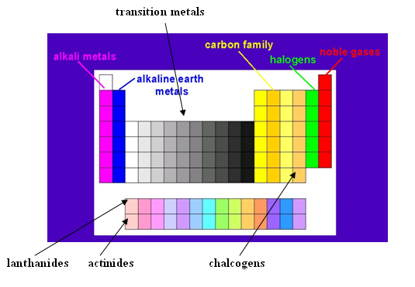
The rows or periods in the periodic table represent the main electron energy levels of the atom. Within each main energy level are sublevels that represent an orbital shape and orientation (s, p, d, & f) where electrons are found. 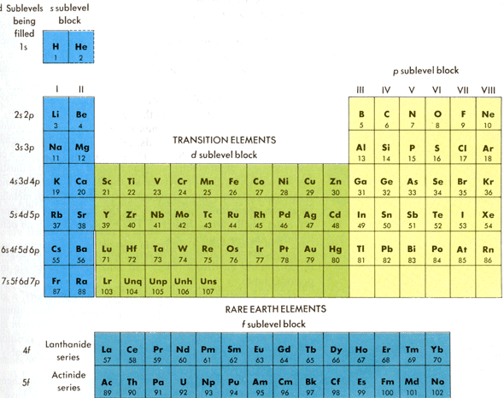

Practice Skill:
http://www.merriam-webster.com/dictionary/periodic
http://dictionary.reference.com/browse/period

Explain what periodic means: ________________________________________________________________

_________________________________________________________________________________________

_________________________________________________________________________________________

Explain what you think periodic means in terms of the Periodic Table:

_________________________________________________________________________________________

_________________________________________________________________________________________

_________________________________________________________________________________________

Activity: Use the chart on page 7 for the following (refer to page 274 in textbook).
- Number the groups.
- Number the periods
- Draw a heavy step like line between the metals and nonmetals.
- Write the name of each of the following groups above the number:
Group 1 alkali metals
Group 2 alkaline earth metal
Group 3-12 (collectively) transition metals
Group 16 chalcogens
Group 17 halogens
Group 18 Noble gases
- Write the names of the two rows at the bottom of the chart: lanthanides and actinides
- Write the symbol of each element that exists as a gas at ordinary conditions in RED.
- Write the symbol of each element that is a solid at ordinary conditions in BLACK.
- Write the symbol of each element that is a liquid at ordinary condition in BLUE.
- Write the symbol of each element that is a man-made element as an outline. Example: Pm
- Place the atomic number for each element above the symbol.

Periodic Variation in Properties
Practice Skill: Use these atomic numbers and information about each element’s properties to prepare the two graphs described on page 9. Look for patterns between atomic numbers and element properties as you construct the plots.
Atomic Number | Symbol | List of Oxides  (chemical property) | Boiling Point (K)  (physical property)
1 | H | Water (hydrogen oxide) (H₂O) | 21
2 | He |  | 4
3 | Li | Lithium oxide (Li₂O) | 1600
4 | Be | Beryllium oxide (BeO) | 2780
5 | B | Boron oxide (B₂O₃) | 2800
6 | C | Carbon dioxide (CO₂) | 4620
7 | N | Dinitrogen pentoxide (N₂O₅) | 77
8 | O | Oxygen Gas (O₂) | 90
9 | F | Oxygen difluoride (OF₂) | 85
10 | Ne |  | 27
11 | Na | Sodium Oxide (Na₂O) | 1162
12 | Mg | Magnesium oxide (MgO) | 1390
13 | Al | Aluminium oxide (Al₂O₃) | 2600
14 | Si | Silicon dioxide (SiO₂) | 2950
15 | P | Phosphorus pentoxide (P₂O₅) | 553
16 | S | Sulphur monoxide (SO) | 718
17 | Cl | Dichlorine monoxide (Cl₂O) | 239
18 | Ar |  | 87
19 | K | Potassium oxide (K₂O) | 1030
20 | Ca | Calcium oxide (CaO) | 1760

Graph 1:
- On a sheet of graph paper, draw a set of axes, and title the graph “Trends in a Chemical Property.”
- Label the x-axis “Atomic Number of E.” What is the range of possible numbers that you will need to display on your graph? Scale your x-axis with these values in mind.
- Label the y-axis “Oxygen Atoms per Atom of E.” What is the possible numbers that you will have to display on your graph? Scale your y-axis with these values in mind.
- Construct a bar graph by plotting the oxide data from the chart on the previous page. For example if no oxide forms, the height of the bar will be 0 because oxygen atoms do not form a compound with atoms of E. If E₂O (1 oxygen atom for 2 E atoms) forms, the height of the bar is 0.5, which is the number of oxygen atoms for each E atom in the compound (note place oxygen atoms in numerator and E atoms in denominator—1/2 = 0.5). Similarly, the heights of the graph bars for other oxides are 1 for EO, 1.5 for E₂O₃, 2 for EO₂, and 2.5 for E₂O₅.
- Label each bar with the actual symbol of the element E involved in that compound.

Graph 2:
- On a separate sheet of graph paper, draw a set of axes, and title the graph “Trends in a Physical Property.”
- Label the x-axis “Atomic Number” and number it from 1 to 20. What range of possible numbers will you have to display on your graph? Scale your x-axis with these values in mind.
- Label the y-axis “Boiling Point (K).” What range of possible numbers will you have to display on your graph? Scale your y-axis with these values in mind. Use as much of the graph paper as possible to plot these Kelvin (K) temperatures.
- Construct a bar graph as in Step 4, this time using the boiling point data from the chart on the previous page. Note do not include data for the element with atomic number 6. The boiling point of this element (carbon) would be quite far off the graph paper.
- Label each bar with the actual symbol of the element it represents.

Questions: Answer after completing graphs.
- Does either bar graph reveal a repeating or cyclic pattern? Hint, focus on elements represented by very large or very small values. Describe any patterns you observe. ________________________________________________________________________________________________________________________________________________________________________________________________________________________________________________________________________________________________________________________________________________
- Based on these two bar graphs, why is the chemist’s organization of elements called a periodic table? Hint, look up the meaning of periodic in the dictionary. ____________________________________________________________________________________________________________________________________________________________________________________________________________________________________________________________
- Where are elements with the highest oxide numbers located on the periodic table? ________________________________________________________________________________________________________________________________________________________________________
- Toward which side of the periodic table do boiling points increase? ____________________________________________________________________________________
- Predict which element should have the lowest boiling point: Se, Br or Kr. Use evidence from your graphs to explain how you decided. ________________________________________________________________________________________________________________________________________________________________________________________________________________________________________________________________________________________________________________________________________________
- In the periodic table, elements are arranged in order of increasing number of protons (called the atomic number). Vertical groups in the periodic table (families) have similar physical and chemical properties due to the same outer electron structures. Use your constructed graphs to answer the following:

Which elements on the periodic table have similar chemical and physical properties?

Claim:

Evidence:

Reasoning:

C4.9c: Ionization Energy: When atoms have equal numbers of protons and electrons, they are electrically 1 neutral. The most stable group is group 18 called the Noble Gases. The number of electrons found in these 2 atoms is the stable electron arrangement. Notice Argon (Ar) has 18 protons and 18 electrons. Generally the 3 noble gases are so stable they never gain or lose electrons. But groups 1-17 do gain or lose electrons. When a 4 neutral atom gains or loses an electron it becomes a charged ion. The energy that is supplied to remove an 5 electron is the ionization energy of the atom. The first ionization energy is the energy required to remove 6 the most loosely held electron from one mole of gaseous atoms to produce 1 mole of gaseous ions each with 7 a charge of 1+.This is more easily seen in symbol terms. 8
All elements have a first ionization energy - even atoms which don't form positive ions in test tubes. The 9 reason that helium (1st I.E. = 2370 kJ mol⁻¹) doesn't normally form a positive ion is because of the huge 10 amount of energy that would be needed to remove one of its electrons. 11
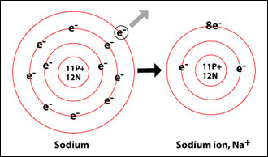 The purpose of becoming an ion is to obtain the configuration 12
of a noble gas as well as to form a chemical bond for the purpose of lowering energy and becoming more 13 stable. All atoms that are not noble gases want to look like and have the same number of valence electrons 14
as the noble gas nearest to them. 15 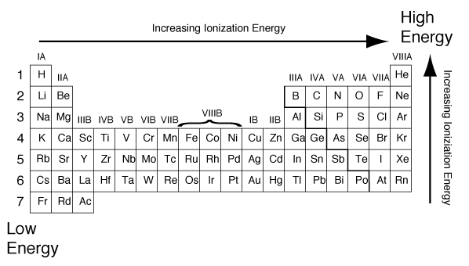Ionization energy decreases as 16
you move down a group because the valence electrons are further away from the nucleus due to the added 17 energy levels. There is also the shielding effect; as you move down a group each successive element 18
contains more electrons in the energy levels between the nucleus and the valence electrons. These inner 19 electrons shield the negative valence electrons from the full attractive force of the positive nucleus. The 20 result is that it takes less energy to remove an electron from K than from Li. As you move across a period 21
or row the ionization energy increases. As you move from left to right more protons are added along with 22
more electrons. More protons make for a stronger positively charged nucleus. However the electrons being 23
added are added to the same energy level. A higher nuclear charge more strongly attracts the outer electrons 24
in the same energy level, but the electron-shielding effect from inner-level electrons remains the same. Thus 25
more energy is required to remove an electron because the attractive force on them is higher. 26
Metals will have a tendency to loose electrons to become positively charged. Positive ions are called cations. 27
When a metal atom becomes ionized its name does not change. 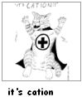 28
Example: Sodium (Na) will loose 1 electron to become a positively charged Sodium Ion (Na¹⁺). 29
It is more difficult for a non-metal to lose an electron because as mentioned the ionization energy increases 30
as you move from left to right; therefore non-metals gain electrons in order to look like a noble gas. Chlorine 31 has 17 electrons; it is quite active and reacts until it obtains another electron. Chlorine will gain one electron 32
for a total of 18 electrons in order to become stable. This is the foundation for what is known as the Octet 33
Rule. This rule states that all atoms are either losing or gaining electrons in order to fill their outermost 34
energy level and become stable like a Noble Gas. This level is called the valence level. All electrons at this 35 level are called valence electrons. 36

Non-metals have a tendency to gain electrons to become negatively charged. Negative ions are called 37
anions. When a non-metal atom becomes ionized its name does change, the suffix is dropped and changed 38 to ‘ide’. 39
Example: Oxygen (O) will gain 2 electrons to become the negatively charged Oxide Ion O²⁻). 40
Chlorine (Cl) will gain 1 electron to become the negatively charged Chloride Ion (Cl¹⁻). 41

Look at the following chart to verify how losing or gaining electrons helps that group (family) to have the 42 electron configuration of the noble gas closets to it. You must memorize these charges for each of these 43
families. 44
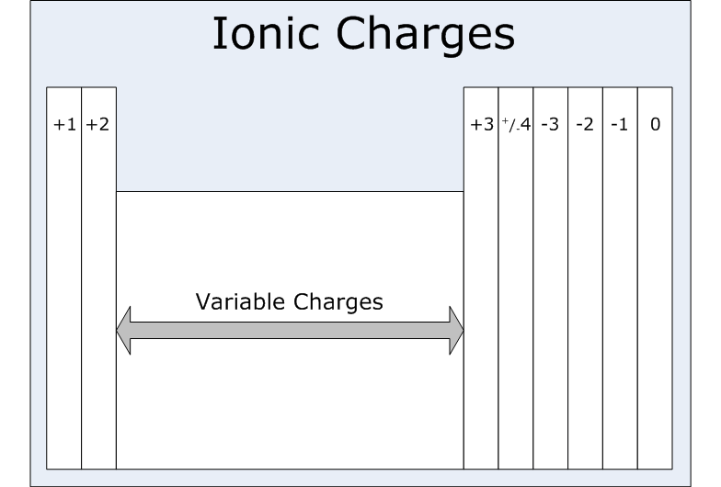

Practice Skill:
- From the following pairs of atoms circle the one with the highest ionization energy.
  - Ca or Cl b. P or Cl
    - Cl or Br d. Na or Rb
e. Ca or Cs f. Cr or As

2 a. Elements of family 16 will need to do what in order to have a stable electron arrangement?
__________________________________________________________________________________________
b. Se will have what charge as an ion? _________ Name the Se ion _______________________________
c. S will have what charge as an ion? __________ Name the S ion ________________________________
d. Ca will have what charge as an ion? _________ Name the Ca ion _______________________________
- Give the most likely symbol and charge for stable ions of:
  - Barium ___________________ Name the Barium ion _______________________________
  - Oxygen ___________________Name the Oxygen ion ________________________________
  - Cesium ___________________ Name the Cesium ion _______________________________
  - Bromine __________________ Name the Bromine ion ______________________________
  - Magnesium _______________ Name the Magnesium ion ____________________________
  - Potassium _________________ Name the Potassium ion _____________________________
4. Chlorine will become sable when it gains an electron; circle the following atoms that will best aid this in
happening?
  - carbon
  - calcium
  - sodium
  - sulfur
  - lithium
5. Which two groups or families will best aid Li to become a stable ion?
________________________________________________________________________________________
6. Which families will have atoms that will:
  - become a negative two ion ____________________________
  - become a positive one ion _____________________________
  - become a positive two ion _____________________________
  - become a negative one ion _____________________________
  - become a positive three ion _____________________________

- Identify which atom or ion has the following atomic make-up. Write the complete and proper symbol for each one.
  - 14 protons and 14 electrons ____________________________
  - 13 protons and 10 electrons ____________________________
  - 35 protons and 35 electrons ____________________________
  - 20 protons and 18 electrons ____________________________
  - 8 protons and 10 electrons _____________________________
  - 18 protons and 18 electrons ____________________________
  - 3 protons and 2 electrons ______________________________
C4.9c: Electronegativity of Elements: https://www.khanacademy.org/science/chemistry/chemical-bonds/types-chemical-bonds/v/electronegativity-and-chemical-bonds
Overall Trends: https://youtu.be/XK-WTYncldA

Electronegativity is the tendency of an atom to attract electrons. High electronegativity means a strong attraction for electrons. A very general relationship between atoms can be obtained from reviewing electronegativity values form the periodic table.
- In a family electronegativity increases as you go toward the top of the periodic table.
- On any horizontal row of the table, the electronegativity is largest on the right side of the table.
- Therefore, atoms of elements in family 17 (halogens) have a higher electronegativity than do atoms from family 1 (alkali metals). This great difference in attracting power enables elements from family 17 to take electrons away from elements from family 1. This creates both positive and negative ions. These opposite charges attract each other much like opposite poles on a magnet. This results in what is known as an ionic bond (the transferring of electrons).
- When two non-metals, both with high electronegativity, come in contact with each other, neither is sufficiently strong enough to remove electrons from the other atom. The atoms then are in a state where each is attracting the electrons of the other. This results in what is known as a covalent bond. In this type of bond electrons are shared between atoms. 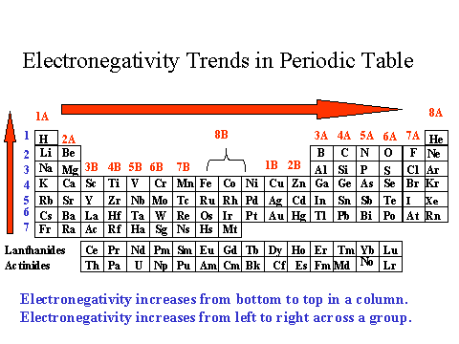

Practice Skill:
1. Which group of the periodic table has the strongest electronegativity? _____________________________
2. Which element from group 1 has the lowest electronegativity? ___________________________________
3. Which element from group 15 probably has the highest electronegativity? __________________________
4. Which element in families 1-17 probably has the highest electronegativity? _______________________
5. Which element in families 1-17 probably has the lowest electronegativity? __________________________
6. Circle the element that has the highest electronegativity from each of the following pairs:
a) Ca or Be b) I or Br c) Li or K d) Al or P e) K or Ca
7. Place the following elements in order from the highest to the lowest electronegativites based on the numbers on the periodic table.
a) Mg, Na, Br, Al, F, Cs __________________________________________________________
b) Sr, Si, Cs, Sn, Rb, C ___________________________________________________________
8. Since F is the atom having the highest electronegativity and is the smallest reacting atom (excluding H), which atom would you think would be the largest atom and have the lowest electronegativity?_________
C4.9c: Atomic Size and Chemical Bonds: Atom size is related to the electronegativity of an atom. Electronegativity is the tendency of an atom to attract electrons. The size is usually expressed in the radius of the atom. Here is a general method of determining atom size directly from the periodic table. The general rule is the further down the table in any family and further to the left in any row the larger the atom will be. This gives Fr of family 1 the distinction of being the largest atom and He the smallest atom.
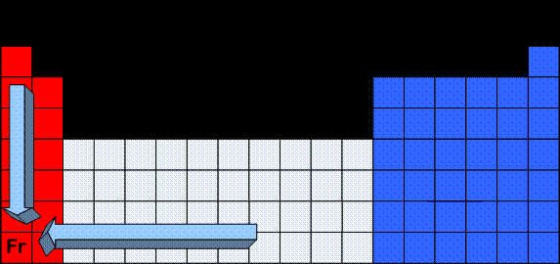
Trends in Atomic Size: https://youtu.be/QBcALKKLeRg
Practice Skill:
1. For each of the following pairs of atoms circle the smallest one.
  - Ca or Cl b. P or Cl c. Cl or Br d. Na or Rd
e. Ca or Cs f. Cr or As g. Li or Be h. O or Al

- Place the following atoms in order of largest to smallest.
Cl, Br, Ag, Cs, Al __________________________________________________________
3. On a sheet of graph paper graph the atomic number vs. the atomic radius for atoms in the 2nd
period or row of the periodic table. http://periodic.lanl.gov/index.shtml

Size of Ions
Atomic Radii vs. Ionic Radii https://youtu.be/cCtM1HBB-EU

Ionic Bonding and Size of Atom: http://www.teachersdomain.org/asset/lsps07_int_ionicbonding/

Ions & the Periodic Table:
Positive ions (cations) are always smaller than the neutral atoms from which they are formed because the larger number of protons (+) overcome the fewer number of electrons (-) and pull them in making a smaller radius. In contrast the negative ions (anions) are always larger than the neutral atom because the smaller number of protons (+) do not have sufficient force to pull in a larger number of electrons (-) making a larger radius.
Practice Skill:
1. Circle the ion or the atom with the largest radius. Explain your reasoning for each.
a. Li or Li ¹⁺ ______________________________________________________________________________________________________________________________________________________________________________
b. Br or Br¹⁻ ______________________________________________________________________________________________________________________________________________________________________________
c. Ca or Ca ²⁺ ______________________________________________________________________________________________________________________________________________________________________________
d. Al or Al ³⁺ ______________________________________________________________________________________________________________________________________________________________________________
e. O or O ²⁻ ______________________________________________________________________________________________________________________________________________________________________________
f. Mg or Mg ²⁺ ______________________________________________________________________________________________________________________________________________________________________________
g. Na or Na ¹⁺ ______________________________________________________________________________________________________________________________________________________________________________
h. Cl or Cl ¹⁻ _______________________________________________________________________________________

______________________________________________________________________________________C5.5A: Ionic and Covalent Bonding: As a reminder, covalent bonding is the sharing of valence electrons in order to fill the outermost energy levels of both atoms. This will allow the bonding atoms to exist at a lower energy thus making them more stable. Covalent bonding occurs between 2 or more non-metals. An ionic bond occurs when an atom gains or loses 1 or more electrons, leaving a formally neutral atom as a charged ion. The 2 charged atoms will be attracted to each other by that charge difference. They will hold together like the opposite poles of two magnets. Most ionic bonding occurs between a positively charged metal and a negatively charged non-metal.
Practice Skill: Identify the following compounds as either ionic or covalent and include your reasoning for each.
2. CO₂ ________________________________________________________________________________
3. CaCl₂ _______________________________________________________________________________
4. C₂H₆ _______________________________________________________________________________
5. H₂O ________________________________________________________________________________
6. NaCl _______________________________________________________________________________
7. SrBr₂ ______________________________________________________________________________
8. AlCl₃ _______________________________________________________________________________
9. CH₄ _______________________________________________________________________________
10. NH₄Cl _____________________________________________________________________________
11. C₃H₈ _____________________________________________________________________________
C5.5A: Chemical Bonds and Electronegativity: An atom’s electron configuration, particularly of the outermost electrons, determines how the atom can interact with other atoms. The interactions between atoms that hold them together in molecules or between oppositely charged ions are called chemical bonds. Ionic and covalent bonding of compounds or molecules can also be predicted using electronegativity values found on the periodic table. http://chemsite.lsrhs.net/ChemicalBonds/electronegativity.html
The electronegativity can be used to assist in determining the main characteristics holding simple binary compounds together. If two elements in question have a large electronegativity difference, the bond characteristics are said to be ionic. This occurs usually between elements from the metal region bonded to elements from the non-metal region of the periodic table. If the two elements in question are both from the non-metal region of the periodic table, the bond is probably covalent. The greater the differences in electronegativities are, the more ionic the bond is. 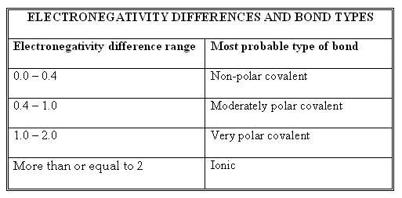
Practice Skill: 1. Determine the electronegativity difference of each of the following and then determine the type of bond. (only look at the difference between two atoms)
Compound | Difference in Electronegativity | Type of Bond
NaCl
CaBr₂
SiO₂
CCl₄
H₂O
CsF
F₂
P₂S₃
P₄
RbBr
CO₂
NO
CH₄
IBr
O₂

2. Arrange the following in order from highest in ionic character to the lowest in ionic character.
a) LiI, BaO, AlCl₃, CsF, RbBr _____________________________________________________
b) K₂O, CaS, ClF, PBr₃, F2 _________________________________________________________________________________
3. Circle the pairs of elements that would have the most tendencies to be an ionic bond because of the great
differences in electronegativity.
a) Ca & Cl or S & Cl b) Br & Se or K & F
c) Ba & O or Ga & P d) Co & Br or Cs & S
e) Si & N or Si & F f) Na & F or Li & B
An atom’s electron configuration, particularly of the outermost electrons, determines how the atom can interact with other atoms. The interactions between atoms that hold them together in molecules or between oppositely charged ions are called chemical bonds.
4. Is the bonding between magnesium and chlorine ionic or covalent?

Claim:

Evidence:

Reasoning:

C5.5d: http://www.meta-synthesis.com/webbook/37_ak/triangles.html
Electronegativities & Physical Properties:
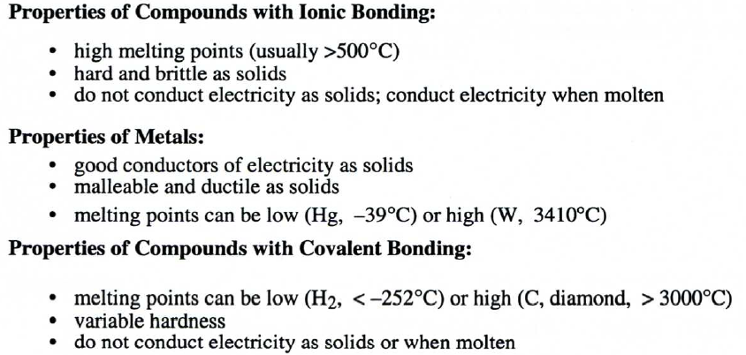
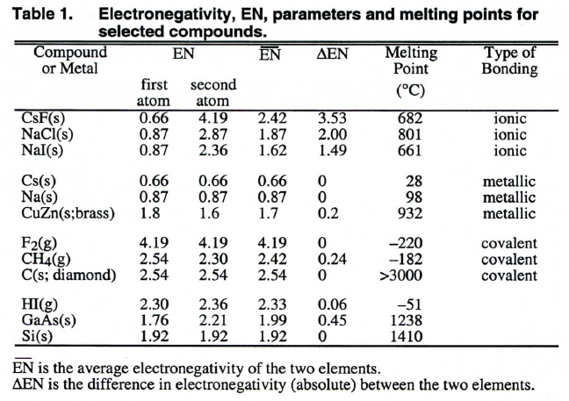
Bond triangles or Van Arkel-Ketelaar triangles help us to predict the properties of a compound based on the electronegativities of the elements that make up a compound. The data for CsF, F2, and Cs from Table 1 have been used to generate three points at the corners of the bond-type triangle shown in Figure 1. The bond-Type triangle can be divided into regions which indicate the predominant type of bonding present in compounds. The dividing lines between regions are not absolute, but they give a general idea of the boundaries between different types of bonding.
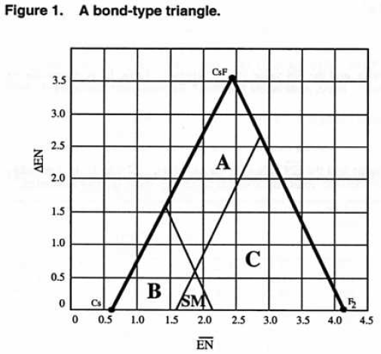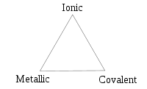
Practice Skill: 1. Fill in the following chart:
Compound or Metal | EN of 1st Atom | EN of 2nd Atom | ___  EN | ∆EN | Type of Bond
NaCl
CH₄
H₂
BaO
NH₃
BaBr₂
CO₂
Fe
Cu

2. For each of the above graph the points on the bond-type triangle.

(is the x-coordinate and ∆EN is the y-coordinate)

- Fill out the following chart on physical properties: (look at chart on page 20 to answer)

Compound or Metal | Conducts Electricity in the Solid State | Conducts Electricity in the Molten State | Does not Conduct Electricity | Has a High Melting Point | Has a Low Melting Point
NaCl
CH₄
H₂
BaO
NH₃
BaBr₂
CO₂
Fe
Cu

C5.5B: Predicting the Formula of a Compound
Oxidation numbers are needed to predict the formula of a compound formed between 2 elements. Once again here are the ionic charges for each family:
For ionic compounds the goal is to get the total charges to equal to 0. Predicting the bond between Li and O:
a. Know the charges for each---- Li ¹⁺ and O ²⁻

I have 1 positive charge and 2 negative charges
So I need a total of 2 positive charges and 2 negative charges
This means I need a total of 2 Li atoms and 1 oxygen atom
The number of atoms is written as a subscript

Li₂O is the correct formula

b. Another way to look at this is by using the crisscross method. You still have to know the charge of the ion. This method is explained in your textbook on page 100.
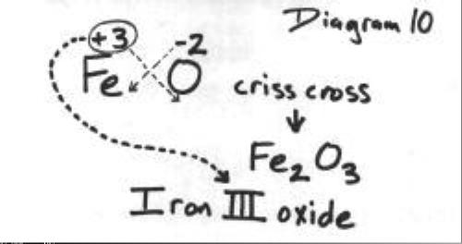
When using the crisscross method remember to reduce to lowest terms:
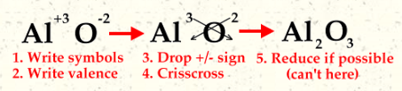
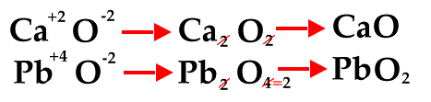
For covalent bonds we cannot look at the charges on the ions. When nonmetallic elements combine they often do so in more than one way. For example the elements C & O can combine as CO, CO₂, or CO₃²⁻; these each have different physical and chemical properties.
  - Prefixes are used to show how many atoms of each element are present in each molecule (and formula) of a binary molecular compound. 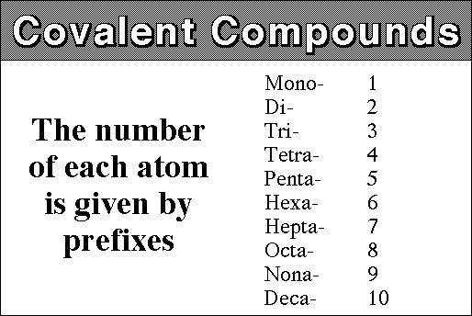 The 2 compounds of carbon and oxygen then are named carbon monoxide (CO) and carbon dioxide (CO2). Note that the second element in the name is written with an –ide ending. Thus all binary compounds, both ionic and molecular, end in –ide. Note also that the vowel at the end of the prefix mono- is dropped when the name of the element begins with a vowel: monoxide, not monoxide.

  - In summary (excluding crisscross):
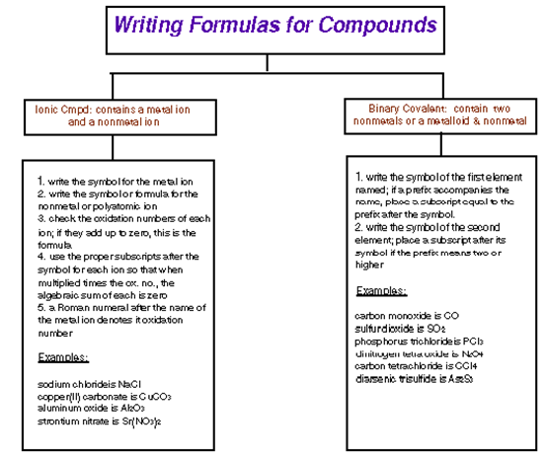
Practice Skill: 1. Using the periodic table and the number of electrons needed to become stable ions, write the formula for the compound formed from the following pairs of elements.
a) Na & F b) K & O c) Ca & Br d) Ca & I e) H & Cl

f) Ba & O g) Na & O h) Al & Cl i) K & I j) Na & Cl

2. Write formulas for these compounds.
a) dinitrogen tertrahydride b) carbon disulfide c) carbon tetrachloride

d) diphosphorus trioxide e) sulfur hexafluoride f) dinitrogen monoxide

g) phosphorus trichloride h) sulfur trioxide i) carbon monoxide

Periodic Trends In Summary:
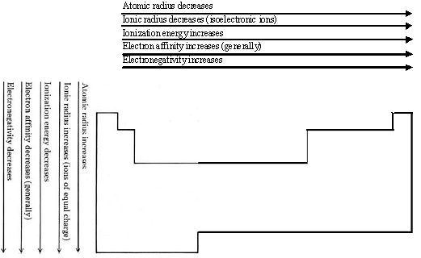

C5.5c:Drawing Lewis Dot Structures
Now that you have some idea of how atoms combine to form compounds or molecules, some effort must be spent to determine the shape of those molecules. This is accomplished through Lewis dot structures.
As we already know, the family number from the periodic table will tell us how many valence electrons each particular element has. In Lewis dot structures we only concern ourselves with those electrons in the outer most energy called valence electrons. This makes the scheme of where those electrons are placed around the symbol very important.

In the following chart, notice the valence electrons assigned to each family.
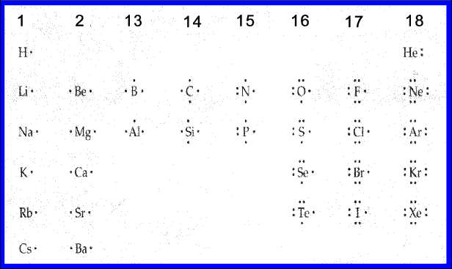

Family 1 elements all have 1 valence electron.
Family 2 elements have 2 valence electrons placed so that each is on either side of the symbol forming a 180⁰ angle. 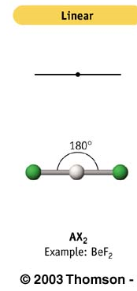
Family 13 elements all have 3 valence electrons arranged in a triangular planer shape around the symbol.
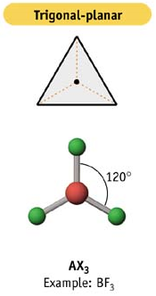
Family 14 elements all have 4 valence electrons arranged so that 1 electron appears on each of the 4 sides of the symbol. In 3-dimensional space the molecule with a family 14 element at its center would have a tetrahedral shape. 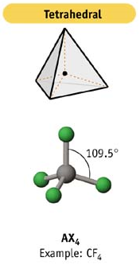
Family 15 elements all have 5 valence electrons arranged with 1 on each of the 4 sides of the symbol. One of the sides shows a pair of electrons. The shape is trigonal-bipyramidal or pyramidal.
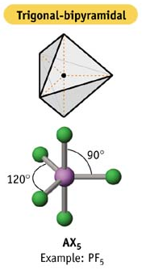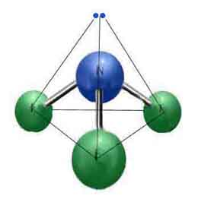
Family 16 elements all have 6 valence electrons arranged so that the 2 sides where there are 2 electrons are adjacent to each other. This allows the molecule with a family 16 element at its center to have a bent or angular shape.
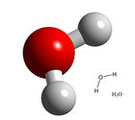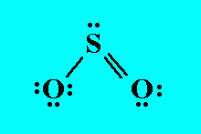

Or it can have an octahedral shape.
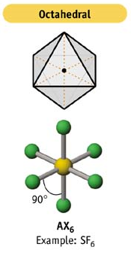

Family 17 elements all have 7 valence electrons arranged with 3 sides of the symbol having pairs of electrons with the remaining side with a single electron. The single electron will allow for only 1 bond.
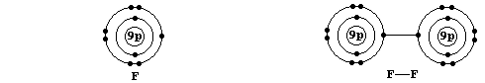

Family 18 elements all have 8 valence electrons. These are arranged with all 4 sides of the symbol having pairs of electrons. They usually do not form bonds with other elements because they have a full set of valence electrons.
We use Lewis dots and the Octet Rule to predict the final shape of a molecule. 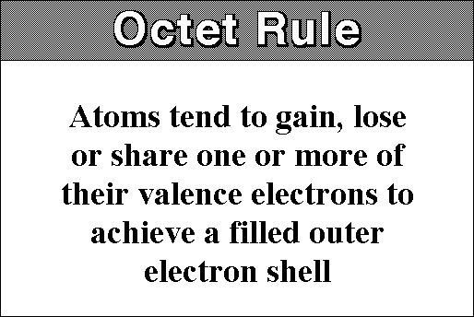Electron dot structure - valence electrons are represented by dots placed around the chemical symbol. Electrons are placed up to two on each side of the elemental symbol for a maximum of eight, which is the number of electrons in a filled s and p shell. We place a single electron on each side before pairing them up. Period one (hydrogen and helium) represents an exception where only a maximum of two electrons are placed on one side of the element. Sometimes we use an x instead of a dot to represent an electron. This allows us to track the electrons better.
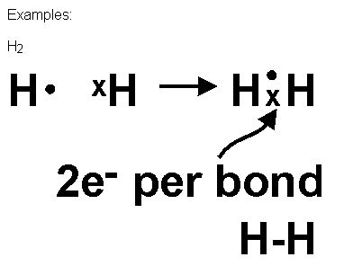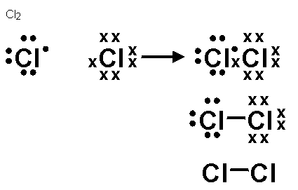
Octet rule (for s- and p-block elements) - atoms combine and form bonds either by transferring electrons to form ions or by sharing electrons in covalent bonds until each atom is surrounded by 8 valence electrons. Electrons in bonds are considered in counting the electrons in both atoms involved in the bond. H and He are the exception to the octet rule. 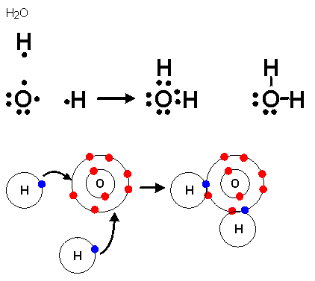Notice the bent angular shape of water.
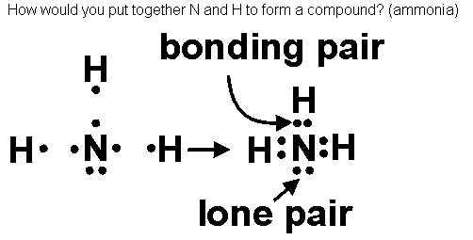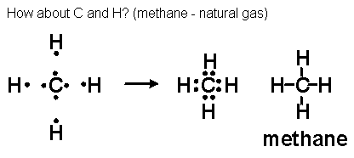
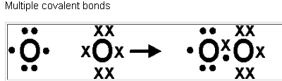octet rule not satisfied - 7 electrons on each oxygen
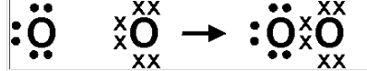octet rule not satisfied on both oxygen atoms - 6 electrons on one and 8 electrons on the other
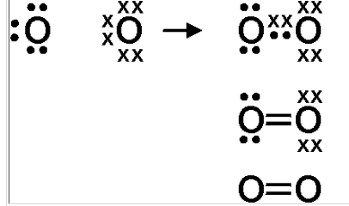Multiple bonds - have two sets of shared electrons. The octet rule is satisfied on both oxygen atoms. Again, the lone pairs are often omitted, but if you understand electron configuration you know that they must be there!

Practice Skill: In the spaces below, draw the Lewis Dot Structure for each indicated molecule.
a. H₂ Hydrogen Gas b. NH₃ Ammonia c. F₂ Fluorine Gas

d. Cl₂ Chlorine Gas e. Br₂ Bromine Gas f. I₂ Iodine

g. H₂O Water h. H₂S Hydrogen Sulfide i. HCl Hydrochloric Acid

j. HBr Hydrogen Bromide k. SF₂ Sulfur Difluoride l. SCl₂ Sulfur Dichloride

m. NCl₃ Nitrogen Trichloride n. NBr₃ Nitrogen Tribromide o. PCl₃ Phosphorous trichloride

C5.2g: Avogadro’s Number More than a century ago, a scientist was working on the properties of certain gases. This scientist, Avogadro, found that gases with an equal number of molecules occupied an equal volume. Avogadro discovered that this number of particles was found by taking the atomic mass of the element in grams, it was later called 1 mole, and multiplying that 1 mole by a factor of 6.02 x 10²³. This number allows scientists to find the number of atoms or molecules that are contained in a specific mass of an element or compound. One mole of any element (the molar mass or molecular mass) is the mass listed on the periodic table rounded to the nearest whole number (with the exceptions of copper and chlorine, they remain 63.5 and 35.5 respectively). This conversion can be done in the other direction. A mass of an element can also be found from a number of atoms or molecules. The decision that must be made in each case would be to multiply or divide by Avogadro’s number.
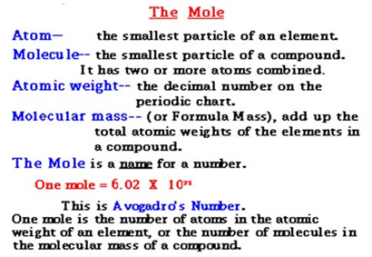
The molar mass of H is 1g/mol.
The molar mass of C is 12g/mol.
The molar mass of O is 16g/mol.
The molar mass of Na is 23g/mol.
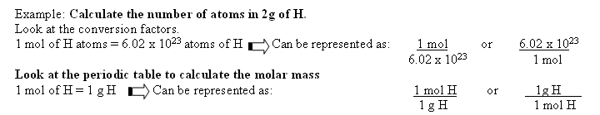
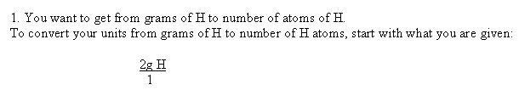
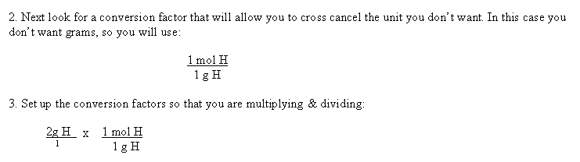
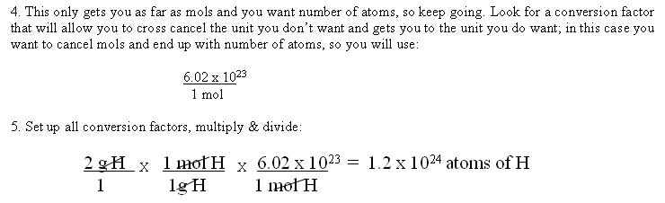
Practice Skill:
- How many Neon atoms are in 30.0 g of Neon?
- A manufacturer needs 500.0 kg of Iron. How many atoms of Iron are included in this mass?
- How many Hydrogen atoms are in 4 g of Hydrogen?
- How many Calcium atoms are in 24 g of Calcium?
As stated earlier this process can be done in the other direction.
Example: 2.05 x 10²⁵ atoms of gold are needed to make a small golden stature. Find the number of moles and the mass needed to make the statue.
Look at the conversion factors:
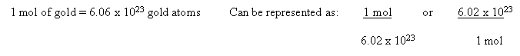
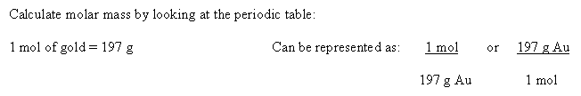
Consider where you need to begin and where you need to end. You need to start with what you are given; atoms of gold and you need to end up with number of moles as well as grams.
Set up all the appropriate conversion factors to calculate the number of moles in 2.05 x 10²⁵ atoms of gold.
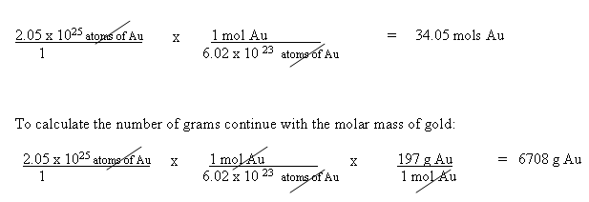
Practice Skill:
- Find the number of moles of Sulfur necessary to account for 3.44 x 10¹⁹ atoms of Sulfur.
- Find the number of grams of Rubidium needed to contain 2.75 x 10³⁴ atoms of Rubidium.
- Find the number of moles of Sodium in 3.5 x 10²⁶ atoms of Sodium.
- Find the number of moles and grams of Potassium in 5.5 x 10³⁶ atoms of Potassium.
C4.10c: Isotopes in Nature; Most elements in nature are mixtures of isotopes. Some isotopes of an element may be radioactive, while others are not. All isotopes of an element behave virtually the same way chemically, because they have the same electron distribution and differ only slightly in mass. The atomic weight of an element as shown on the periodic table, represents averages based on the relative natural abundances of the isotopes of that element. What is the relationship between an element’s atomic mass and the percent abundance of the element’s isotopes?
Calculating Average Atomic Mass:
Naturally occurring copper (Cu) consists of 69.1% Cu-63 and 30.9% Cu-65. The atomic (molar) masses of these two isotopes are: Cu-63 = 62.93 g/mol Cu-65 = 64.93 g/mol
Isotope | Molar mass | Percentage | Decimal fraction | Contribution
Cu-63 | 62.93 g/mol | 69.1% | 0.691 | 62.93 x 0.691
Cu-65 | 64.93 g/mol | 30.9% | 0.309 | 64.93 x 0.309
Average atomic (molar) mass is the sum of the individual contributions. Since there are two naturally occurring copper isotopes the average atomic (molar) mass of copper can be calculated as follows:
Average atomic mass of Cu = (62.93 g/mol)(0.691) + ( 64.93 g/mol)(0.309) = 63.5 g/mol
Note this is the mass on the periodic table
Practice Skill:
- Calculate the average atomic mass for gallium if 60.00% of its atoms have a mass of 68.926 g/mol and 40.00% have a mass of 70.925 g/mol.

- Calculate the average atomic mass of oxygen. Its composition is 99.76% of atoms with a mass of 15.99 g/mol, 0.038% with a mass of 17.00 g/mol, and 0.20% with a mass of 18.00 g/mol.

3. Magnesium has three stable isotopes as follows:
Mass Number | Isotopic Mass | % Abundance
24 | 23.98504 | 78.99
25 | 24.98594 | 10.00
26 | 25.98259 | 11.01
Calculate the average atomic mass for magnesium.

4. Element X has two natural isotopes. The isotope with a mass number of 10 has a relative abundance of 20%. The isotope with a mass number of 11 has a relative abundance of 80%. Estimate the average atomic mass for the element from these figures. What is the true identity and atomic number of element X?

C4.10d: Predicting Which Isotope will have the Greatest Abundance Notice that you can predict which isotope will have the greatest abundance by looking at the percent abundances of each isotope and the average atomic mass in the periodic table. Example: If B has only isotopes of B¹¹ and B¹⁰ but the atomic mass is listed as B^{10.81}; atoms of isotope B-11 must be more abundant than isotope B-10.
Practice Skill: 1. Given the percent abundance and mass of each isotope in the table below, what is the average atomic mass, in atomic mass units (amu), for an unknown element (X)?
Mass and Percent Abundance of Different Isotopes of Element (X)
Isotope | Mass of Isotope (amu) | Percent Abundance
X-32 | 31.9720707 | 95.02
X-33 | 32.9714585 | 0.7500
X-34 | 33.9678668 | 4.210
X-36 | 35.9670809 | 0.02000

- 30.97
- 32.06
- 33.00
- 35.45

2. For each of the following isotopes place a check mark next to the isotope you believe has the greatest abundance. You will need to refer to the periodic table.

Natural Percent Abundance of Stable Isotopes of Some Elements
Name | Natural Percent Abundance | Mass (amu)
Hydrogen-1 |  | 1.0078
Hydrogen-2 |  | 2.0141
Hydrogen-3 |  | 3.0160
Helium-3 |  | 3.0160
Helium-4 |  | 4.0026
Nitrogen-14 |  | 14.003
Nitrogen-15 |  | 15.000
Carbon-12 |  | 12.00
Carbon-13 |  | 13.003
Oxygen-16 |  | 15.995
Oxygen-17 |  | 16.995
Oxygen-18 |  | 17.999
Sulfur-32 |  | 31.972
Sulfur-33 |  | 32.971
Sulfur-34 |  | 33.967
Sulfur-36 |  | 35.967

References:

Ionization energy: http://www.chemguide.co.uk/atoms/properties/ies.html
Bond Triangles: http://en.wikipedia.org/wiki/Van_Arkel-Ketelaar_triangle
http://www.laney.peralta.edu/Projects/31016/chemistry_1A/laboratory_handouts/lab_handouts_/the_bond_type_triangle.pdf
http://www.wwnorton.com/college/chemistry/chemistry3/ch/04/chemtours.aspx

