C5.5A: Ionic and Covalent Bonding: As a reminder, covalent bonding is the sharing of valence electrons in order to fill the outermost energy levels of both atoms. This will allow the bonding atoms to exist at a lower energy thus making them more stable. Covalent bonding occurs between 2 or more non-metals. An ionic bond occurs when an atom gains or loses 1 or more electrons, leaving a formally neutral atom as a charged ion. The 2 charged atoms will be attracted to each other by that charge difference. They will hold together like the opposite poles of two magnets. Most ionic bonding occurs between a positively charged metal and a negatively charged non-metal.
Practice Skill: Identify the following compounds as either ionic or covalent and include your reasoning for each.
2. CO₂ ________________________________________________________________________________
3. CaCl₂ _______________________________________________________________________________
4. C₂H₆ _______________________________________________________________________________
5. H₂O ________________________________________________________________________________
6. NaCl _______________________________________________________________________________
7. SrBr₂ ______________________________________________________________________________
8. AlCl₃ _______________________________________________________________________________
9. CH₄ _______________________________________________________________________________
10. NH₄Cl _____________________________________________________________________________
11. C₃H₈ _____________________________________________________________________________
C5.5A: Chemical Bonds and Electronegativity: An atom’s electron configuration, particularly of the outermost electrons, determines how the atom can interact with other atoms. The interactions between atoms that hold them together in molecules or between oppositely charged ions are called chemical bonds. Ionic and covalent bonding of compounds or molecules can also be predicted using electronegativity values found on the periodic table. http://chemsite.lsrhs.net/ChemicalBonds/electronegativity.html
The electronegativity can be used to assist in determining the main characteristics holding simple binary compounds together. If two elements in question have a large electronegativity difference, the bond characteristics are said to be ionic. This occurs usually between elements from the metal region bonded to elements from the non-metal region of the periodic table. If the two elements in question are both from the non-metal region of the periodic table, the bond is probably covalent. The greater the differences in electronegativities are, the more ionic the bond is. 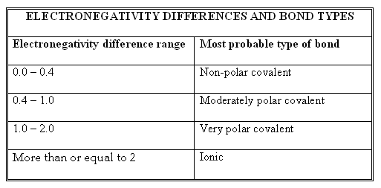
Practice Skill: 1. Determine the electronegativity difference of each of the following and then determine the type of bond. (only look at the difference between two atoms)
Compound | Difference in Electronegativity | Type of Bond
NaCl
CaBr₂
SiO₂
CCl₄
H₂O
CsF
F₂
P₂S₃
P₄
RbBr
CO₂
NO
CH₄
IBr
O₂

2. Arrange the following in order from highest in ionic character to the lowest in ionic character.
a) LiI, BaO, AlCl₃, CsF, RbBr _____________________________________________________
b) K₂O, CaS, ClF, PBr₃, F2 _________________________________________________________________________________
3. Circle the pairs of elements that would have the most tendencies to be an ionic bond because of the great
differences in electronegativity.
a) Ca & Cl or S & Cl b) Br & Se or K & F
c) Ba & O or Ga & P d) Co & Br or Cs & S
e) Si & N or Si & F f) Na & F or Li & B
An atom’s electron configuration, particularly of the outermost electrons, determines how the atom can interact with other atoms. The interactions between atoms that hold them together in molecules or between oppositely charged ions are called chemical bonds.

4. Is the bonding between magnesium and chlorine ionic or covalent?

Claim:

Evidence:

Reasoning:

