**Big Idea**

Quantum theory provides a foundation for the atomic model and the understanding of electron behavior and arrangement.

**Core Concepts**

* Electrons are arranged in main energy levels (1-7) with sublevels (s, p, d, f, g, h…..) that specify particular shapes and geometry
* Evidence for the movement of electrons between different energy levels can be observed through absorption and emission spectra

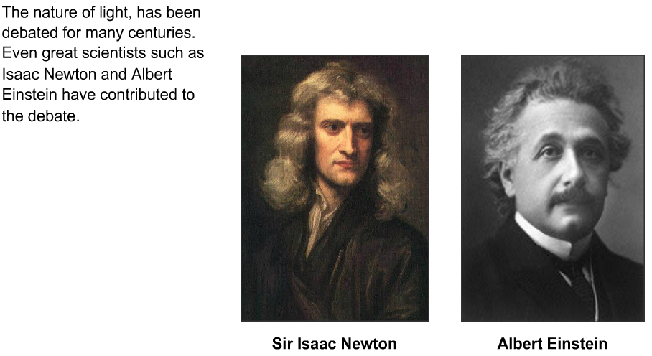

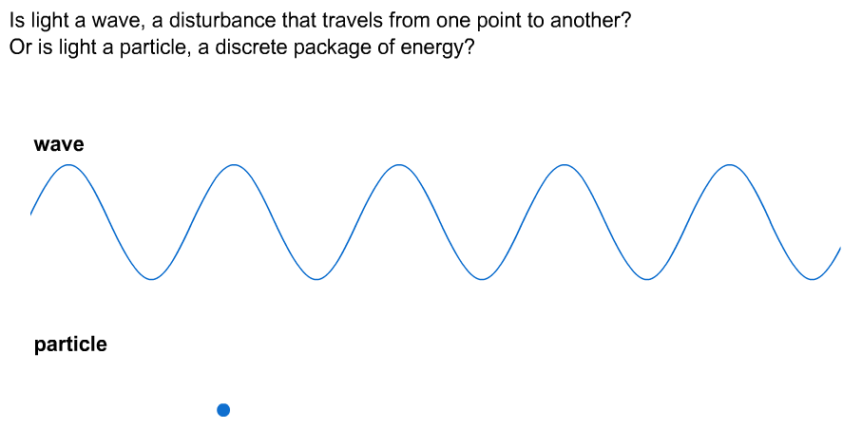

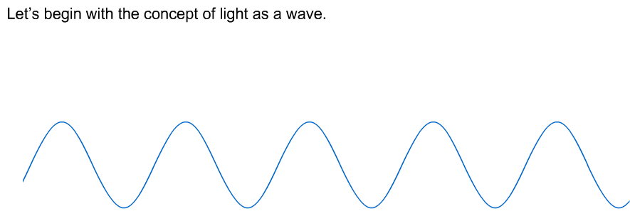

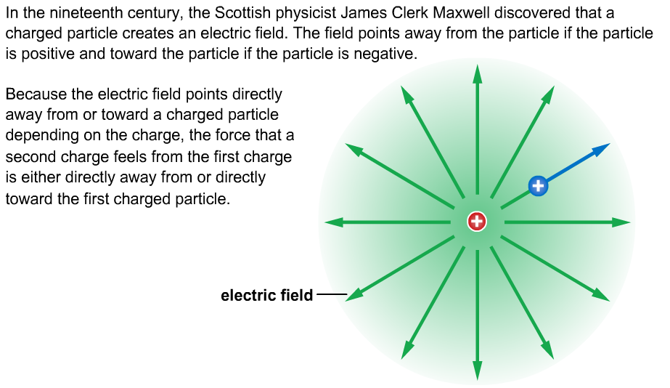

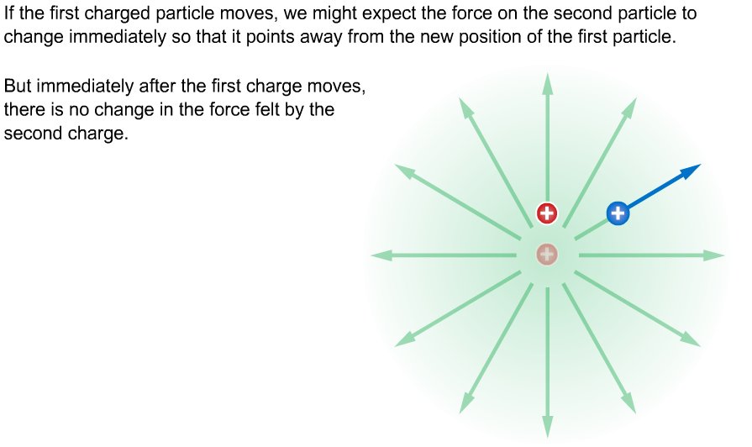

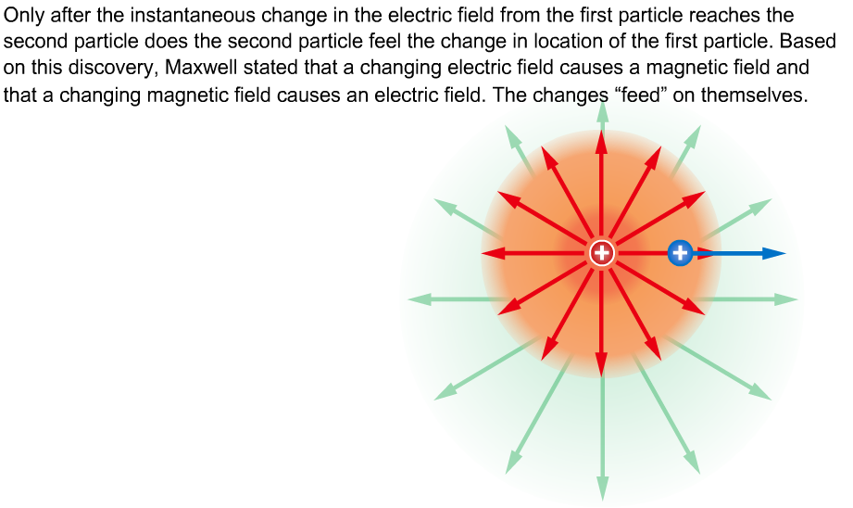

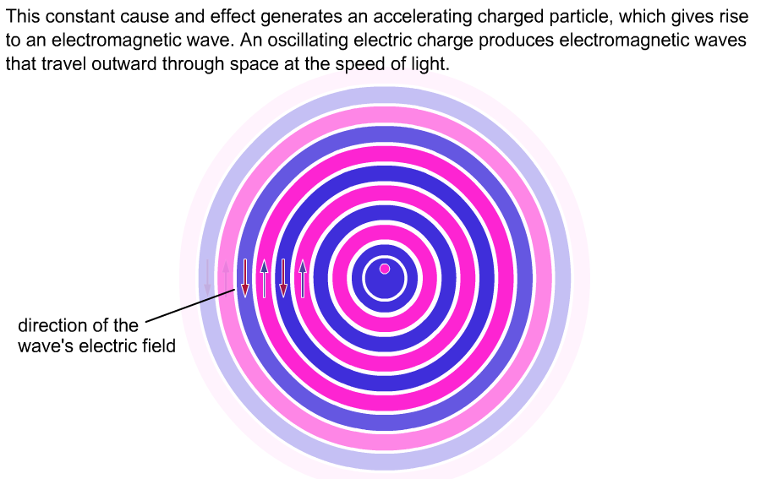

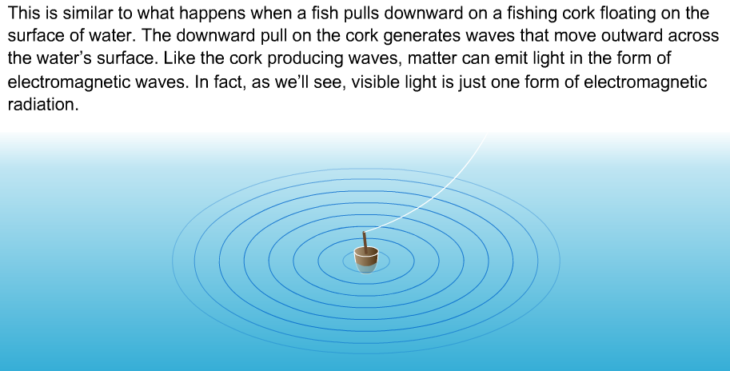

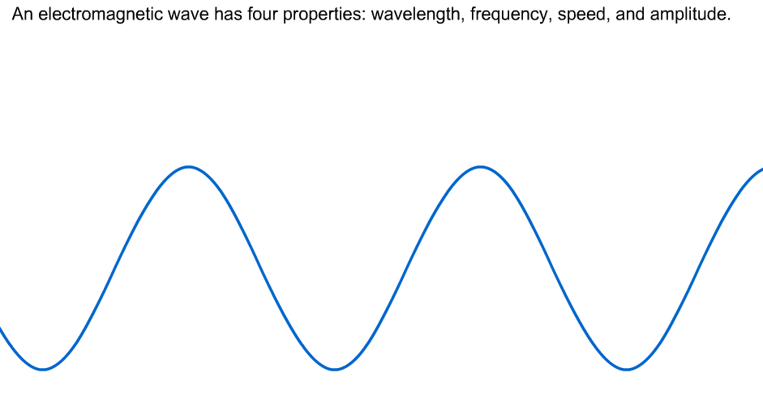

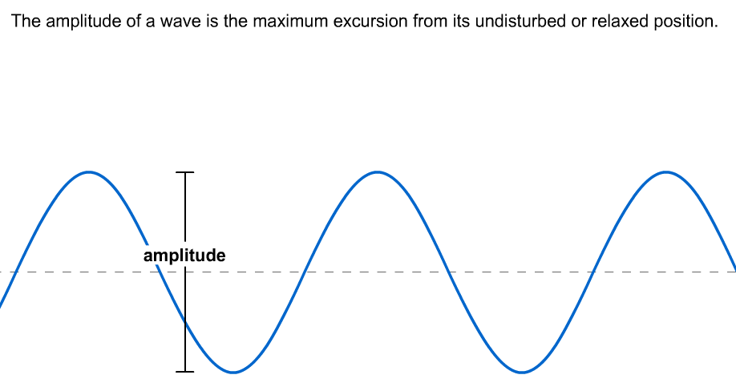

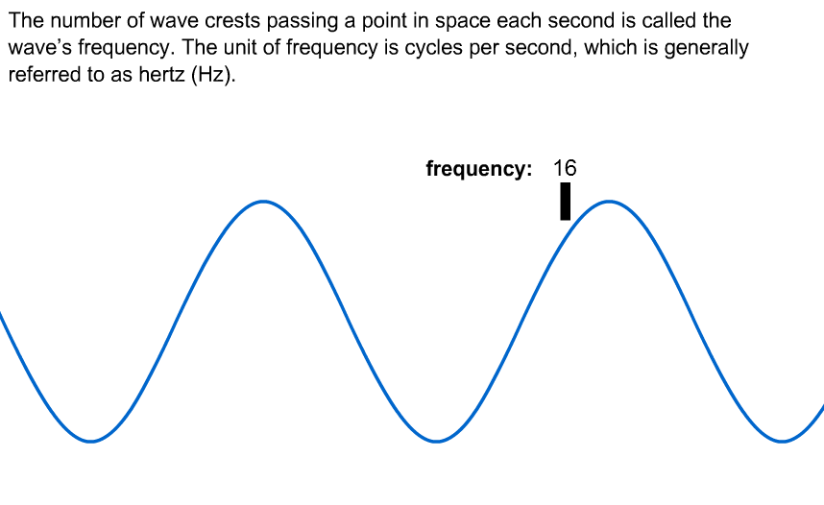

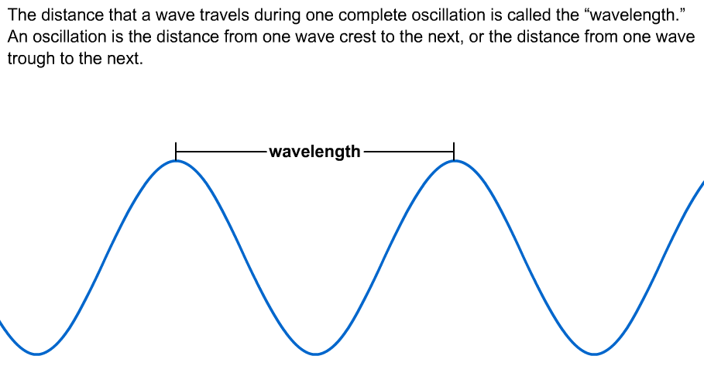

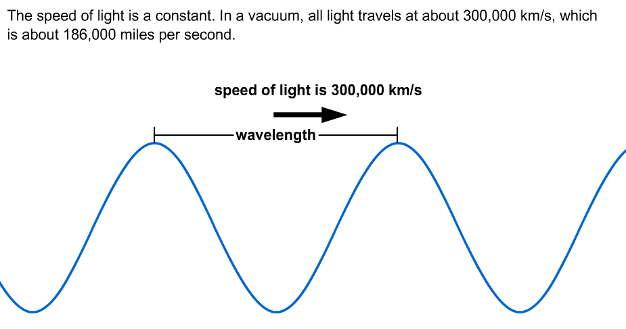

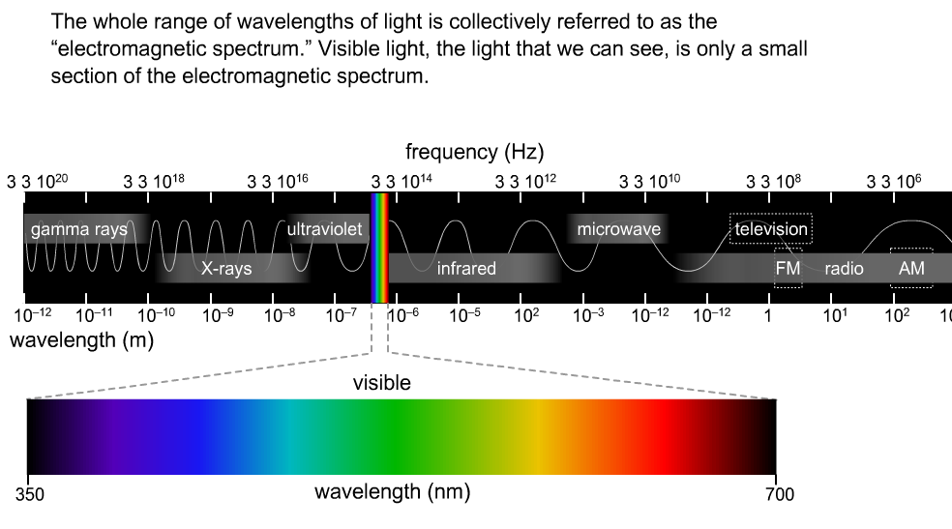

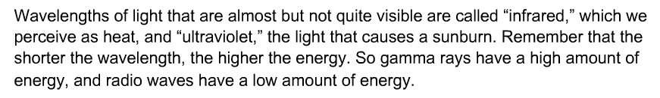

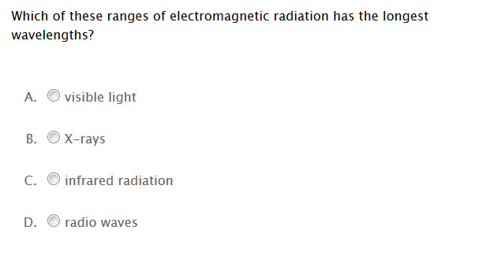

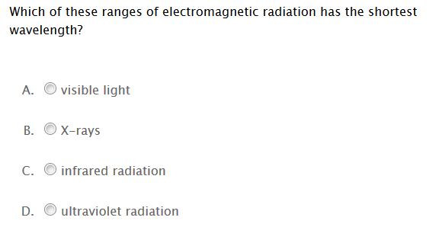

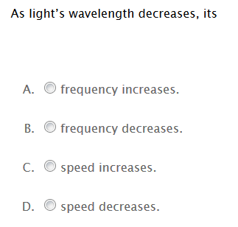

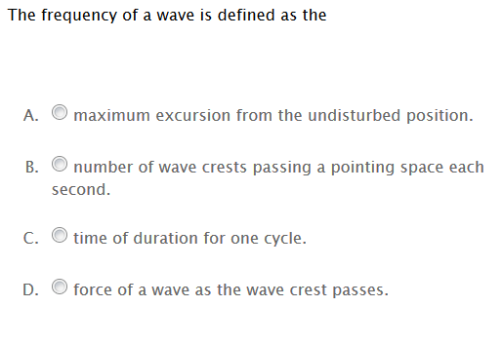

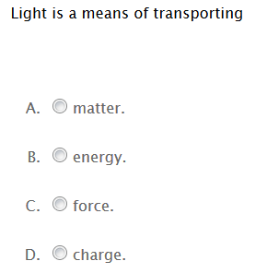

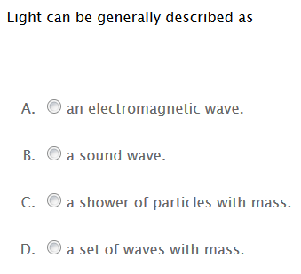

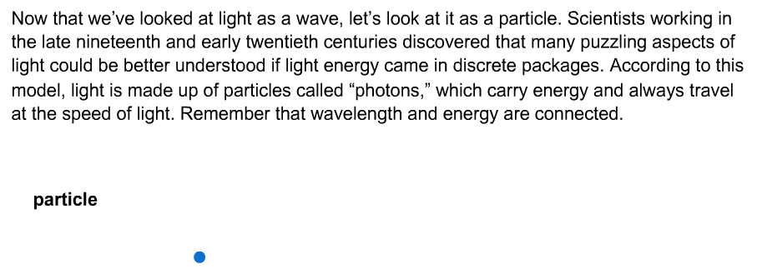

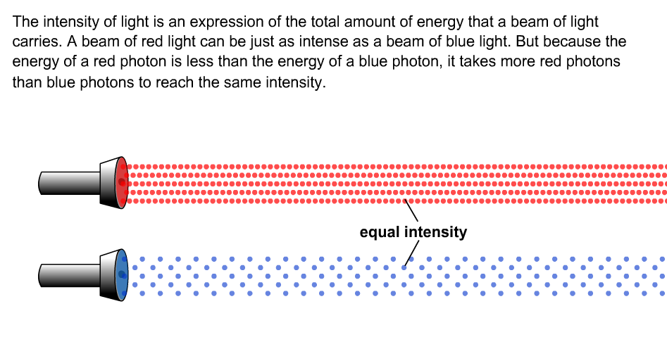

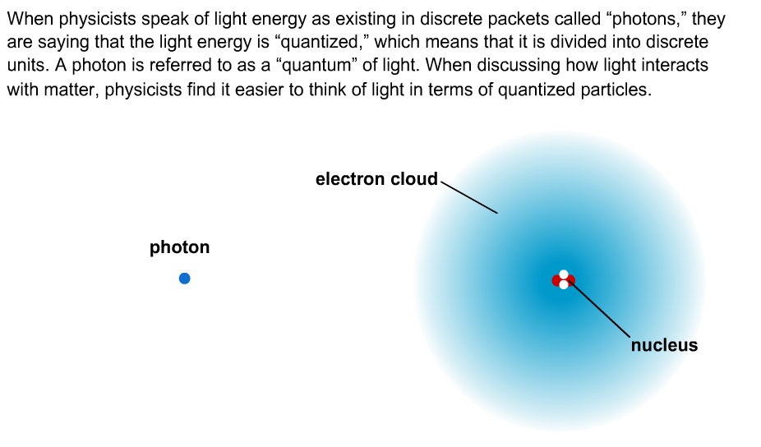

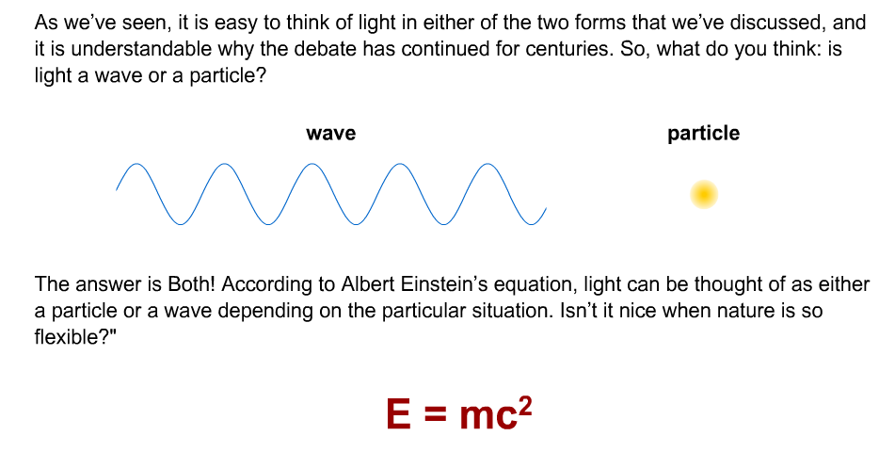

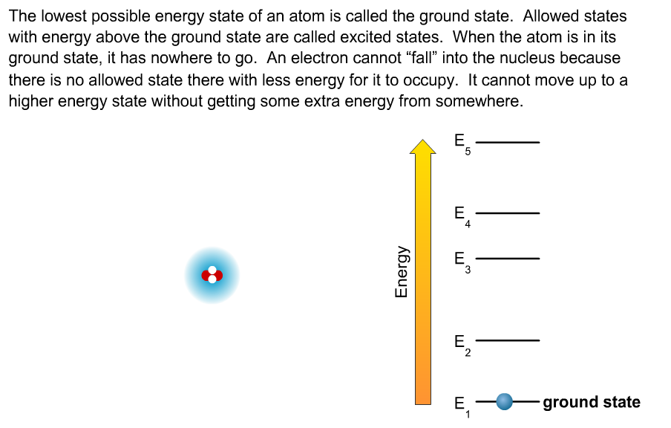

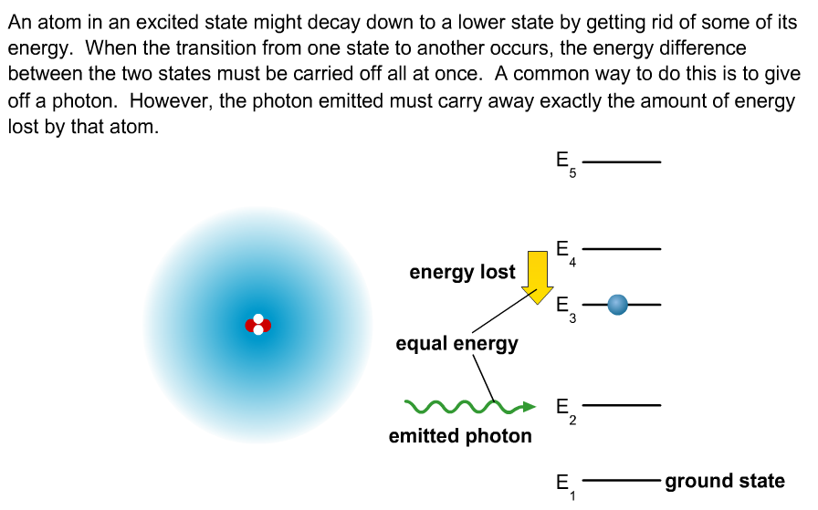

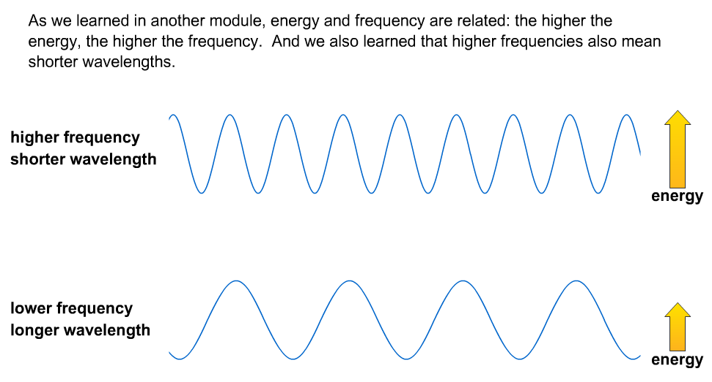

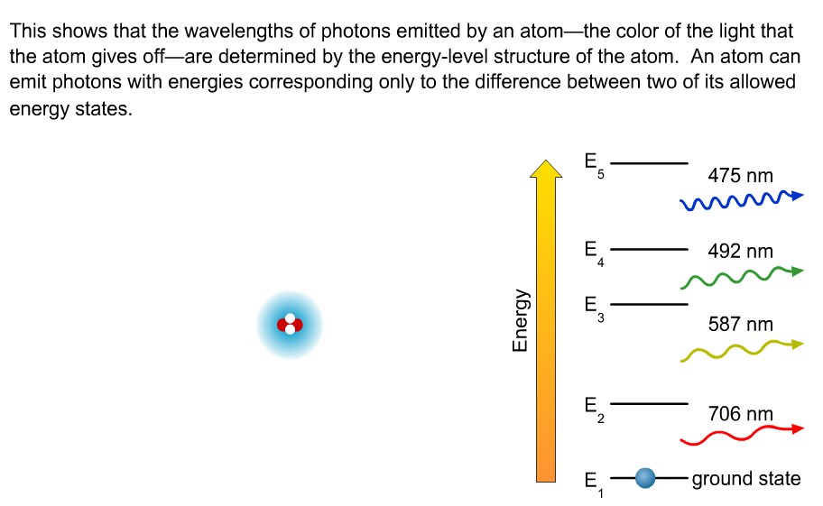

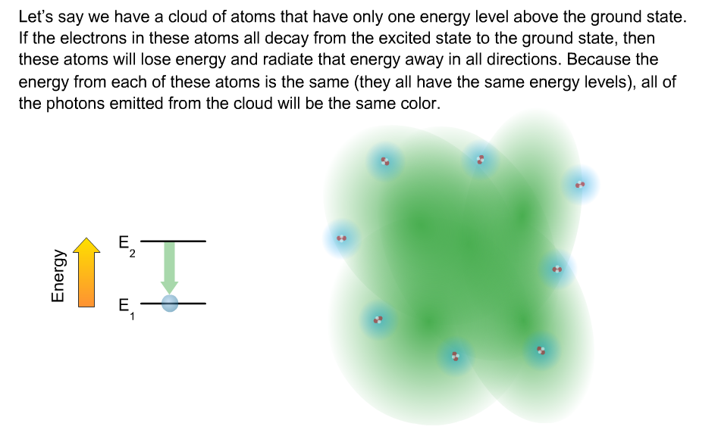

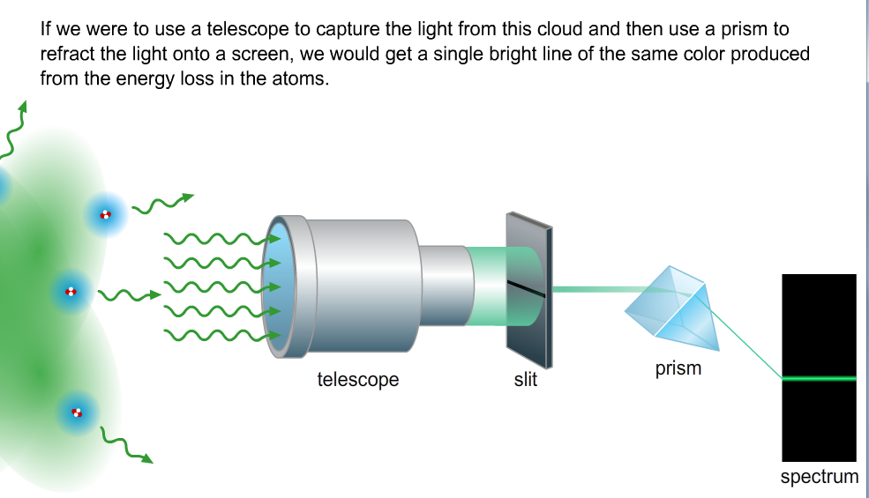

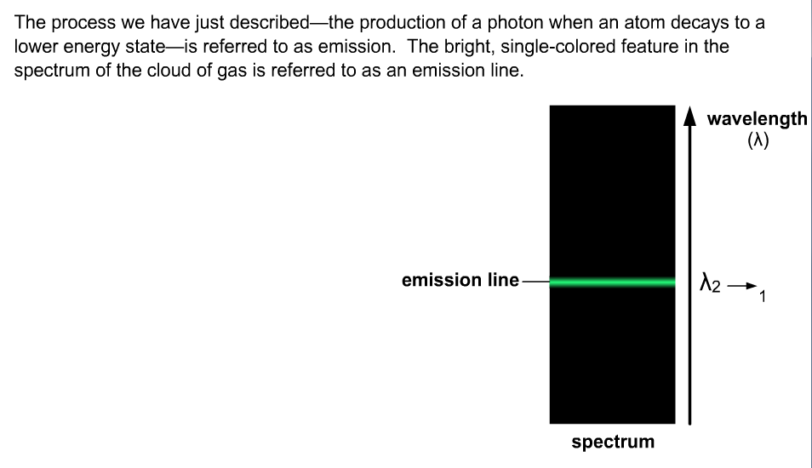

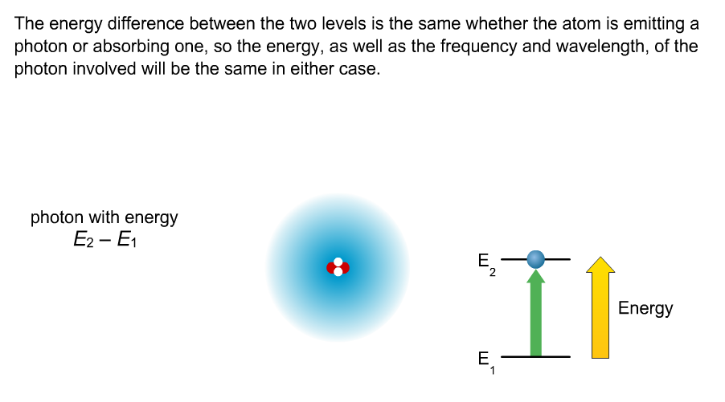

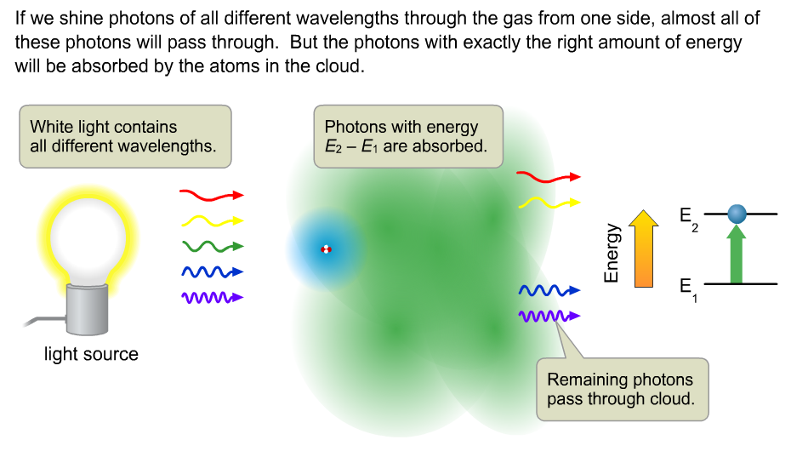

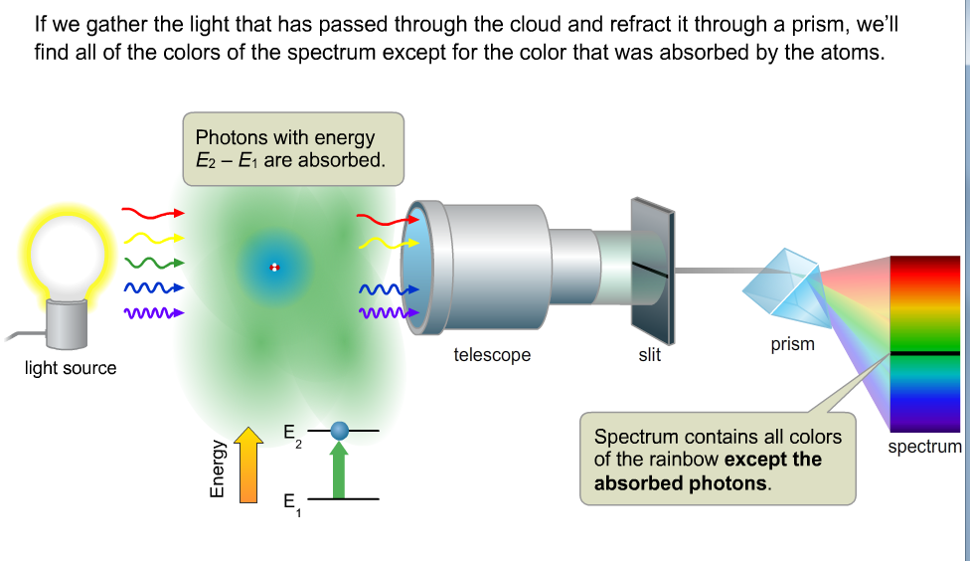

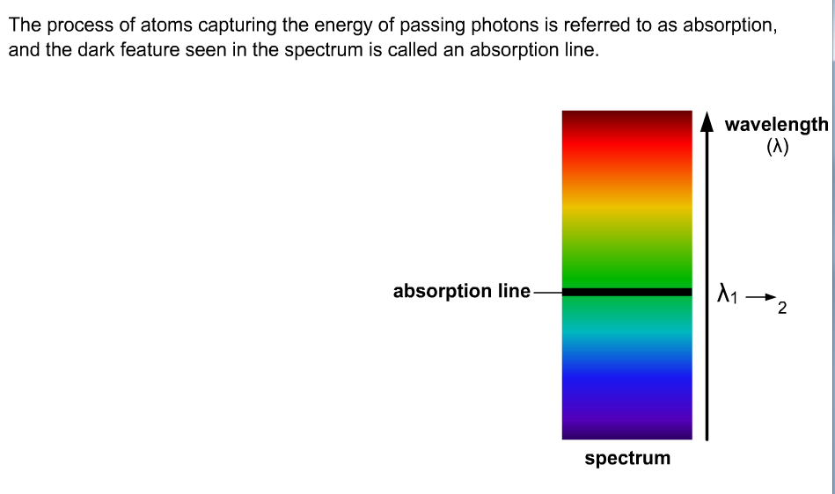

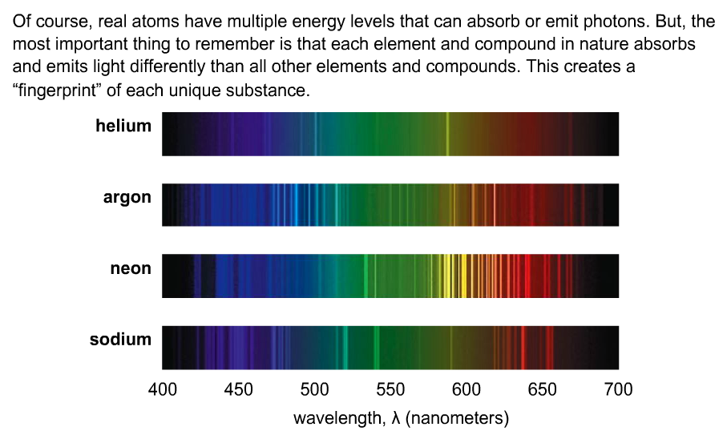





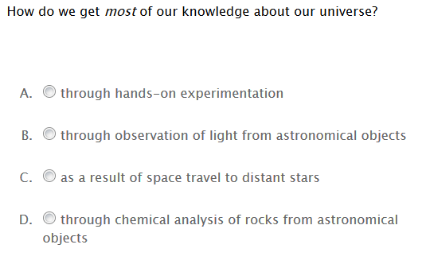

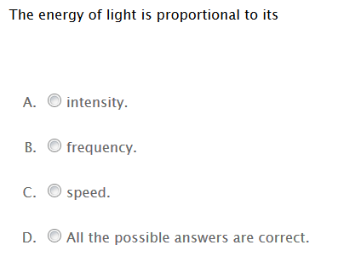

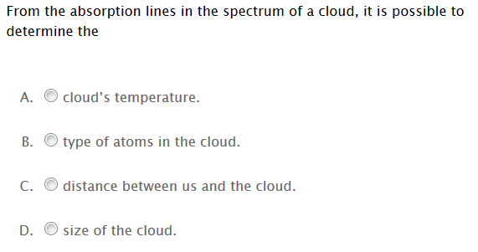

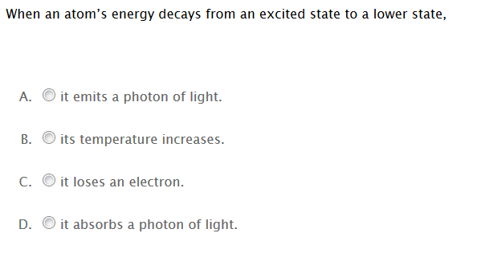

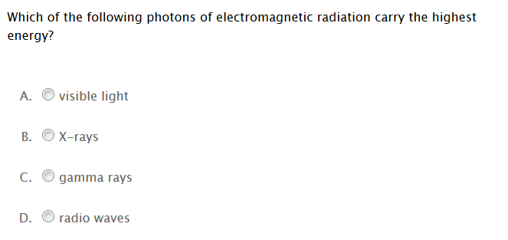

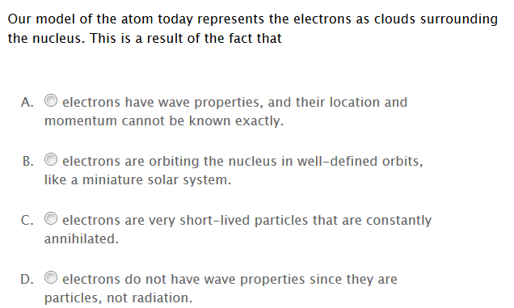

**C2.4d: The Electromagnetic Spectrum: How light travels**

The spectrum is the arrangement of all the various forms of electromagnetic radiation in order of decreasing wavelengths or increasing frequencies.

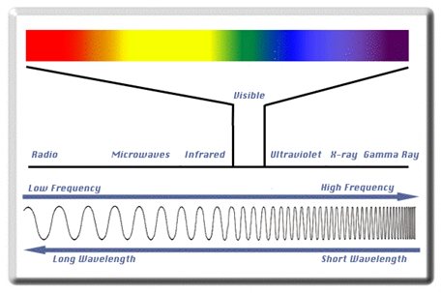



Examples of using electromagnetic radiation include listening to the radio, using a microwave oven, a remote control, or a cell phone. The bright lights of a neon sign, getting an x-ray, or even a rainbow are also examples of electromagnetic radiation. All of these are different examples of light energy known as electromagnetic radiation that travels as waves through space. Visible light at wavelengths from 700 to 400 nm is the only form of light our eyes can detect. **The longer the wavelength, the lower the energy is**. The wavelength is the distance from one peak to another and the frequency is the number of waves that pass a certain point in 1 second.

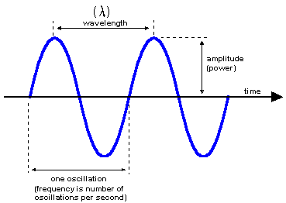

**C1.2i: The Wave-Mechanical Model**

**String Theory: Quantum Mechanics**

In the early 1920’s it was becoming apparent that there were some difficulties with the Bohr model of the atom. One difficulty was that Bohr used classical physics to calculate the orbits of the hydrogen atom but this could not be used to explain the ability of electrons to stay in only certain energy levels without the loss of energy. The Bohr model could also not be used to explain that the only change of energy occurred when an electron “jumped” from one energy level to another and could not exist in the atom at any energy level between these levels. In short classical physics could be use to explain how a baseball travels in three dimensional space but it could not be used to explain how an electron travels in three dimensional space, at the subatomic level; the level of the atom. A new approach to the laws governing the behavior of electrons inside the atom was needed and such an approach was developed in the 1920’s by the combined work of many scientists. Their work dealt with a more mathematical model usually referred to as quantum mechanics or wave mechanics.

**C1.2i, C4.8h, C4.8i: Quantum Mechanics: Electrons Particles or Waves?**

Like light, electrons have properties of both waves and particles (matter). Because a wave extends in space in all directions, its location is not precisely defined. In 1927 Werner Heisenberg stated what is now called the **uncertainty principle**. This principle states that it is impossible to know both the precise location and precise momentum of an electron at the same time. Heisenberg along with Erwin Schrodinger developed the complex equations that describe the wave mechanical model of the atom. The solution of these equations gave specific wave functions called orbitals. These were not at all related to the Bohr orbits. The electron was not moving in a circular orbit in this model but contained within highly specific regions called orbitals. The best that can be done is to calculate a probability of finding an electron within these orbitals (s, p, d, and f).

**Practice Skill:**

1. Visible light contains colors from red to violet.

a. What color has the shortest wavelength? ______________________________

b. What color has the lowest frequency? ________________________________

2. Arrange the following in order of increasing frequencies: X-rays, ultraviolet light, FM radio waves, and microwaves.

_____________________________________________________________________________________

3. How does light with a wavelength of 100 nanometers (nm) compare to light with a wavelength of 800 nm?

A. The 100-nm light has a higher frequency and lower energy than the 800-nm light.

B. The 100-nm light has a higher frequency and higher energy than the 800-nm light.

C. The 100-nm light has a lower frequency and lower energy than the 800-nm light.

D. The 100-nm light has a higher frequency and higher energy than the 800-nm light.

4. Which statement regarding red and green visible light is correct?

* 1. The speed of green light is greater than that of red light.

B. The wavelength of green light is longer than that of red light.

1. The energy of green light is lower than that of red light.
2. The frequency of green light is higher than that of red light.

5. The difference between visible light and x- rays is that

A. the amplitude of visible light is greater. C. they travel through a different medium.

B. the speed of X rays is greater. D. the frequency of X rays is greater.

6. The quantum mechanical model of the atom describes the probability of finding an electron in a region of space around the nucleus. Why is the term “probability” used?

A. The term is used due to the spin of an electron.

B. The model does not define the exact path an electron takes.

C. The model defines the speed and position of an electron.

D. The quantum mechanical model is primarily mathematical.

7. Which statement **best** describes the location of an electron in an atom?

A. The electron is found somewhere within an electron “cloud” since the electron

is in constant motion.

B. The electron is found at a single point in one of the electron’s orbitals

surrounding the nucleus.

C. The electron is found either in the center of the atom or in the outermost

energy level.

D. The electron is found in constant vibrating motion inside the nucleus.



8. The above diagram depicts a hydrogen atom. Schrodinger developed the probability function for the hydrogen atom. The probability function describes a cloud like region surrounding the nucleus of an atom where

A. an electron is likely to be found.

B. a proton may be found.

C. the Aufbau principle exists.

D. a neutron can be found.

References:

<http://wwnorton.com/college/astronomy/astro4/ch/05/quiz.aspx>